**RESIDENTS QUESTIONNAIRE**

**Review of Houses in Multiple Occupation (HMOs) Mandatory and Additional Licensing Schemes for Ceredigion**

The Housing Act 2004 introduced a requirement for certain Houses in Multiple Occupation (HMO’s) to be licensed. This enables Local Authorities to ensure that HMOs are suitably equipped with amenities and facilities for the number of occupants residing in them and are effectively managed by 'fit and proper persons'.

HMOs are rented houses which are shared by more than one household, for example, shared student houses and houses converted into flats/bedsits.

The **Mandatory** Licensing Scheme applies to larger, high-risk HMOs of 5 or more occupants and of 3 or more storeys.

The **Additional** Licensing Scheme is a discretionary licensing scheme. Since April 2019 Ceredigion County Council has run an Additional Licensing scheme which has incorporated the following.

* HMOs occupied by three or more persons, forming three or more separate households regardless of the number of storeys in the following specified wards only:

i. Aberystwyth Bronglais

ii. Aberystwyth Central

iii. Aberystwyth North

iv. Aberystwyth Penparcau

v. Aberystwyth Rheidol

vi. Faenor

vii. Llanbadarn Fawr Padarn

viii. Llanbadarn Fawr Sulien

* The whole of the County of Ceredigion for:
* HMOs occupied by 5 or more persons, forming two or more separate households, regardless of the number of storeys, and
* Section 257 HMOs (Housing Act 2004)

This Additional scheme is due to end in April 2024 and the Council is reviewing whether this scheme should be continued in its current form, extended, reduced or otherwise changed.

The results of this questionnaire will enable Ceredigion County Council to ensure that the HMO Mandatory and Additional Licensing Schemes that operate in the County are achieving the desired outcomes and will be used to address any concerns in future schemes that we may introduce.

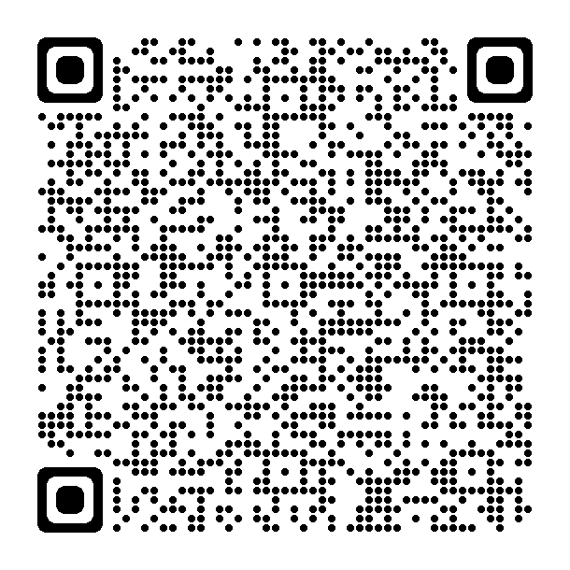**The consultation will close on Friday 23rd February2024**

**You can also complete the survey online via Ceredigion County Council Engagement and Consultation webpage or via this QR code.**

1. What is the postcode of your home address?
2. Which of these best describes you?

Private Tenant  Social housing tenant

Owner Occupier  Landlord  Letting Agent

1. What kind of property do you live in? (Owner occupiers and tenants only) *(please tick):*

Flat single family occupancy

House single family occupancy

Shared house with others (not one family)

Shared flat with others (not one family)

If flat, how many flats are there in the block?

If shared house or flat, how many people live there?

How many storeys are there in the house/flat you live in?

1. How long have you lived at the property?

**Questions 5 - 10 are for tenants only.**

1. If you are a tenant, please provide details of what was provided by your landlord when you moved in? *Tick all that apply*

Written Tenancy Agreement

Information about refuse collection days

Details of how deposit is protected

Your responsibilities as a tenant

Copy of gas safety certificate

Copy of energy performance certificate

Inventory

Location of gas, electric, water meters

How to silence fire alarm

Rent book

1. If you are a tenant, are you concerned about any of the following in relation to your home?

Not enough amenities (i.e. toilet, kitchen facilities)

Waste, storage and refuse

Fire safety

Too little space/too many people

Security

Efficient heating system/ adequate insulation (Energy Efficiency)

Property in poor state of repair

Damp and mould

Security of your tenancy (getting evicted)

Other, please specify

1. If you are a tenant, are you aware of the requirement for landlords to be licenced under Rent Smart Wales?

Yes  No

1. Do you think that the Rent Smart Wales Scheme has improved the quality of your home or relationship with your landlord?

Yes  No

Please explain further.

1. Do you think that landlords and agents manage your property or other properties in your area to an acceptable standard?

Yes  No  Don’t Know

Please comment further if necessary:

1. Do you think Rent Smart Wales licencing of landlords is enough to ensure proper management of your property?

Yes  No  Don’t Know

Please comment further if necessary:

**These questions are for ALL**

1. Are you concerned about any of the following in relation to your area?

Noise, nuisance

Litter, waste and refuse

☐ Unkempt and overgrown gardens/forecourts

☐ Properties detrimental to the amenity of the area (untidy properties)

Burglary

Anti-Social Behaviour

Other crime

Other, please specify

1. Do you have any ideas about how these could be tackled?
2. Do you think that the Licensing Scheme for HMOs benefits the community?

Yes  No  Don’t Know

Please comment further if necessary:

1. Do you think a HMO Licensing Scheme benefits tenants of HMOs?

Yes  No  Don’t Know

Please comment further if necessary:

1. Do you support the continuation/ introduction of an Additional licencing scheme?

Yes  No  Don’t Know  Depends on the scheme/ in part

Please explain your answer:

1. Please indicate which of the following types of property you would like to see licenced?

A dwelling shared by 5 persons or more and 3 storeys or more – *This is mandatory and will continue*

A dwelling occupied by one family

A dwelling shared by 2 or more families/ households

A dwelling shared by a family/household and a non-related lodger

A dwelling shared by a family/ household with two or more lodgers

A dwelling shared by three single people, not related

A dwelling shared by four single people, not related

☐ A dwelling shared by five or more single people, not related

1. Do you think the number of storeys should be taken into consideration as part of the licensing scheme?

Yes  No

If yes, what number of storeys should be licensed? No. of floors? …….

Please return this questionnaire to the following address:

Ceredigion County Council, Community Wellbeing Service

Canolfan Rheidol

Aberystwyth

Ceredigion

SY23 3UE

Ref: Additional Licensing Review 2023

Email: [housing@ceredigion.gov.uk](mailto:housing@ceredigion.gov.uk)

**The consultation will close on Friday 23rd February2024**

**Equality Monitoring Form**



These questions are optional, but we need to ask them to understand if our consultation has reached the right people (in accordance with the requirement of the Equality Act 2010) and to understand how different groups may be affected by the proposal allowing us to address this if we can.

In accordance with the Data Protection Act, any information requested on the following questions is held in the strictest confidence for data analysis purposes only.

|  |  |  |  |
| --- | --- | --- | --- |
| **1. Age:** What is your age group? | | | |
| Under 16 | □ | 45 – 64 years | □ |
| 16 – 24 years | □ | 65+ | □ |
| 25 – 44 years | □ | Prefer not to say | □ |

|  |  |  |  |  |  |  |  |  |
| --- | --- | --- | --- | --- | --- | --- | --- | --- |
| **2. Gender:** What is your gender? | | | | | | | | |
| Male | | □ | | | Female | | □ | |
| Other | | □ | | | Prefer Not To Say | | □ | |
| **3. Transgender:** Is your gender the same now as when assigned at birth? | | | | | | | | |
| Yes | □ | | No | □ | | Prefer not to say | | □ |

|  |  |  |  |
| --- | --- | --- | --- |
| **4. Sexual Orientation:** Which of the following options best describes how you think of yourself? | | | |
| Heterosexual/Straight | □ | Bisexual | □ |
| Gay Man | □ | Prefer not to say | □ |
| Gay Woman/Lesbian | □ | Other (state if desired) _______________________ | □ |
| Note: This question should only be asked of people age over 16. | | | |

|  |  |  |  |
| --- | --- | --- | --- |
| **5. Partnership:** Which of the following options describes your partnership status? | | | |
| Single | □ | Widowed | □ |
| Married | □ | Civil Partnership | □ |
| Living with Partner | □ | Separated | □ |
| Divorced  Prefer not to say | □  □ | Other | □ |

|  |  |  |  |
| --- | --- | --- | --- |
| **6. National identity:** How would you describe your national identity? | | | |
| Welsh | □ | British | □ |
| English | □ | Irish | □ |
| Scottish | □ | Prefer not to say | □ |
| Northern Irish | □ | Other (please describe) _____________________________________ | |

|  |  |  |  |
| --- | --- | --- | --- |
| **7. Race:** What is your ethnic group? Choose one option that best describes your ethnic group or background. | | | |
| White | □ | Gypsy Travellers | □ |
| Asian | □ | Prefer not to say | □ |
| Black/African/Caribbean | □ | Other (Please State) | |
| Mixed | □ | ______________________________________ | |

|  |  |  |  |  |  |  |
| --- | --- | --- | --- | --- | --- | --- |
| **8. Language:** What is your preferred language? | | | | | | |
| Welsh | □ | Prefer not to say | | | □ | |
| English | □ | Other (including British Sign Language)  ______________________________________________ | | | | |
| **Can you understand, speak, read or write Welsh?** | | | | | | |
| Understand spoken Welsh | | | □ | Write Welsh | | □ |
| Speak Welsh | | | □ | None of the above | | □ |
| Read Welsh | | | □ | Prefer not to say | | □ |

|  |  |  |  |  |  |  |
| --- | --- | --- | --- | --- | --- | --- |
| **9. Disability:** Do you have a long term physical or mental health condition or illness that reduces your ability to carry out day to day activities | | | | | | |
| Yes | □ | | | No | □ | |
| Prefer not to say | □ | | |  |  | |
| If you answered ‘**Yes**’ please indicate which applies to you: | | | | | | |
| Hearing Impairment | | □ | Mental Health Issues | | | □ |
| Visual Impairment | | □ | Physical / Mobility Impairment | | | □ |
| Speech Impairment | | □ | Prefer not to say | | | □ |
| Learning Difficulties | | □ | Other (please specify) | | | |

|  |  |  |  |  |  |
| --- | --- | --- | --- | --- | --- |
| **10. Caring Responsibilities:** Do you look after or give help or support to family members, friends, neighbours or others because of long term physical or mental ill-health, disability or problems related to old age? | | | | | |
| Yes | □ | No | □ | Prefer not to say | □ |

|  |  |  |  |
| --- | --- | --- | --- |
| **11. Religion or Belief:** What is your religion? | | | |
| Christian (all denominations) | □ | Jewish | □ |
| Buddhist | □ | Atheist | □ |
| Hindu | □ | No religion | □ |
| Muslim | □ | Prefer not to say | □ |
| Sikh | □ | Other | □ |

Thank you for completing this form.