
Ceredigion County Council

SAFETY INFORMATION CARD

A.6. MANUAL HANDLING

Manual Handling is one of the most common activities we do, it involves lifting and pushing and pulling. It is ESSENTIAL that the following instructions are adhered to ensure safe working practices and reduce the risk of personal injury

The initial and most important consideration should be:
- Can moving the load be avoided?
- Can I move this load with mechanical aids or equipment?

If neither of these options are possible:
- Examine the object to be lifted
- NEVER try to handle something that is too heavy or awkward to get to
- Ensure you are wearing appropriate PPE for the task.
- Plan the task and inspect the route to be taken
- Get a good grip on the object to be lifted and protect your hands
- Keep the object close to your body – don’t twist.
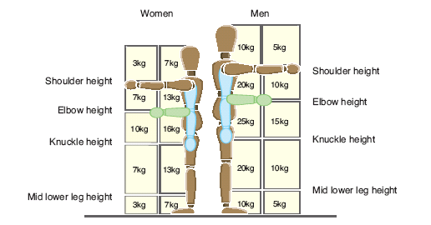

IDENTIFY YOUR CAPABILITIES

Don’t lift or handle more than can be easily managed.
There is a difference between what people can lift and what they can safely lift.
If in doubt, seek advice or get help.

- Only carry what you can comfortably manage
- Drive the lift with the legs

- Move your feet to turn – DON’T twist your body

Always consider:

T . I . L . E. O. – TASK, INDIVIDUAL, LOAD, ENVIRONMENT and OTHER

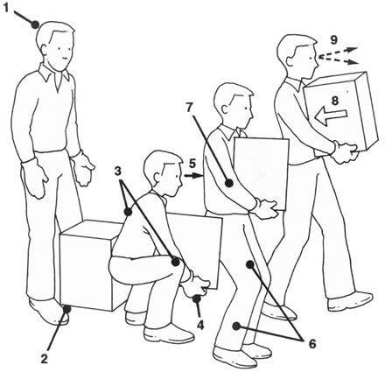
LIFTING

- Think before lifting or handling
- Keep load as close to your waist as possible.
- Adopt a stable & balanced position
- Ensure you have a good hold on load
- Lift by moderately bending back, hips & knees, don’t flex joints any further while lifting
- Look up when lifting, lead with the head
- Unlock knees and move smoothly
- Support the weight of the load
- Look ahead and assess route
- Carry a similar weight in each hand
- Don’t rest the object against your body
- Handle bags with care as they may contain sharp objects
- Be aware that the bags may suddenly split and spill the contents

PUSHING AND PULLING

Pushing and pulling exert forces across the spine rather than down it, but safer than lifting.
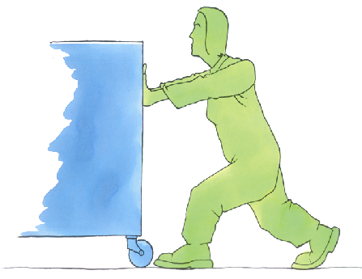
- Check the weight. If it is heavy get assistance. Get close to the load – don’t over reach
- Use both hands on the equipment
- Keep one foot in front of the other
- Put one foot against a wheel
- Unlock the knees
- Tip the equipment towards you
- 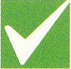Always start the movement with the legs

DO NOT START PULLING OR PUSHING WITH THE BACK OR SHOULDERS,
DIP N’ DRIVE!
Use your LEG muscles to help you as back, arm and abdominal muscles are weaker.

Bad habits when lifting and carrying can lead to injured backs, slipped discs, sprains and hernias etc.
STOP and THINK

Issued by CCC CHSU 2013

