**Parenting and Family Support Referral Form.**



Send the completed form to [taf@ceredigion.gov.uk](mailto:taf@ceredigion.gov.uk)

Ensure all sections of the form are filled out, to the best of your ability.

Allow up to **10** working days after submitting the request before   
hearing from a member of the team.

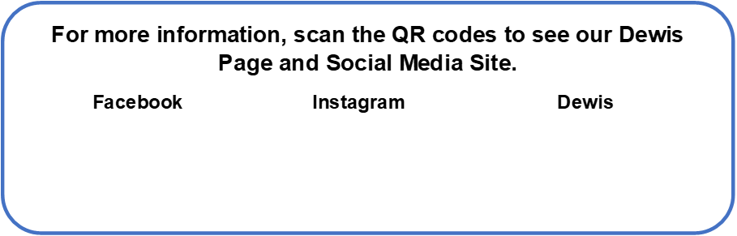



Understanding and Agreement

# Consent

We have collected information in this form so that we can understand what help your family may need and begin planning with you. We may need to share some of this information with other organisations so that they can help us to provide the services you may need.

We will treat your information as confidential and will not share it with any other organisation unless you have consented, or unless we are required by law to share it, or if you or any other person will come to some harm if we do not share it. In all cases we will only ever share the minimum information we need to share.

**I understand the reasons for information sharing and information storage and agree that the information provided will be stored and used for the purpose of providing appropriate support.**

**Singed by parent/carer Date**

|  |  |  |
| --- | --- | --- |
| 1.Referrer Name: | Signature: (Practitioner) | Date: |
|  |  |  |
| Job position and organisation: | Email Address: | Telephone: |
|  |  |  |

**Please select which support service you require**

|  |  |
| --- | --- |
|  | **Team Around the Family** |
|  | **Outreach** |
|  | **Family Support Go to page 7 of the form after completing ‘Your information’** |
|  |  |

|  |  |  |  |
| --- | --- | --- | --- |
| **Name of Child:** |  | **Name of parent/carer:** |  |
| **Date of Birth:** |  | **Contact number:  Email Address:** |  |
|  |
| **Gender:** |  | **Preferred Language:** |  |
| **Address:** |  | **Name and address of GP:** |  |
| **Educational setting:** |  | **Have you worked with us before:** |  |
| **Percentage of School Attendance:** |  | **Caring Responsibilities:** |  |

**Your information**

Family Members (Please include details of parents / carers and also other family members such as siblings, carers, step siblings, or other significant people who visit the home)

|  |  |  |  |
| --- | --- | --- | --- |
| Name | Relationship to child | Household member | Contact Details |
|  |  |  |  |
|  |  |  |  |
|  |  |  |  |
|  |  |  |  |
|  |  |  |  |
|  |  |  |  |
|  |  |  |  |

|  |
| --- |
| Additional Needs information: |
| Health Concerns that directly affect the child: |
| What has happened for you to contact us now? |
| Best hopes for our assistance? |
| Any other useful information? |

What other services have supported you in the past

|  |  |  |  |
| --- | --- | --- | --- |
| Contact Name | Agency | Contact details | What support was provided. |
|  |  |  |  |
|  |  |  |  |
|  |  |  |  |
|  |  |  |  |

**JAFF Assessment**  
 (please fill in when requesting TAF and Outreach support)

|  |  |
| --- | --- |
| Dim (Medium Sun) outlineCloud With Lightning And Rain with solid fillYour Family | |
| I live in an appropriate, safe home. | 1 2 3 4 5 6 7 8 9 10 |
| I manage our income and have few debts. | 1 2 3 4 5 6 7 8 9 10 |
| My family generally get on well together. | 1 2 3 4 5 6 7 8 9 10 |
| We have supportive friends and neighbours. | 1 2 3 4 5 6 7 8 9 10 |
| Your child’s Health and Wellbeing. (fill this part in for you as a young/expectant parent or for your child depending on which is most appropriate) | |
| My/my child’s general health is good. | 1 2 3 4 5 6 7 8 9 10 |
| My/My child’s emotional health is good. | 1 2 3 4 5 6 7 8 9 10 |
| I am/ my child’s behaviour is generally good. | 1 2 3 4 5 6 7 8 9 10 |
| I am/ my child is confident. | 1 2 3 4 5 6 7 8 9 10 |
| I am/ my child is able to take care of them selves (age appropriately) | 1 2 3 4 5 6 7 8 9 10 |
| Learning and social connection. (fill this part in for you as a young/expectant parent or for your child depending on which is most appropriate) | |
| I am/my child can understand, be reasoned with and can problem solve appropriate to their age. | 1 2 3 4 5 6 7 8 9 10 |
| I am/my child is attending and take part in learning, education and recreation opportunities. | 1 2 3 4 5 6 7 8 9 10 |
| I am/ my child is making good progress | 1 2 3 4 5 6 7 8 9 10 |
| My child and I have hopes for the future | 1 2 3 4 5 6 7 8 9 10 |
| Your Strengths and needs (please also answer if you’re due to become a parent) | |
| I am able to provide warmth, food and shelter to ensure my child’s safety and protection | 1 2 3 4 5 6 7 8 9 10 |
| I am confident about providing routines and boundaries for my child | 1 2 3 4 5 6 7 8 9 10 |
| I am able to ensure my child feels loved and secure | 1 2 3 4 5 6 7 8 9 10 |
| I am in good physical health. | 1 2 3 4 5 6 7 8 9 10 |
| I am mentally and emotionally well. | 1 2 3 4 5 6 7 8 9 10 |

Information about what is going well and where the support is needed.

|  |  |
| --- | --- |
| **Section** |  |
| Your Family |  |
| Health and Well-being |  |
| Child’s learning |  |
| Your strength and needs |  |

**If at any time you have reasonable concern that a child or young person may be at risk of harm, you should follow Safeguarding procedures and contact Social Services Safeguarding.**

**Family Support**

Programme Required (please tick box to select)

|  |  |
| --- | --- |
|  | Family Links |
|  | Talking Teens |
|  | SPACE |
|  | Autism Programme |
|  | Blame it on the Brain |
|  | Online Safety and Gaming |
|  | Take 3 |
|  | One plus One |
|  | Welcome to the world |
|  | Mentoring Support |
|  | Other |

Please Note;

* Programmes are delivered on a need and demand basis.
* We aim to deliver in venues throughout Ceredigion, with some programmes delivered online via Teams/Zoom.
* Programmes are designed and evaluated on group deliver. 1:2:1 intervention is only available for certain programmes and in certain circumstances. Please speak to the relevant facilitator.
* The loan of an iPad and/or WIFI access to attend online programmes available, if required.

For further information on each of our programmes please see documents enclosed.

Our programmes are also advertised on our Social Media Platforms..