
Ceredigion County Council

D.5 Personal Safety Card

SAFETY INFORMATION CARD

PERSONAL SAFETY

Risks at work do not just exist just at a desk or workspace. There may be risks travelling to and from work or in connection with your work; in work that you might do on someone else’s premises; or in car parks, lifts corridors etc. You should remember that personal safety is a shared responsibility between employer and employee. You also have a responsibility to help yourself to be safer.

If you are out and about or travelling and need to call the police:

Dial 999 or 112 – the call is free

KEY TO PERSONAL SAFETY

Develop confidence – learn how to deal with difficult situations. Look Confident and keep fit, this can help you to develop posture, stamina and strength

Avoid Risk – Avoid confrontation. When out of the office inform others of your location/movements. Know where you are going and how you’re going to get there. Assess risky situations, especially when travelling.

Never assume it won’t happen to you – Beware of your surroundings and potential hazards. TRUST your intuition. Recognise that fear is natural, but can be channelled into positive action.

Take action when in real danger – Get away FAST, remember avoiding violence is a sign of strength not weakness. Be prepared to help someone else in danger. Ring 999/112

REDUCING THE RISKS

Communicate:

Effective communication can greatly reduce the risk of aggression or potentially violent situations developing. Talk you way out of problems

Respect personal Space/territory:

Avoid actions which may appear aggressive or invasion of privacy

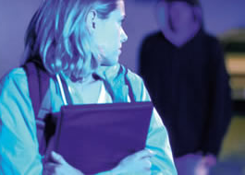
Protect yourself:

Do not give out your home telephone number or address

If anyone in a lift makes you feel uneasy – get out at the next floor

Avoid unnecessary after hours meetings

Do not enter a house if the person you expect to see isn’t there

Don’t wear clothes which give out signals you don’t intend

No matter how confident, do not get into a car with somebody you do not know and trust.

DEALING WITH AGGRESSION

Stay calm; speak gently, slowly and clearly. Do not argue or try to outsmart the person verbally. Breathe slowly to control your own tension. Avoid body language which may be misinterpreted. Talk through the problem. Compromise: offer the aggressor a way out of the situation.

Report the incident to your supervisor – Ensure that the incident is reported to LM & CHSU

Be prepared: While talking assess possible ways you can escape if the situation worsens. Try to prevent the aggressor blocking any possible escape routes. Never turn your back. If you are trying to get away move gradually backwards.
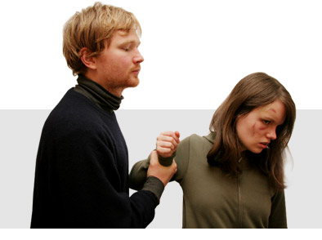

PHYSICAL ATTACK

Avoid

Get away as fast as you can. Aim towards a place you know where there will be people

Don’t look back

Report the incident immediately. Someone else might be attacked and might not be able to get away.

If you cannot get away, protect yourself

Shout and scream – your voice is your best defence

Give the command ‘Phone the police’ or similar positive instruction – people are more likely to react when given a call to action

Use a personal alarm to shock and disorientate your assailant. You will create vital seconds to get away.

As a last resort, the police advice is:

‘Bash and Dash’ – If you have to fight back, do it quickly. Aim for the knee, solar plexus, elbow joint or little fingers. Then get away.

It is safer to carry a personal alarm then an offensive weapon, which could be used against you.

SELF-DEFENCE

Physical self-defence should only be used as a last resort because it limits your options of getting away and will invariably commit you to a fight that you could well lose. Remember also, that if you respond physically you could be legally liable for assault.

AVOIDING RISKY SITUATIONS IS YOUR BEST FORM OF SELF-DEFENCE…

A PERSONAL SAFETY CHECKLIST:

OUT AND ABOUT

Does anyone know where you are?

If your travel plans change, do you tell your supervisor/colleagues?

Do you check out people you meet alone?

Have you made sure you can be contacted?

Do you know exactly where you are going and how to get there?

If you are returning home after dark, have you considered the possible risks?

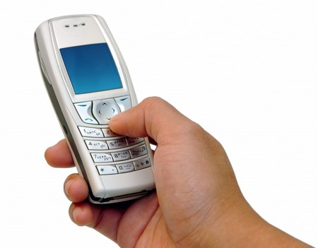
Are you likely to be carrying cash or valuable items?

Do you carry a personal alarm?

AT YOUR PLACE OF WORK

Are you alone at work at all, especially if working late?

Are there areas where you feel uneasy?

If your work involves contact with the general public, do you know what to do if someone becomes aggressive?

Do you report aggressive behaviour?

Issued by the Corporate Health and Safety Team May 2014

