**CYNGOR SIR CEREDIGION COUNTY COUNCIL**



**Draft Version Consultation Document**

**Hackney Carriage (Taxi) and Private Hire Vehicle Drivers**

**Licensing Policy and Conditions**

**2024**

Contents

Introduction 3

Hackney Carriage & Private Hire Driver Licences 10

Equality Act Medical Exemption Policy 14

Hackney Carriage & Private Hire Vehicles 18

Additional Provisions for Hackney Carriages ONLY 28

Private Hire Vehicle Operators 28

General Compliance & Enforcement 31

Privacy Notice 34

List of Annexes 35

**Document Control**

Author and service: Corporate Lead Officer Policy, Performance and Public Protection

Date approved by Cabinet: XXX

Publication date: XXX

Policy Review Date: XXX (5yrs from date of adoption)

# Introduction

Taxis and PHVs are a vital form of public transport. They deliver a practical direct transport solution and provide an essential service to; people living in rural communities where other forms of public transport may be insufficient, the night-time economy, passengers with disabilities, and have an important role in facilitating social inclusion.

It is important that hackney carriage and private hire vehicles meet regulatory standards and are able to convey passengers safely and comfortably, ensuring that the customer experience is a positive one.

This policy and related procedures will advise applicants of the standards and requirements that must be met and guide the Council in the way it carries out its licensing functions. This policy will be reviewed every 5 years but may be subject to interim reviews should the need arise.

However where updates are required due to changes in national legislation, statutory guidance or contact details the council reserves the right to amend this policy without consultation where it is necessary to ensure the policy reflects national legislation or statutory guidance.

**Application of the Policy**

Ceredigion County Council is the Licensing Authority under the Local Government Miscellaneous Provisions Act 1976 (as amended) and the Town and Police Clauses Act 1847. It has the duty to carry out its licensing functions in respect of:

* Hackney Carriage Vehicle Licences
* Hackney Carriage Drivers Licences
* Private Hire Vehicle Licences
* Private Hire Drivers Licences
* Private Hire Operator Licences

This Policy will apply to the licence types listed above. Throughout this Policy any reference to the following general terms means:

"**The Act of 1847**" means the Town Police Clauses Act 1847.

"**The Act of 1976** " means the Local Government (Miscellaneous Provisions) Act 1976.

A ‘**hackney carriage’** is legally defined in the Act of 1847 but, in general terms, may be described as a vehicle which can stand or ply for hire in a street which has been duly licensed by the Council. The licence number will be displayed on a plate, which will be fitted to the outside rear of the vehicle. A taxi may have more than 4 and up to 8 passenger seats and any vehicles that carry more than 8 passengers are public service vehicles, which are subject to separate licensing controls. A hackney carriage is a vehicle in respect of which there is a licence in force under Section 37 of the Act 1847.

A hackney carriage licence is required under Section 37 of the Town Police Clauses Act 1847 and is subject to standard conditions. In consideration of Section 16 of the Transport Act 1985, this authority does not intend, at this stage, to restrict the number of vehicles licensed as hackney carriages. However, all vehicles will be subject to appropriate standards of design specification and mechanical fitness.

A **‘private hire vehicle’** means a motor vehicle constructed or adapted to seat fewer than eight passengers, other than a hackney carriage or public service vehicle which is provided for hire with the services of a driver for the purposes of carrying passengers, as in accordance with section 80 the Local Government (Miscellaneous Provisions) Act 1976. A private hire vehicleis a vehicle in respect of which there is a licence in force under Section 48 of the Act.

A **private hire vehicle (stretched limousine)** is a vehicle constructed or adapted, by lengthening the wheelbase of a standard factory built vehicle, to seat fewer than nine passengers which is made available with a driver to the public for hire for the purpose of carrying passengers, other than a licensed taxi or a public service vehicle. An “American stretched limousine” is a stretched limousine imported from the USA and typically will have been manufactured originally by Lincoln (Ford), Cadillac or Chrysler. However other specialist manufacturers may be included.

A **private hire vehicle (novelty vehicle)** includes Fire Engines, Ambulances, Army Trucks and Hearses and any similar vehicles not being a limousine and carrying up to eight passengers.

All private hire vehicles must be operated through a private hire vehicle operator licensed by the Council. ‘Operate’ means, in the course of business, to make provision for the invitation or acceptance of bookings for a private hire vehicle. No person shall operate any vehicle as a private hire vehicle without holding a private hire vehicle operator’s licence. This is in addition to any requirement for a private hire vehicle licence and private hire vehicle driver’s licence.

**‘Authorised officer’** means any officer of the Council authorised in writing

**‘The Council’** means the Ceredigion County Council.

**“The Licensing Committee”** means the Council’s Licensing Committee

**‘Licensee’** is the holder of a hackney carriage/private hire vehicle driver’s licence, a hackney carriage licence, a private hire vehicle licence or a private hire vehicle operator’s licence.

**‘Driver’** means a the driver of a hackney carriage or private hire vehicle;

**‘Driver’s licence’** means, in relation to a hackney carriage driver, a licence issued under section 46 of the Town Police Clauses Act 1847 and in relation to a private hire vehicle driver, a licence issued in accordance with section 51 of the Local Government (Miscellaneous Provisions) Act 1976.

**‘Driver’s badge’** means, in relation to a hackney carriage driver, a badge issued under section 68 of the Town Police Clauses Act 1847 and in relation to a private hire vehicle driver, a licence issued in accordance with section 54 of the Local Government (Miscellaneous Provisions) Act 1976.

**‘Vehicle’** means a hackney carriage or a private hire vehicle with less than 8 passenger seats.

**‘Vehicle licence’** means, in relation to a hackney carriage, a licence issued under sections 37 to 45 of the Act of 1847 or, in relation to a private hire vehicle, a licence issued in accordance with section 48 of the Act of 1976.

**‘Proprietor’** means any interested party or parties named in the licence who is concerned in the keeping, employing or letting on hire of the hackney carriage.

**‘Licence plate’** mean the plate issued by the Council for the purposes of identifying the vehicle as a licensed hackney carriage.

"**Vehicle licence number**" means the number allocated by the Council to a licence granted for a private hire vehicle or a hackney carriage.

‘**Operator**’ means a person holding a licence to operate private hire vehicles issued pursuant to Section 55 of the Act of 1976 and is the person(s) who carries on the business of making provision for the invitation or acceptance of bookings for a private hire vehicle or hackney carriage;

‘**Contract’** means the acceptance of a booking between the operator and the person making the booking;

“**Employ**” means to use the services of, whether under a contract of service or a contract for services or otherwise, and employee, employer and employed shall be construed accordingly.

All other words and phrases in these Conditions shall bear the meanings ascribed to them (if any) in the relevant legislation.

In undertaking its licensing function, the Licensing Authority will have regard to the following legislation:

* Town and Police Clauses Act 1847
* Local Government (Miscellaneous Provisions) Act 1976,
* Transport Act 1985
* Environmental Protection Act 1990
* Health Act 2006
* The Smoke-free (Premises and Enforcement) Regulations
* The Smoke-free (Vehicle Operators and Penalty Notices) Regulations 2007
* The Equality Act 2010
* Crime and Disorder Act 1998
* Data Protection Act 2018
* Immigration Act 2016
* Human Rights Act 1998
* The Rehabilitation of Offenders Act 1974 (Exceptions) (Amendment) Order 2002
* Wellbeing of Future Generations (Wales) Act 2015

Consideration has been given to other relevant legislation and guidance, including:

* Guidance on the Rehabilitation of Offenders Act 1974 (March 2014)
* Disclosure and Barring Service (DBS)
* Guidance on Eligibility Regulators Code 2014
* The Department for Transport “Taxi and Private Hire Vehicle Licensing Best Practice Guidance” (March 2010)
* The Department for Transport “Statutory Taxi and Private Hire Standards” July 2020
* Welsh Government –“Taxi and private hire vehicles: Licensing Guidance” March 2021

**Policy Aims & Objectives**

The overall aim of hackney carriage and private hire licensing is to protect the public and promote public safety by:

* Setting out the Licensing Authority’s approach to regulation, enforcement and sanction of vehicles, drivers and operators,
* Defining and offering guidance on the legislation in relation to the provision of hackney carriage and private hire vehicles,
* Setting out the licensing conditions applicable to drivers, vehicles and operators.

This policy contains information and guidance to advise and assist applicants for hackney carriage and private hire vehicle licences and existing licence holders on the Council’s policies and procedures and the law relating to such licences.

The conditions stated within this policy will apply to both hackney carriage and private hire drivers, vehicles and their operators or proprietors. This therefore means any drivers’ licence and badge granted will be known as the Dual Drivers Badge and/or Licence. However, it shall be noted that within this document there are circumstances where conditions relate specifically to private hire drivers and hackney carriage drivers. Consideration must therefore also be made to the relevant Annexes.

It is not intended to be an exhaustive or definitive statement of the law and all drivers should familiarise themselves with the provisions of the relevant Acts, including the Town Police Clauses Act 1847 and the Local Government (Miscellaneous Provisions) Act 1976.

In exercising its discretion in carrying out its functions, the Licensing Authority will have regard to this Policy and the objectives set out therein. Where it is necessary for the Licensing Authority to depart significantly from this Policy, clear ans substantial reasons for doing so will be given.

This policy should be read and understood by all licensed drivers, vehicle proprietors and operators and those intended to become licensed. It explains how the above-mentioned legislation is interpreted by the Council.

Ceredigion County Council has a duty to protect the public through its licensing process, particularly children and vulnerable people. It also aims to ensure that the level of service provided by the hackney carriage and private hire vehicle trade is of a good standard. To allow these standards to be met, the Council may attach any conditions it may consider reasonably necessary and such conditions are included in this document.

The Council reserves the right to vary any conditions from time to time. Any person aggrieved by any of the conditions may appeal to a Magistrates’ Court.

Taxi and PHV licensing is a devolved function in Wales. In the Welsh Government’s “Taxi and private hire vehicles: Licensing Guidance”, Welsh Government has the following aim as part of its vision statement:

“Our aim is to update Wales’s taxi and PHV licensing system to make it fit for a modern Wales. We want to create one consistent standard applied across Wales that promotes safety, contributes to a cleaner environment, improves the customer experience, and is accessible by all.”

The Council agrees with this vision and will work towards the aim and the following four objectives:

* **Safety:** Operators, vehicles and drivers will be safe and suitable for licensing
* **Environment:** licensed vehicles should contribute to targets for a cleaner environment
* **Equality:** All passengers should have access to a suitable vehicle. Driver and operators should provide a service that fits customer needs
* **Customer Experience:** All customer should experience a good standard of taxi/PHV service.

In promoting these licensing aims and objectives, the Council will expect to see licence holders and applicants continuously demonstrate that they meet or exceed the standards set by the Council as set out in this policy.

**Licensing process and delegation of functions**

The Council’s Constitution details who is responsible for making decisions on matters relating to taxi licensing.

The Council operates a scheme of delegation where certain powers are delegated to Authorised Officers and Elected Members who sit on the Licensing Committee. A copy of the Constitution which contains the scheme of delegation is available on the Council’s website or upon request.

**Departure from Policy**

In exercising its discretion in carrying out its functions, the Licensing Authority will have regard to this Policy and the objectives set out therein.

Where it is necessary for the Licensing Authority to depart significantly from this Policy, clear and substantive reasons for doing so will be given.

**Licence Fees**

Licence fees will be set in order for the Licensing Authority to recover the costs associated with the administration, issue and enforcement of each licensing regime, so far as is permissible by statute.

The fees will be reviewed periodically, and any surplus or deficit will be taken into account the next time the fees are set.

The current licence fees are included in **Appendix 1**. The fees are subject to annual review and whilst this document will be updated accordingly, applicants and licence holders are advised to contact the Council’s Licensing Team for up-to-date licence fees.

**GENERAL INFORMATION**

**Contacts**

All licence applications or enquiries must be made to the Licensing Section, Public Protection Service, Ceredigion County Council. Licensing staff are no longer office based and work hybridly. However, the team does have a base at Penmorfa, Aberaeron, SA46 0PA and wherever possible, can be available at this office providing an appointment is made. You can still contact the team by telephone or email from 9am to 5pm, Monday to Thursday. And 9am to 4.30pm on Fridays.

Tel. No.: 0545 570881

E-Mail: publicprotection@ceredigion.gov.uk

**Fees and Charges**

* Licence fees will be set in order for the Licensing Authority to recover the costs associated with the administration, issue and enforcement of each licensing regime, so far as is permissible by statute.
* All fees will be reviewed annually and increased if necessary
* A full list of fees is available on request and are available on the Council’s website
* All fees and charges are normally payable in advance
* Cheques and postal orders must be made payable to Ceredigion County Council
* Refunds will not normally be given if a licence is issued.

**Determination of Applications**

Most applications are dealt with administratively by Licensing Officers and will be determined on their individual merits. However, some applications are referred to the Licensing Committee, depending on the circumstances of the application. The Committee will make a decision based on the information supplied and applications may be refused as well as granted.

**Licence Renewals**

A courtesy reminder letter will be sent to all licence holders before a licence expires. As the Council is not obliged to send reminders, it is the licensee’s responsibility to ensure that applications are submitted and a licence issued before the expiry date, as there is no automatic period of grace. Any application received after the expiry date will be treated as a new application and trade must cease until a new licence has been issued.

**Changes in Circumstances**

All licence holders are required to notify the Council’s Licensing Team immediately of any changes in circumstances during the period of licence, for example, change of address, medical condition, convictions etc.

**Enforcement**

The Licensing Team operates in accordance with the Corporate Enforcement Policy. Formal enforcement action, such as suspension or revocation of licences, is taken either by officers, under delegated powers, or by elected Members of the Licensing Committee.

**Offences and Penalties**

The contravention of certain conditions may constitute an offence under various provisions of the Local Government (Miscellaneous Provisions) Act 1976, the Town Police Clauses Act 1847 and the Road Traffic Act 1988. In addition, it is also an offence to obstruct an authorised officer or police constable in their duty.

**Production of Licences**

All licence holders shall produce their licence at the request of any authorised officer of the Council or any Police Officer.

**Loss of Licences**

Lost or stolen licences should be reported to the Licensing Section of the Council immediately. A fee may be payable for any replacement licence.

**Appeals**

In most cases, if an application is refused or issued subject to conditions, or if a licence is suspended, revoked or refused on renewal, the applicant has the right to appeal to a Magistrates’ Court, normally within 21 days from the date of notice of the decision.

**Smoking**

It is illegal for anyone to smoke in a licensed hackney carriage or private hire vehicle. This includes times when there are no passengers in the vehicle. Further advice is available at www.smokingbanwales.co.uk. The use of electronic cigarettes and similar devices is also prohibited in licensed vehicles.

**Suitability Policy**

In order to assess the suitability of applicants and licence holders the licensing authority will have regard to the Institute of Licensing’s ‘Guidance on determining the suitability of applicants and licensees in the hackney and private hire trades’ April 2018.

The guidance is detailed in the Institute of Licensing’s “Guidance on determining the suitability of applicants and licensees in the hackney and private hire traders”: ‘[**https://instituteoflicensing.org/documents/Guidance_on_Suitability_Web_Version_(16_May_2018).pdf**](https://instituteoflicensing.org/documents/Guidance_on_Suitability_Web_Version_(16_May_2018).pdf)’.

# Hackney Carriage & Private Hire Driver Licences

**Licence Requirements**

Any person who drives a hackney carriage or private hire vehicle must hold the appropriate licence.

Hackney carriage vehicle driver’s licences are issued in accordance with section 46 of the Town Police Clauses Act 1847.

Private hire vehicle driver’s licences are issued in accordance with section 51 of the Local Government (Miscellaneous Provisions) Act 1976.

Ceredigion County Council issues dual licences which means that anyone issued with a hackney carriage/private hire vehicle driver’s licence can drive both types of vehicles in their employment.

Any reference to ‘driver’s licence’ in this section will refer to a hackney carriage/private hire driver’s licences. The Licensing Authority will issue a dual drivers licence to applicants that are considered to be “fit and proper” to hold a licence, and this will permit the driving of both hackney carriage and private hire vehicles.

**Licence Duration**

Driver licences may be granted for a maximum period of three years, however the Licensing Authority does have the discretion to issue a licence for a shorter duration if it is considered to be appropriate in the circumstances of the individual case, or at the request of the applicant.

**Application Process**

The application procedure and guidance for obtaining a hackney carriage/private hire driver’s licence is detailed in **Annex 2**.

**Fitness and Propriety**

The purpose of the following pre-requisites of licensing is to assist the Licensing Authority in determining whether an applicant/driver is a ‘fit and proper’ person to hold a licence, or to continue to hold a licence.

In the absence of a legal definition of ‘fit and proper’ the Licensing Authority will use the following test:

**Without any prejudice, and based on the information before you, would you allow a person for whom you care, regardless of their condition, to travel alone in a vehicle driven by this person at any time of day or night?**

In order to further assist in understanding the interpretation of this definition, the Licensing Authority will be considering issues that assist them in determining whether or not applicants are safe drivers with a good driving record, are mentally and physically fit, are honest, and that they are persons who would not take advantage of their position to abuse, assault or defraud members of the public.

When assessing the fitness of an applicant to hold a driver licence, the Licensing Authority will consider the applicant’s criminal history as a whole, together with all other relevant evidence, information and intelligence including their history (e.g. complaints and commendations from the public, compliance with licence conditions and willingness to co-operate with licensing officers) whilst holding a licence from the Licensing Authority or any other authority. Particular attention will be given to patterns of behaviour, irrespective of the time-scale over which they have occurred, both in terms of proven criminal offences and other behaviour/conduct that may indicate the safety and welfare of the public may be at risk from the applicant.

It must also be recognised that the Licensing Authority will consider all criminal history, behaviour and conduct irrespective of whether the specific history, behaviour or conduct occurred whilst applicants were directly engaged in hackney carriage or private hire licensed work at the time or whether they occurred during the applicants’ own personal time. The Licensing Authority considers a person or individual who has a propensity to commit offences and/or demonstrate unacceptable conduct whilst not engaged in hackney carriage or private hire work to be equally as serious as offences and/or unacceptable conduct committed whilst engaged in hackney carriage or private hire work.

The Licensing Authority takes into account significantly that drivers may carry vulnerable members of the public such as elderly persons, unaccompanied children, disabled persons, lone women, foreign visitors and persons who are incapacitated from alcohol or other substances.

In order to assess the suitability of applicants and licence holders the licensing authority will have regard to the Institute of Licensing’s ‘Guidance on determining the suitability of applicants and licensees in the hackney and private hire trades’ April 2018.

The guidance is detailed in **Appendix 3**.

**DBS check**

In order to satisfy the authority that they are a ‘fit and proper’ person, all applicants for the role of a hackney carriage and private hire vehicle driver will undergo an Enhanced Disclosure and Barring Service (DBS) check, which includes a check of the children and adult barred lists. For licensed drivers this check will be repeated every 6 months.

All applicants/licence holders must sign up to the DBS Update Service and maintain their subscription for the duration of their licence. The licence holder must give permission for the Licensing authority to undertake checks of their DBS status. Failure to provide DBS information every 6 months will result in the Licence Authority suspending a driver licence until such time the information is provided or is accessed.

Disclosure and Barring Service certificates will only be accepted if the disclosure is dated within one calendar month prior to the application. To assist in assessing the suitability of applicants and licence holders the licensing authority will have regard to the Institute of Licensing’s ‘Guidance on determining the suitability of applicants and licensees in the hackney and private hire trades’ April 2018 (or any revised versions as applicable).

It should be noted that individuals that appear on either barred list will routinely have their application refused, unless there are exceptional circumstances in which the licensing authority considers that, on the balance of probabilities, the individual is ‘fit and proper’.

DBS disclosure applications must be completed through Ceredigion County Council. Ceredigion County Council is an approved Disclosure & Barring Service body. Therefore, applicants must apply for a DBS (CRB) check through the Council.

Photocopies of documents will not be accepted unless certified as a true copy of an original by an officer of the Licensing Authority. In any event, only original documents can be submitted if being used as supporting documents for a DBS disclosure application. The LA does not accept responsibility for original documents that are returned via Royal Mail. It is for this reason that applicants are required to submit and/or collect their documents in person.

The LA will only process DBS disclosure applications as part of a valid and complete application and not prior to submission of an application.

**Overseas criminal record check**

All applicants for a hackney carriage or PHV driver’s licence that have spent 6 or more continuous months outside the United Kingdom since their tenth birthday the Licensing authority will need to see evidence of a criminal record check from the country / countries visited covering the period that the applicant was overseas.

The applicant will be required to cover any financial costs of such checks.

For EU nationals (including UK citizens) suitable checks should be available. For those countries for which checks are not available, the Licensing authority will require a certificate of good conduct authenticated by the relevant embassy. The certificate must be authenticated, translated and sealed by the Embassy or High Commission. Information regarding certificates of good conduct or similar documents from a number of countries is available from: [**GOV.UK Criminal records checks for overseas applicants.**](https://www.gov.uk/government/publications/criminal-records-checks-for-overseas-applicants)

In the event that an applicant is not able to obtain a certificate of good conduct, they should not progress with their application and should contact the licensing authority for further information.

Overseas criminal history checks must have been obtained within the 6-month period preceding the application.

The Licensing Authority will require any Certificate of Good Conduct that the applicant may have regardless of the age of the document.

Certificates of Good Conduct which are in a language other than English will be required to be translated into English at the applicant’s expense by an independent translation service and the translation must be verified.

**Driving Experience & Standards**

All applicants must have at least 12 months driving experience i.e. they must have held a full UK driving licence, a driving licence issued by a member state of the European Union or other “exchangeable licence” as defined in the Road Traffic Act 1988 for at least 12 months prior to the date of application.

At the time of application, all applicants must have held a UK driving licence for Category B vehicles for 12 months. Details on ways to convert a foreign driving licence to a UK driving licence can be found at: <https://www.gov.uk/exchange-foreign-driving-licence>

To ensure that applicant’s driving standard is suitable, the Licensing Authority will undertake a check of the status of the applicant’s DVLA driver’s licence to view the applicant’s driving history. This check will take place prior to first licence, prior to renewal of a driver’s licence and at any time considered necessary by the Licensing Authority.

**Medical checks**

The licensing authority recognises that licensed drivers should have more stringent medical standards than those applicable to normal car drivers because they carry members of the public who have expectations of a safe journey; they are on the road for longer hours than most car drivers; and they may have to assist disabled passengers and handle luggage.

Therefore, all applicants for a hackney carriage/private hire driver’s licence are required to meet the DVLA Group 2 medical standards of fitness to drive. The medical must be carried out by the applicant’s own general practitioner (GP) or another GP at the applicant’s registered practice that has full access to their medical records.

In exceptional circumstances, and only with prior agreement from the Licensing authority, a medical assessment may be carried out by another registered GP practice as long as the applicant’s full medical history has been viewed and assessed by that GP.

The licensing authority may direct any licence holder to supply satisfactory evidence in the form of a medical certificate, stating the licence holder meets the required Group 2 standards, should their medical fitness be called into question.

Any applicant for the grant or renewal of a licence who is unable to satisfy the licensing authority that they meet the required medical standard shall not have a licence granted to them, or the licence shall not be renewed, or shall be revoked.

The frequency of medical checks for applicants/licensed drivers are as follows:

* Upon application, every 5 years between the ages of 45 and 65
* Every year when the driver is aged 65 years or over
* Or anytime as required by the licensing authority or the medical practitioner.

The medical form is valid for 4 months from the date the examining doctor, optician or optometrist signs it.

All licence holders are required to inform the licensing authority of any illness or condition that affects their ability to drive.

All costs associated with obtaining the relevant medical certificate are to be met by the applicant/licence holder.

Find the medical form: [Medical report for taxi or private hire vehicle drivers licence: application form | GOV.WALES](https://www.gov.wales/medical-report-taxi-or-private-hire-vehicle-drivers-licence-application-form)

# Equality Act Medical Exemption Policy

The Equality Act 2010 places a number of legal duties on licensed drivers when transporting passengers with disabilities. This includes the carriage of assistance dogs and the carriage of wheelchair users whilst seated in their wheelchair in purpose-built wheelchair accessible vehicles without additional charges.

Where drivers cannot themselves assist wheelchair users or have allergies relating to dogs, exemptions can be applied for from the Licensing Authority.

In addition to the Equality Act 2010, the Taxis and PHV (Disabled Persons) Act 2022 now allows all hackney carriage and private hire vehicles drivers to apply for an exemption, regardless of whether or not they are carrying wheelchair users in a wheelchair accessible vehicle.

In order to improve compliance with the requirements of the Equality Act 2010 and the Taxis and PHV (Disabled Persons) Act 2022, and to support drivers that have genuine medical conditions that prevent them from fully undertaking the duties under the Acts described above, the Council has adopted the Taxi and private hire vehicles: Equality Act medical exemption policy detailed in **Appendix 4**.

**Safeguarding Training**

Hackney carriage and private hire drivers have an important responsibility in the safe transportation of fare paying passengers. Drivers are expected to act in a professional manner at all times and provide excellent customer service.

Licensed drivers can often be the eyes and ears of a community. Training can be important in assisting licensed drivers in recognising when they carrying passengers at risk of abuse and exploitation.

All new applicants for a hackney carriage/private hire driver’s licence must undertake safeguarding training. The training focuses on recognising what makes adults and children vulnerable, violence, sexual exploitation, county lines and human trafficking indicators. It includes examples of suspicious journeys as well as information on maintaining professional boundaries.

The training will explain to drivers how they should report safeguarding concerns and provide useful contact details.

Safeguarding training is required. The training is in the form of the following video and a test based on the content of the video must be passed prior to obtaining a licence. Watch the video: Safeguarding training for Hackney Carriage and Private Hire drivers and passenger assistants: <https://vimeo.com/369335248/be28cb645a>

**Driver Knowledge tests**

Hackney carriage and private hire drivers have an important responsibility in the safe transportation of fare paying passengers. Drivers are expected to act in a professional manner at all times and provide excellent customer service. Completion of training is required in order to assist drivers in being equipped to perform their duties.

Drivers will then be assessed to demonstrate that they have understanding of the issues that they may face in role and to prove they have the necessary skills.

The Applicant must have a good knowledge of the district in which they intend to operate and possess good means of verbal communication through the medium of English. To determine this, the Applicant must undertake a test written by the Licensing Authority and attain a pass score.

A non-refundable fee will be charged to cover the cost of officer time and administration of the test. The test must be successfully completed prior to the grant of a licence.

Whilst undertaking the examination, the Applicant must switch off any electronic and / or GPS enabled devices.

The cancellation of any test must be made twenty-four [24] hours in advance. If the applicant does not sit the test, the Licensing Authority will not proceed with the application. No refunds will be provided for cancelled tests.

An applicant will be given a maximum of 3 attempts within a 6 month period from the date of the first test to pass . If an applicant fails on the third occasion a fee will be required in order to cover Officer costs.

The onus lies on the Applicant to ensure they have sufficiently read and studied the policy and conditions and watched the safeguarding video prior to the examination.

1. **Knowledge of the County**

This will involve applicants being tested on the following sections and will be relevant to the town/area in which they operate, however applicants are expected to know the key routes within the County along with:

* Names of significant roads
* Locations of residential areas
* Locations of caravan sites, holiday parks, hotels and guest houses
* Locations of public houses, private and registered clubs
* Locations of churches, hospitals, public offices, schools, train and bus stations
* Routes to specific destinations.

This list is not exhaustive.

1. **Law and Conditions**

This will involve all applicants being tested on the basic requirements of hackney carriage and private hire licensing laws and the conditions laid down in the Policy.

**Applicants who speak English as a second language**

The Licensing Authority welcomes applicants from all backgrounds. However, it is important that drivers can communicate with passengers effectively in the English language and have the ability to read and understand the statutory requirements placed upon them.

Where it is apparent to Licensing Officers during the application process that an applicant is unable to understand or communicate effectively in English the applicant will be required to undertake a Skills for Life English for Speakers of Other Languages Course (ESOL), or equivalent qualification at entry level 3, at their own cost, prior to proceeding with the application process.

**Right to work check**

It is a requirement under the Immigration Act 2016 that prior to the grant of a licence, all applicants must demonstrate that they have the right to work in the UK.

Once this requirement has been satisfied, further proof will not be required unless the right to work is time restricted, in which case further proof will be required to demonstrate continued right to work.

The list of acceptable documents for right to a licence are detailed in **Appendix 5**.

Applicants that cannot successfully demonstrate the right to work in the UK will not be granted a licence.

Where the holder of a licence breaches immigration laws, this will be grounds to review, suspend or revoke a licence.

If immigration permission is cut short, the holder of the licence will be committing an offence if they do not return the hackney carriage driver, private hire driver or operator licence to the licensing authority, for which they may be fined.

**Driver Conduct**

It is expected that licensed drivers behave in a professional manner and provide a high standard of service at all times.

The Driver Code of Conduct detailed in **Annex 6** has been developed to outline the standards expected of licensed drivers and is an integral part of the ‘fit and proper’ assessment.

The Code also serves to advise potential passengers of the level of service they should expect when hiring a licensed vehicle.

**Drivers Dress Code**

It is recognised that the hackney carriage and private hire trade plays an important role in portraying a positive image of Ceredigion and drivers can be seen as key ambassadors for Wales.

Anything that serves to enhance the professional image of the Hackney Carriage and Private Hire trade, and promotes the concept that drivers of licensed vehicles are professional vocational drivers, is to be welcomed.

To ensure that not only are the above objectives are met but, also that driving is carried out safely, a Dress Code for licensed drivers has been set, which is detailed in **Annex 7**.

**Hackney Carriage Byelaws**

Currently there are no byelaws in relation to hackney carriage in force in the district of Ceredigion County Council.

**Vehicle emission Policy**

Ceredigion County Council does not currently enforce a Vehicle emissions Policy.

**National register for hackney carriage and private hire licence revocations and refusals (NR3)**

The licensing authority provides information to the National Register of Taxi Licence Refusals and Revocations (NR3), a mechanism for licensing authorities to share details of individuals who have had a hackney carriage or Private Hire Vehicle (PHV) licence revoked, or an application for one refused. This is necessary for the performance of a task carried out in the public interest or in the exercise of official authority vested in the licensing authority – that is, assessing whether an individual is a fit and proper person to hold a hackney carriage or PHV licence. Therefore:

* Where a hackney carriage/ PHV licence is revoked, or an application for one refused, the authority will automatically record this decision on NR3.
* All applications for a new licence or licence renewal will automatically be checked on NR3. If a search of NR3 indicates a match with an applicant, the authority will seek further information about the entry on the register from the authority which recorded it. Any information received as a result of an NR3 search will only be used in respect of the specific license application and will not be retained beyond the determination of that application.

The information recorded on NR3 itself will be limited to:

* name
* date of birth
* address and contact details
* national insurance number
* driving licence number
* decision taken
* date of decision
* date decision effective

Information will be retained on NR3 for a period of 25 years.

This is a mandatory part of applying for being granted, a hackney carriage / private hire vehicle driver licence.

Information will be processed in accordance with the Data Protection Act (DPA) and General Data Protection Regulation (GDPR). Any searches, provision or receipt of information of or under NR3 are necessary to the authority’s statutory licensing functions of ensuring that all drivers are fit and proper to hold the applicable licence. It is not intended that any NR3 data will be transferred out of the United Kingdom.

If you wish to raise any issue related to the data protection legislation, including by relying on any of the rights afforded to data subjects under the GDPR, you can do so to the authority’s Data Protection Officer at data.protection@ceredigion.gov.uk

This includes submitting a subject access request.

You always have the right to make a complaint to the Information Commissioner’s Office (ICO). Advice on how to raise a concern about handling of data can be found on the ICO’s website: <https://ico.org.uk/make-a-complaint/>

# Hackney Carriage & Private Hire Vehicles

**Application process**

All applications will be determined on their own merits. The application procedure for obtaining a vehicle licence is detailed in **Annex 8**.

**Proprietor Fitness & Propriety**

Although vehicle proprietors may not have direct contact with passengers, it is important to ensure that they are considered to be ‘fit and proper’ to hold a licence, in order to ensure that vehicles are appropriately licensed so maintain the safety benefits of the licensing regime.

When assessing the fitness of an applicant to hold a vehicle licence, the Licensing Authority will consider the applicant’s criminal history as a whole, together with all other relevant evidence, information and intelligence including their history (e.g. complaints and positive comments from the public, compliance with licence conditions and willingness to co-operate with licensing officers) whilst holding a licence from the Licensing Authority or any other authority. Particular attention will be given to patterns of behaviour, irrespective of the time-scale over which they have occurred, both in terms of proven criminal offences and other behaviour/conduct that may indicate the safety and welfare of the public may be at risk from the applicant.

It must also be recognised that the Licensing Authority will consider all criminal history, behaviour and conduct irrespective of whether the specific history, behaviour or conduct occurred whilst applicants were directly engaged in hackney carriage or private hire licensed work at the time or whether they occurred during the applicants’ own personal time. The Licensing Authority considers a person or individual who has a propensity to commit offences and/or demonstrate unacceptable conduct whilst not engaged in hackney carriage or private hire work to be equally as serious as offences and/or unacceptable conduct committed whilst engaged in hackney carriage or private hire work.

To assist in assessing the suitability of applicants and licence holders the licensing authority will have regard to the Institute of Licensing’s ‘*Guidance on determining the suitability of applicants and licensees in the hackney and private hire trades’* April 2018. The guidance is detailed in **Annex 3**.

**DBS Check**

All applicants for a hackney carriage and private hire vehicle licence will be required to submit a basic disclosure from the DBS to the Licensing Authority in order to satisfy the authority that they are a “fit and proper” person.

Where the proprietor is a company or partnership, the Authority will require a basic DBS from all Directors or Partners in that company or partnership. Where an applicant has lived or worked overseas, a certificate of good conduct will be required, which must be translated to Welsh or English by a reputable translation service. The DBS should be submitted with the application for the vehicle licence.

These checks will be repeated for vehicle licence holders annually. The cost of these checks will be covered by the applicant/licence holder.

Applicants that already hold a hackney carriage or private hire driver licence with this authority are not required to provide the basic disclosure as part of their application for a hackney carriage/private hire vehicle licence.

To assist in assessing the suitability of applicants and licence holders the licensing authority will have regard to the Institute of Licensing’s ‘Guidance on determining the suitability of applicants and licensees in the hackney and private hire trades’ April 2018. The guidance is detailed in **Annex 3**.

Driving offences will not normally be considered as part of the assessment for vehicle licence holders.

Information contained within an enhanced DBS check that would not be disclosed on a basic check will not be considered as part of the assessment for a vehicle licence.

**Overseas Criminal Record Check**

All applicants for a hackney carriage or PHV driver’s licence that have spent 6 or more continuous months outside the United Kingdom since their tenth birthday the Licensing Authority will need to see evidence of a criminal record check from the country/countries visited covering the period that the applicant was overseas.

The applicant will be required to cover any financial costs of such checks.

For EU nationals (including UK citizens) suitable checks should be available. For those countries for which checks are not available, the Licensing Authority will require a certificate of good conduct authenticated by the relevant embassy. The certificate must be authenticated, translated and sealed by the Embassy or High Commission. Information regarding certificates of good conduct or similar documents from a number of countries is available from:

https://www.gov.uk/government/publications/criminal-records-checks-for-overseas-applicants

In the event that an applicant is not able to obtain a certificate of good conduct, you should not progress with your application and should contact the Licensing Authority for further information.

Overseas criminal history checks must have been obtained within the 6 month period preceding the application.

The Licensing Authority will require any Certificate of Good Conduct that the applicant may have regardless of the age of the document.

Certificates of Good Conduct which are in a language other than English will be required to be translated into English at the applicant’s expense by an independent translation service and the translation must be verified.

**General Vehicle Construction**

All vehicles to be considered for licensing must comply with:

1. All aspects of the requirements of the Motor Vehicle (type Approval) Regulations 1980
2. The Motor Vehicle (Type Approval) Regulations (Great Britain 1984).
3. The Motor Vehicles (EC Type Approval) Regulations 1998 and with any further national or international legislation as may be applicable.
4. The Road Vehicles (Construction and Use) Regulations 1986 (C & U).
5. All respects of British and European vehicle regulations and be ‘type approved’ to the requirements of the **M1 category** of European Community Whole Type Approval Directive 2007/46/EC as amended.

http://www.dft.gov.uk/vca/vehicletype/index.asp

1. In the absence of European Community Whole Type Approval, or if a vehicle has been modified in any way since manufacture, vehicles may be considered for licensing that have:
   * 1. National Small Series Type Approval http://www.dft.gov.uk/vca/vehicletype/index.asp or
     2. Individual Vehicle Approval http://www.dft.gov.uk/vca/vehicletype/index.asp

**Modifications/additional equipment**

No modifications to the vehicle or the fitting of additional equipment may take place without prior written consent from the licensing authority. A written application explaining the full nature of the modification or equipment must be accompanied by appropriate information and a confirmation from the vehicle’s manufactured that the modification/equipment will not compromise the vehicle’s safety and specification. A satisfactory engineers report may be required.

**Vehicle specification and Licence Conditions**

In order to ensure the safety and comfort of the travelling public, the licensing authority has set out a minimum specification for licensed vehicles that must be met before a vehicle can be licensed.

The licensing authority is also empowered to impose conditions as it considers reasonably necessary in relation to the grant of a hackney carriage vehicle or private hire vehicle licence.

The specification and conditions for taxis is detailed in **Annex 9**, and the specification and conditions for private hire vehicles is detailed in **Annex 10**.

**Licence Duration**

When granted, the licence will remain in force for a maximum period of 12 months unless it is surrendered, suspended or revoked.

**Vehicle Age**

All vehicles licensed by the Council as a hackney carriage or private hire must be first registered in the U.K., not more than five years before the date of commencement of the licence, except London-type taxi cabs, prestige vehicles, limousines and novelty vehicles, which will be licensed at the discretion of the Council.

Vehicles licences renewed after the vehicle is more than ten years old from the date of first registration, will be subject to an additional examination after six months and re-licensed at the discretion of the Council.

The licensing authority’s vehicle age policy is detailed in **Annex 9**.

**Vehicle in Exceptional Condition**

The Licensing Authority recognises that some older vehicles may have less wear and tear, may be exceptionally well maintained by the proprietor, and will have a physical and mechanical condition of a younger vehicle. In those circumstances when the vehicle is found to be in ‘exceptional condition’, the Licensing Authority may consider the vehicle to be licensed beyond the upper age limits detailed above.

The criteria detailing what will be considered ‘exceptional condition’ is detailed in **Annex 11**.

In order to determine that a vehicle meets the exceptional condition criteria it must undergo an inspection by an inspector approved by the Licensing Authority. In addition, the vehicle must pass an MOT test.

Vehicles that are deemed to be in exceptional condition may be licensed for an additional year (subject to passing all required vehicle tests).

**Insurance**

Certificates of insurance are required in accordance with the following requirements:

* The vehicle must have a valid certificate of insurance for public hire and reward in respect of taxis, and private hire and reward in respect of private hire vehicles.
* Certificates of insurance or cover notes issued to cover “any vehicle” or “any driver” must be accompanied by a schedule showing all the vehicles and drivers covered by the insurance as detailed in the certificate of insurance.
* Where an insurance cover note is provided a full certificate of insurance must be produced to the licensing authority at the earliest opportunity.
* With respect to a licensed vehicle, in the event that a proprietor fails to present to the Council a valid certificate of insurance as required (unless delayed or prevented by sufficient cause accepted and agreed by the licensing authority), the licensing authority may suspend the licence and require the proprietor of that hackney carriage to return all the plates to the licensing authority subject to any appeal period.

**V5 Registration Certificate**

The licensing authority accepts that a full V5 registration certificate in the new owner’s name is not always available upon first licence; however, the V5/2 green section of the V5 form and proof of purchase must be produced. Where possible a full copy of the previous owners V5 registration certificate should be obtained and submitted alongside the V5/2 green section.

A full V5 registration certificate and proof of purchase must be produced upon transfer of a vehicle licence. Where possible a full copy of the previous owners V5 registration certificate should be obtained and submitted alongside the V5 green section.

Where the green section has been produced on first licensing the vehicle, a full V5 registration certificate in the new owner’s name must be produced to the Council within 7 calendar days of the form being received by the owner of the vehicle.

**Accident Reporting**

In accordance with Section 50(3) of the Local Government (Miscellaneous Provisions) Act 1976, any accident to a hackney carriage or private hire vehicle causing damage materially affecting:

1. the safety, performance or appearance of the vehicle, or
2. the comfort or convenience of the passengers,

must be reported to the licensing authority as soon as reasonably practicable, and in any case within seventy-two (72) hours of the occurrence thereof.

Following an accident or damage to a licensed vehicle, if it is the intention of the owner or operator to continue licensed use, the vehicle must immediately be inspected by the licensing authority’s nominated testing facility to determine its fitness for continued use. It is the responsibility of the licence holder to notify the licensing authority that this requirement has been satisfied. If the licensing authority’s nominated testing facility determines that the vehicle is fit for continued use, the time-scale for cosmetic repairs must be agreed with an authorised Officer of the licensing authority.

The licensing authority may suspend the use of a licensed vehicle until it is suitably repaired and conforms to the licensing authority’s testing requirements.

A licensed vehicle which has suffered major accident damage or requires substantial mechanical repair may be temporarily replaced by a hire vehicle, provided:

1. the damage to, or defect in, the vehicle has been reported to the licensing authority,
2. an application is made in the prescribed manner for a temporary vehicle licence,
3. the replacement vehicle meets the requirements of this Policy and is suitable to be used for hire purposes.

All accidents must be reported on the “Taxi Accident form” which can be downloaded from:

<https://www.ceredigion.gov.uk/business/licences-permits/hackney-carriage-private-hire/> or a copy may be obtained by request to [publicprotection@ceredigion.gov.uk](mailto:publicprotection@ceredigion.gov.uk) 01545 570 881.

**GPS meters/management & dispatch systems**

GPS ‘meters’ utilize global positioning systems (GPS) rather than ‘pulse’ method used by standard taximeters to calculate distance. GPS meters do not currently comply with Measuring Instruments Directive (MID) (2004/22/EC) on taximeters, as such they cannot be used as alternative to a traditional pulse taximeter in licensed taxis.

The use of GPS meters, and dispatch/management systems is permitted in taxis and private hire vehicles, however it must not replace the approved taximeter and must not obstruct or distract from the display of the taximeter. It must be clear to passengers that the fare they are paying is displayed on the approved taximeter. In order to avoid any confusion to passengers, any fare displayed on the GPS system must be hidden from the passenger’s view.

Any GPs system must be installed in accordance with the manufacturer’s instructions.

**Vehicle Closed Circuit Television Cameras (CCTV)**

Security for drivers and passengers is of paramount importance and internal vehicle CCTV cameras can be a valuable deterrent.

This licensing authority has not mandated the use of CCTV in licensed vehicles, however can recognise the benefits to both driver and passengers. Future consultation on the mandatory use of CCTV may be considered, but in the meantime the licensing authority will permit the use of CCTV systems on a voluntary basis.

The use of an internal vehicle CCTV system must be approved by the Licensing authority, and proprietors deciding to fit CCTV systems in their vehicles must ensure full compliance with the Licensing Authority’s CCTV Policy details in **Annex 12**.

The system must be capable of both visual and audio recordings (in emergency situations).

Conditions in relation to CCTV systems are included in the hackney carriage and private hire vehicle licence conditions.

It is the responsibility of the licensed driver to make certain that the CCTV system is fully operational at the start of each shift and before accepting a fare paying passengers.

**Video Point of Impact Systems (VPIS) / Dash cams**

The licensing authority allows the use of VPIS systems in hackney carriage and private hire vehicles. The proprietor of any vehicle fitted with a VPIS system must comply with the conditions set out in **Annex 13**.

**Lost Property**

The driver of the vehicle must carefully check the vehicle after the termination of each hiring, or as soon as practicable thereafter, for any personal belongings left in the vehicle.

Within 48 hours of finding lost property, the driver must hand the item(s) into a police station in the district and obtain a receipt for it.

**Livery & Signage**

It is essential that the public should be able to identify and understand the difference between a hackney carriage and private hire vehicle.

Hackney carriage and private hire vehicles are required to display the external licence place, securely fixed to the rear of the vehicle. No temporary fixing is allowed.

Hackney carriage vehicles must be fitted with a roof sign bearing the word ‘TAXI’, which must be illuminated at all times when the vehicle is available for hire.

Private hire vehicles are not permitted to display roof mounted signs.

The Licensing Authority’s Policy on livery and signage is detailed in **Appendix 14**.

**Advertising**

No signs or advertising may be displayed on licensed vehicles without prior written consent from the licensing authority other than the name of the taxi company and contact details.

Where written consent has been provided, advertising is permitted on hackney carriage vehicles only in accordance with the advertising policy detailed in **Annex 15**.

All advertisements shall conform with the requirements of the Advertising Standards Council in all matters relating to good taste, both in content and appearance and shall not relate to matters concerning tobacco, gambling, alcohol, politics, religion, matters of a sexual nature, or any other content likely to cause offence.

**Card Payments**

Licensed vehicles may be fitted with a council approved credit and debit card payment device. The device must have the facility to produce a printed receipt.

Where a vehicle is fitted with a card payment device two, double-sided signs must be displayed, either specifying card company logos or a bilingual (English & Welsh) sign stating ‘*This licensed vehicle now accepts credit and debit card payments including contactless’*

The sign must be positioned internally at the top of both passenger windows.

Should a problem occur with a card payment, the driver should follow this advice:

* Ask the passenger to try the payment card again
* If the issue persists, ask the passenger if they have an alternative card or cash
* Offer to take the passenger to the nearest ATM (cashpoint)
* If the passenger refuses to pay the fare, consider contacting the police.

Drivers should check that their card payment is working before they start work, including ensuring it is capable of printing receipts.

**Accessibility**

Designated wheelchair accessible vehicles (WAVs) must be able to facilitate the carriage of disabled persons and accommodate a disabled person in a ‘reference’ wheelchair* in the passenger compartment.

*A reference wheelchair is defined in Schedule 1 of the Public Services Vehicles Accessibility Regulations 2000;

http://www.legislation.gov.uk/uksi/2000/1970/schedule/1/made

Section 167 of the Equality Act 2010 permits Local Authorities to maintain a designated list of wheelchair accessible vehicles. This licensing authority has taken the decision to maintain such a list. Which is published on the licensing authority’s website at:

https://www.ceredigion.gov.uk/business/licences-permits/hackney-carriage-private-hire/

Proprietors have a responsibility to ensure that any licensed driver who drives one of their wheelchair accessible vehicles is made aware of their duties in respect of carrying disabled persons in wheelchairs when driving a licensed wheelchair accessible vehicle.

The proprietor of a licensed wheelchair accessible vehicle must demonstrate to every driver of the vehicle how to assist a passenger in a wheelchair into and out of the vehicle and correctly secure the wheelchair in the vehicle. This will include showing the driver how to deploy the ramp(s) and how to use and adjust the restraints. The proprietor must keep a record of this demonstration and include the following:

1. The date of the demonstration
2. The name and licence number of the driver
3. A signed and dated acknowledgment by the driver that the demonstrating has taken place and he/she clearly understands how to transport a passenger in a wheelchair into the vehicle

The proprietor must retain this record for as long as the driver is using the vehicle. If the driver rents the vehicle again in future the proprietor must repeat the demonstration and record.

In the case that the proprietor is also the licensed driver of the vehicle, the proprietor shall record a signed acknowledgement to certify that he/she can perform the vehicle manufacturer’s instructions on how to safely transport a wheelchair passenger into and out of the vehicle and how to secure the wheelchair.

**Executive Hire (Private Hire Only)**

Vehicles used solely for executive hire may be exempt a number of standard conditions such as displaying livery and external licence plate.

A vehicle will only be considered for the exemption if undertaking executive service for corporate or business contracts, proms/race days and corporate airport runs would not be deemed as an executive use and therefore subject to standard private hire vehicle conditions.

The type of work considered to be ‘executive hire’ includes, but is not restricted to:

* Exclusive business to business contracts, i.e. to transport employees and clients on business related journeys under a written contract to a company or person,
* Bookings for certain clients (for example politicians and celebrities) who, for security or personal safety reasons, would not want the vehicle to be identifiable as a private hire vehicle.

The vehicle interior and exterior shall be of the very highest quality in design and use of materials available and in exceptional condition. The trim of vehicles to be considered ‘executive’ must be the highest specification of a particular type of vehicle. Relevant considerations as to whether a vehicle meets an executive standard include, but are not limited to, cost, reputation, specification, appearance, perception, superior comfort levels and seating specification, e.g. whether the vehicle offers additional space per passenger compared to standard vehicles.

Any proprietor wishing to licence a vehicle for executive hire must apply to the licensing authority providing written confirmation from their private hire operator that the vehicle will only be used for executive hire.

A written notice from the licensing authority which states which vehicle licence conditions are exempt must be carried in the vehicle at all times.

Vehicles licensed for executive hire are required to be driven by a licensed private hire driver.

**Novelty/Special Event Private Hire Vehicles Including Limousines**

Novelty private hire vehicles are licensed in accordance with the provisions of the Local Government (Miscellaneous Provisions) Act 1976. Novelty private hire vehicles must not have the appearance of a hackney carriage vehicle and must be designed to carry 8 passengers or less.

Proprietors wishing to licence limousines should have regard to VOSA’s ‘Guidance for Operators of Stretch Limousines’ (2011):

https://assets.publishing.service.gov.uk/government/uploads/system/uploads/attachment_data/file/147836/Guidance_for_Operators_of_Stretch_Limousines__2_.pdf

Novelty vehicles such as vintage cars, decommissioned fire engines and motorised rickshaws may also be considered for private hire use.

The specification and conditions relating to limousines, novelty and special event vehicles are contained in **Appendix 16.**

# Additional Provisions for Hackney Carriages ONLY

**Quantity Restrictions**

Licensing authorities have the power to limit the number of hackney carriage vehicle licences it issues, provided they are satisfied that there is no significant unmet demand for hackney carriage service.

In order to assess the level of unmet demand in the area, licensing authorities should commission an independent survey. In line with the Department for Transport’s Best Practice Guidance (https://www.gov.uk/government/publications/taxi-and-private-hire-vehicle-licensing-best-practice-guidance) where quantity restrictions are in place, surveys should be repeated at least every 3 years.

Legislation does not currently allow licensing authorities to impose quantity restrictions on private hire vehicle licences.

Ceredigion County Council does not currently limit the number of hackney carriage licences it issues.

**Taxi Ranks (legally referred to as hackney carriage stands)**

It is not a mandatory requirement that the local authority provide ranks for the hackney carriage trade. Where ranks are provided the use and location of these ranks will periodically be reviewed by the local authority.

Any amendments to existing ranks or the addition of new ranks will be subject to consultation. Comments and suggestions with regards to the location of new ranks are welcomed.

Taxi ranks are provided for hackney carriages only. Private hire vehicles are not permitted to wait, pick up or drop off at designated taxis ranks.

Hackney carriages are licensed to ‘ply for hire’, i.e. to pick up passengers in the street or whilst waiting at authorised taxi ranks and may also accept pre-booked fares.

There are a number of taxi ranks in Aberystwyth, the locations of which are available from the Licensing Service upon request.

Private Hire vehicles are prohibited from using the taxi rank.

# Private Hire Vehicle Operators

**Application process**

All applications will be determined on their own merits. The application procedure for obtaining a private hire vehicle operator licence is detailed in **Annex 17**.

**Licence Duration**

Operating licences will be granted for a period of 5 years, however the licensing authority does have the discretion to issue licences of a shorter duration, if it considers this to be appropriate in the circumstances of the case.

**Responsibilities and Fitness/Propriety of the Operator**

The operator is responsible for all persons (and vehicles) that are employed, contracted or otherwise used in the course of their business. To that end, the operator must undertake sufficient checks to satisfy themselves that only suitable drivers, administrative staff and vehicles are used (and continue to be used) in the course of their business. The failure of an operator to ensure that appropriate checks are carried out may call into question the operator’s fitness and propriety. In addition, a failure to take appropriate action in relation to drivers that persistently breach licence conditions may also be detrimental to the continued fitness and propriety of the operator.

The following are examples of circumstances that may affect the fitness and propriety of a Private Hire operator:

* Licensed drivers or vehicle proprietors persistently (either individually or as a group) breaching the conditions of their licence whilst working for / under the instruction of a particular operator.
* Vehicles being operated that are in an unsuitable condition.
* Failure by the operator to satisfactorily address concerns in relation to licensed drivers / vehicle proprietors (including matters related to child / adult safeguarding).
* Employment of ancillary staff where a basic DBS check has not been completed for the individual, or the results of which may pose a risk to the public.
* Loss/misuse of personal data

The licensing authority expects licensed operators to support its aims to raise awareness of and tackle issues around child and adult safeguarding. Operators must remain alert to these and similar issues, failure to do so will call into question the fitness and propriety of the operator.

When assessing the fitness of an applicant to hold a private hire operator’s licence, the licensing authority will consider the applicant’s criminal history as a whole, together with all other relevant evidence, information and intelligence including their history (e.g. complaints and positive comments from the public, compliance with licence conditions and willingness to co-operate with licensing officers) whilst holding a licence from the licensing authority or any other authority. Particular attention will be given to patterns of behaviour, irrespective of the time-scale over which they have occurred, both in terms of proven criminal offences and other behaviour/conduct that may indicate the safety and welfare of the public may be at risk from the applicant.

It must also be recognised that the Licensing Authority will consider all criminal history, behaviour and conduct irrespective of whether the specific history, behaviour or conduct occurred whilst applicants were directly engaged in hackney carriage or private hire licensed work at the time or whether they occurred during the applicants’ own personal time. The Licensing Authority considers a person or individual who has a propensity to commit offences and/or demonstrate unacceptable conduct whilst not engaged in hackney carriage or private hire work to be equally as serious as offences and/or unacceptable conduct committed whilst engaged in hackney carriage or private hire work.

To assist in assessing the suitability of applicants and licence holders the licensing authority will have regard to the Institute of Licensing’s ‘*Guidance on determining the suitability of applicants and licensees in the hackney and private hire trades’* April 2018. The guidance is detailed in **Appendix 3**.

**DBS Check**

All applicants for a grant or renewal of a Private Hire Operator’s licence must submit a basic disclosure (dated within one month of the application) which can be obtained from Disclosure & Barring Service in order to satisfy the authority that they are a ‘fit and proper’ person. In the case of applications from a company or organisation, all director of the company/organisation must provide a basic disclosure. The cost of these checks will be covered by the applicant/licence holder.

Applicants that already hold a hackney carriage or PHV driver’s licence with this authority are not required to provide the basic disclosure as part of their application for a private hire operator’s licence.

Driving offences will not normally be considered as part of the assessment for private hire operator licence holders. Information contained within an enhanced DBS check that would not be disclosed on a basic check will not be considered as part of the assessment for a private hire operator’s licence.

**Overseas Criminal Record Check**

All applicants for a private hire vehicle operator’s licence that have spent 6 or more continuous months outside the United Kingdom since their tenth birthday the Licensing Authority will need to see evidence of a criminal record check from the country / countries visited covering the period that the applicant was overseas.

The applicant will be required to cover any financial costs of such checks.

For EU nationals (including UK citizens) suitable checks should be available. For those countries for which checks are not available, the Licensing Authority will require a certificate of good conduct authenticated by the relevant embassy. The certificate must be authenticated, translated and sealed by the Embassy or High Commission. Information regarding certificates of good conduct or similar documents from a number of countries is available from: https://www.gov.uk/government/publications/criminal-records-checks-for-overseas-applicants

In the event that an applicant is not able to obtain a certificate of good conduct, you should not progress with your application and should contact the Licensing Authority for further information.

Overseas criminal history checks must have been obtained within the 6 month period preceding the application.

The Licensing Authority will require any Certificate of Good Conduct that the applicant may have regardless of the age of the document.

Certificates of Good Conduct which are in a language other than English will be required to be translated into English at the applicant’s expense by an independent translation service and the translation must be verified.

**Licence Conditions**

The licensing authority has the power to impose such conditions on a private hire operator licence as it considers reasonable, necessary and proportionate. The conditions of licence are detailed in **Appendix 18**.

# General Compliance & Enforcement

The principal purpose of Hackney Carriage and Private Hire licensing is to protect the public and promote public safety.

It is recognised that well-directed enforcement activity by the Licensing Authority benefits not only the public t also the responsible members of the hackney carriage and private hire vehicle trade. In pursuing its objective to encourage responsible hackney carriage and private hire businesses, the Licensing Authority will operate a proportionate disciplinary and enforcement regime. In order to balance the promotion of public safety with the need to prevent unnecessary interference in a licence holder’s business, the Licensing Authority will only intervene where it is necessary and proportionate to do so. Where defects are such that use of a vehicle needs to be immediately prohibited, livelihood interference is inevitable.

Compliance assessments are to ensure that license holders remain ‘fit and proper’. The Licensing Authority may use a variety of tools and powers to identify non- compliance, this may include, but is not limited, pro-active and reactive inspections, ‘mystery shopper’ exercises, programmed exercises with relevant partners, targeted enforcement operations, investigation of complaints/service requests.

Enforcement action will be proportionate, consistent and reasonable, whilst ensuring the public are protected. Determination of the method of enforcement may consider the following:

* The seriousness of the offence
* The offender’s previous compliance history
* The consequence of the non-compliance
* The risk to public
* The likelihood of repeated non-compliance
* The effectiveness of other compliance/enforcement methods

**Licence Holder Self-Reporting**

All Licence holders are required to notify the issuing authority within 48 hours of any arrest and release for any sexual offence, any offence involving dishonesty or violence and any motoring offence. Further notifications to the licensing authority must be made within 48 hours of any charge and any conviction. Failure by a to disclose an arrest that the issuing authority is subsequently advised of might be seen as behaviour that questions honesty and therefore the suitability of the licence holder regardless of the outcome of the initial allegation.

**Disciplinary Procedure**

Complaints made against licence holders from members of the public, police officers, council offers, or any other relevant person will be fully investigated by Licensing Authority.

Following investigation of a complaint concerning a licence holder’s conduct or behaviour or the notification of an offence the Licensing Authority will consider the following disciplinary sanctions:

* **To take no action** –If relatively minor complaint with no history of poor behaviour or possible mitigating circumstances
* **Warning letter** -for minor/moderate complaints/offences or if a pattern of poor behaviour/conduct is evident. A warning letter may be issued where the seriousness of the complaint/offence doesn’t warrant suspension or revocation. A warning letter will stay on the licence holder’s file for 2 years (or a period determined appropriate by the Licensing Authority). There is no limit to the number of warning letters a driver can receive however if a driver receives 2 or more warning letters within 2 years for similar complaints the Licensing Authority may wish to consider more serious action such as a final written warning or suspension.
* **Final written warning** – for minor/moderate complaints/offences whereby a licence holder has received a warning letter(s) regarding a similar matter.
* **Driver required to undertake further training**. The Licensing Authority may conclude that the complaint or report against a licence holder may be due to lack of knowledge and may recommend that a licence holder undergoes further training in order to correct behaviour and prevent further misconduct.
* **Prosecution** – where there is a clear evidence and it is in the public interest, a licence holder may be prosecuted for offences under the relevant legislation.
* **Suspension** –for more serious complaints/offences or cases whereby a licence holder has previously received a warning for a similar complaint/offence in the past 2 years. The length of the suspension will be determined on a case by case basis. Suspension can be considered an option where no previous warning has been issued if the Licensing Authority feel that due to seriousness of the matter it is warranted.
* **Vehicle suspension (Stop Notice)** – a vehicle licence may be suspended when the vehicle is not meeting the licence conditions or is not roadworthy. The notice requires the vehicle to not be used as a licenced vehicle until the defect has been rectified and the notice has been lifted by the Licensing Authority
* **Revocation** – for repeat patterns of poor conduct or behaviour where warning(s) or suspension(s) have already been issued. For serious matters whereby the Licensing Authority consider the driver is no longer a fit and proper person to hold a licence.
* **Immediate suspension/revocation** – when it is the interest of public safety, the Licensing Authority may require the suspension/revocation to have immediate effect.
* **Refusal to renew a licence** – as for revocation above.

The Corporate Enforcement Policy for the Authority embeds its principles of enforcement. The Policy is available on the Council’s website at: [www.ceredigion.gov.uk](http://www.ceredigion.gov.uk)

**Appeals**

Any individual that is aggrieved by the suspension/refusal/revocation of a licence may appeal against the decision of the Licensing Authority to the local Magistrate’s Court within 21 days of the decision. This must be lodged with the Court in accordance with the relevant statutory provisions. The Licensing Authority strongly advises parties to promptly seek appropriate independent legal advice in such circumstances.

A further right of appeal against the decision of the Magistrate’s Court lies with the Crown Court.

**Working in Partnership**

In order to maximize effective enforcement and compliance, it is often necessary for the Licensing Authority to work in partnership with other agencies. Examples of partnerships may include, the police, Driver and Vehicles Standards Agency (DVSA), Her Majesty’s Revenue and Customs (HMRC), neighbouring local authorities, adult and children safeguarding teams.

The Licensing Authority also aims to work closely with the licensed trade to continue to professionalise the industry and improves standards of service.

**Service Requests & Complaints**

The Licensing Authority will investigate all service requests and complaints made against licence holders, provided details are received that will allow for establishment of the identity of the licence holder. Details would include, licence holder’s name, licence number, or vehicle registration number. In most cases, the Council will not act on anonymous complaints, depending on the nature of the complaint.

It should be noted that the investigation of the complaint may result in the complainant being asked to provide a written witness statement. In addition the complainant may be required to provide evidence in person at a disciplinary Committee or at Court.

Statements may also be taken from the licence holder and any other witnesses.

In coming to decision regarding what, if any, action should be taken, the Licensing Authority will consider all evidence and mitigating circumstances.

**Cross Border Enforcement**

Where it is becomes apparent that either a number of vehicles licensed by this authority are undertaking the majority (i.e. over 50%) of private hire work in another local authority area, or when it is evident that a number of vehicles licensed by another local authority are undertaking the majority of private hire work in this area, the licensing authority will endeavour to develop enforcement protocols with those local authorities.

In these circumstances the following protocol (as described in the *Local Government Association’s Taxi and PHV Licensing- Councillor’s handbook*) will be followed:

* All authorities agree what level of expertise/qualification/skills is the minimum for approval of authorisation of each individual.
* All authorities establish, via their own schemes of delegation, what procedural steps need to be taken to validly authorise (i.e. chief officer’s report, sub-committee or full committee decision).
* All authorities agree the form and wording of the ‘letter of authorisation’ and ‘photo warrant card’ to be issued.
* Each ‘requesting council’ formally requests authorisation of named individual officers.
* Each ‘receiving council’ obtains authorisation and provides a ‘letter of authorisation’ in respect of the other authority’s officers.
* Each employing authority provides its own officers with a photo warrant card specifying which legislation the officer is duly authorised to enforce on behalf of the authority.
* Each authority provides all officers with copies of appropriate bylaws, conditions and agreed methodologies/reporting mechanisms for dealing with defective vehicles and other issues from other areas.
* Each authority seeks political and financial approval for pre-planned joint operations both with each other and also police/HMRC Customs & Excise.
* Data sharing protocols, as required, be established between authorities, including standard incident reporting templates/operation logs to be used by all for consistency and scheme recording.

# **Privacy Notice**

**How we will use your information**

The information you provide is used to process your application(s) for Hackney Carriage / Private Hire Vehicle driver’s licence, Hackney Carriage or Private Hire Vehicle licence and Private Hire Vehicle Operator’s licence. This information will be used to determine your or your vehicle’s suitability / continued suitability for the purposes of licensing.

Your identity may form part of a publicly available committee report and / or a public register. Your information will also be used for the purposes of statutory returns, compliance and customer service reviews. It will also be used for the purpose of sharing information regarding driver licence revocations and refusal of applications on the National Register of Taxi Licence Revocations and Refusals (NR3S). We may obtain information about you from other sources and we may share your information with others where there is a legal basis for doing so.

Further details on how long we will keep your information are provided in the link below.

You have a number of rights in relation to the information including the right of access to information we hold about you and the right of complaint if you are unhappy with the way your information is being processed.

For further information on how we process your information and your rights please visit [www.ceredigion.gov.uk](http://www.ceredigion.gov.uk)

# List of Annexes

Appendix 1 – Licensing Fees

Appendix 2 – Driver Application Procedure

Appendix 3 – Institute of Licensing’s “Guidance on determining the suitability of applicants and licensees in the hackney and private hire trades” April 2018

Appendix 4 – Taxi and private hire vehicles: Equality Act medical exemption policy

Appendix 5 – Right to Work acceptable ID guidance

Appendix 6 – Hackney Carriage/ Private Hire Driver Code of Conduct (dual driver)

Appendix 7 – Hackney carriage / Private Hire Driver Dress Code

Appendix 8 – Vehicle Application Process

Appendix 9 – Hackney Carriage Vehicle Licence Conditions

Appendix 10 – Private Hire Vehicle Licence Conditions

Appendix 11 – Exceptional Condition Policy

Appendix 12 – CCTV Conditions

Appendix 13 – Dash Cam Policy

Appendix 14 – Vehicle Livery Policy

Appendix 15 – Advertising Policy

Appendix 16 – Limousines, Novelty and Special Event Vehicles

Appendix 17 – Private Hire Vehicle Operator Application Process

Appendix 18 – Private Hire Operators Licence Conditions

**Appendix 1 – Licensing Fees**

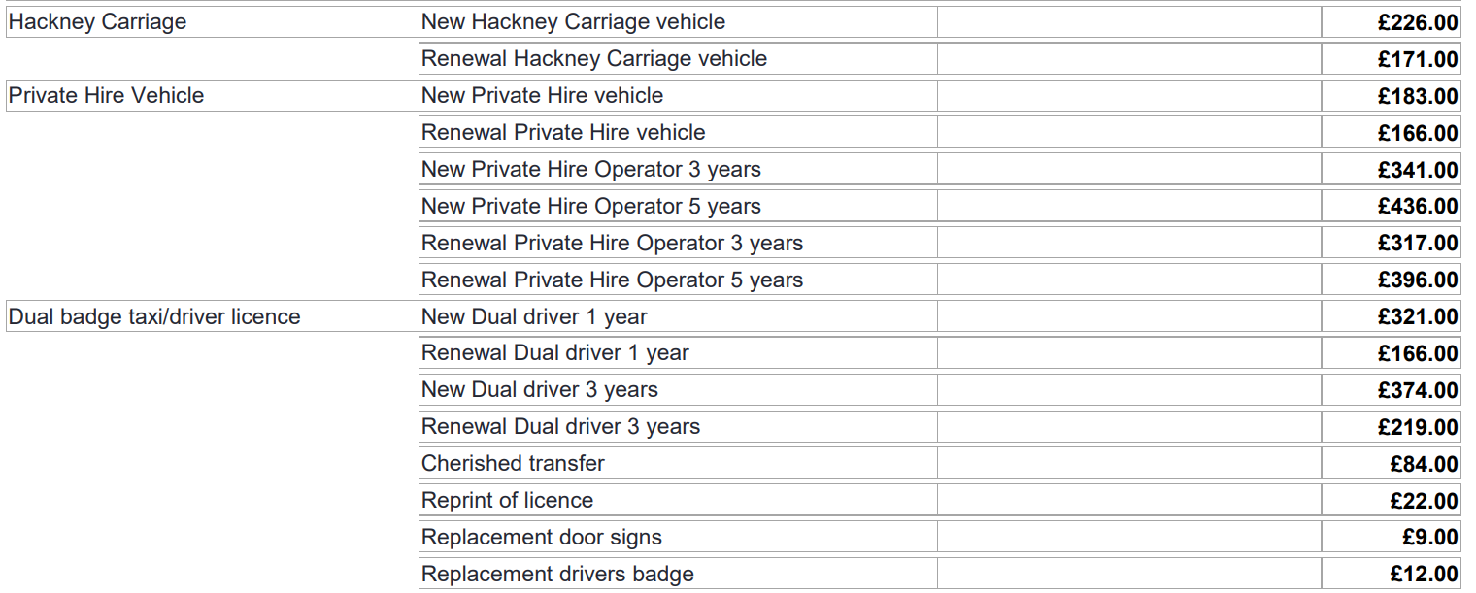

**APPENDIX 2 - Driver Application Procedure Guidance**

**Application and Supporting Documentation**

The Applicant shall complete and submit to the Licensing Authority an application on the form prescribed by the Licensing Authority accompanied by the required fee and following supporting documentation and information:

1. The details of two referees to whom the Licensing Authority may write for the purpose of obtaining a character reference.
2. One recent digital photograph of the applicant, taken from the shoulders upwards and on a plain background. “Recent” in this instance means taken within the last 12 months.
3. An enhanced Disclosure and Barring Service (DBS) check completed and submitted via the Licensing Authority.
4. A certificate signed by a registered medical practitioner certifying their fitness to the DVLA Group 2 medical standard to drive a licensed vehicle
5. Their current, valid driver’s licence.
6. DVLA check code.
7. HMRC Tax check code; renewals only
8. Right to work check code or birth certificate/passport, where applicable

No driver’s licence will be issued unless the appropriate fee is paid. Where payment is made by cheque which is subsequently dishonoured, any licence issued will become null and void.

To ensure the authenticity of documents, photographs of documents will not be accepted. All documents, including the application form, must be scanned using a flatbed scanner. If you do not have access to a scanner, please use the facilities at one of our libraries.

Only original documents can be submitted if being used as supporting evidence for a DBS disclosure application. It is for this reason, that applicants are required to submit and/or collect their documents in person at one of our libraries.

For further information about the supporting documents, please refer to the Taxi and Private Hire Vehicle Policy.

Process

Once a complete application is received, along with the required supporting documentation, the Licensing Authority will submit a request to the Human Resources section of this Authority who will send the applicant a link to complete the Enhanced DBS application.

The DBS will be submitted to and processed by the DBS service.

Once the DBS check has been completed, the DBS service will send the applicant a certificate. If there is adverse information contained on the certificate, the applicant will be required to submit their certificate to the licensing Authority in order to process it in line with the fitness criteria.

Further information can be viewed via the following link: https://www.gov.uk/government/organisations/disclosure-and-barring-service

While the DBS is processing, the applicant will be required to undertake an in-person “knowledge test” and a “safeguarding test” at one of our Offices. Your language skills, your understanding of your duties as a professional driver, your general appearance and attitude will be considered as part of your general propriety by the Officer.

Once the DBS certificate has been received, the HR department will send us an email advising us that the DBS is either “clear” or “adverse”.

If the DBS is “clear” and the application is complete; i.e., all supporting documents have also been received, then the processing Officer will submit the driver details on to Reprographics in order to print your badge and licence. The badge and licence will be sent to you in due course via Royal Mail.

All drivers are required to check the details on the badge and return the delivery receipt to the Authority to acknowledge receipt or advise us of incorrect details.

If the DBS returns “adverse” then the application will be processed in line with the fitness Policy and will likely require the applicant to appear before the licensing sub-committee who will determine whether or not to grant the licence.

Further information about the knowledge test, safeguarding test, Medical, and DBS can be viewed on our overarching Policy document.

All applicants have the right to appeal to the Magistrates Court a refusal to grant a licence.

**APPENDIX 3 - Institute of Licensing’s “Guidance on determining the suitability of applicants and licensees in the hackney and private hire trades” April 2018**



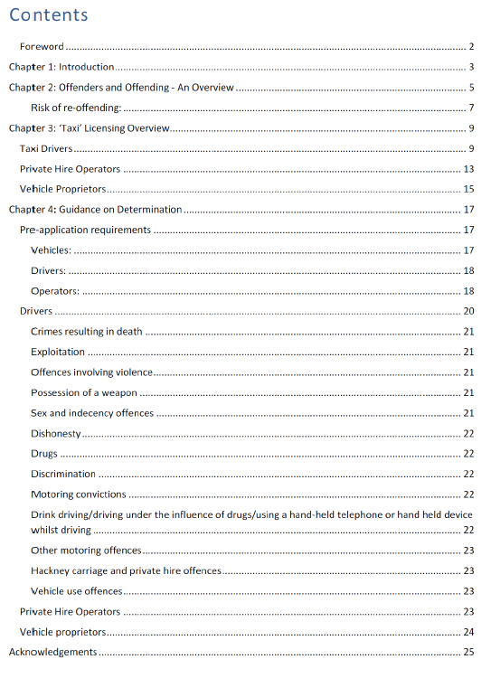

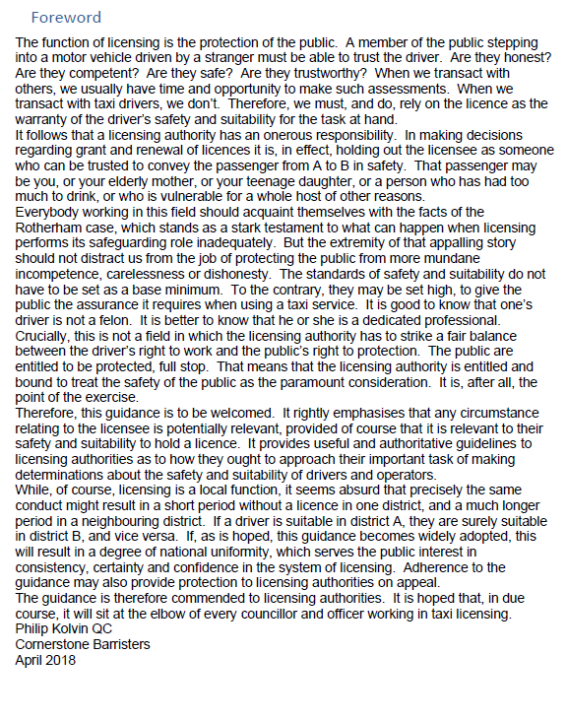

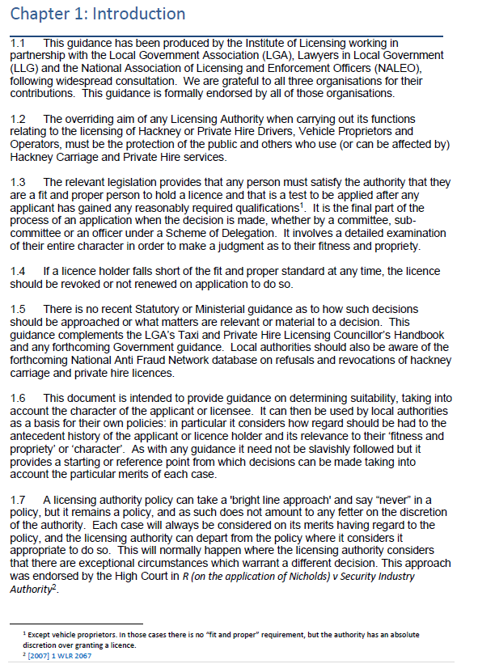

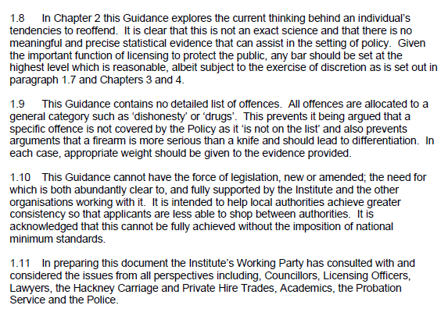

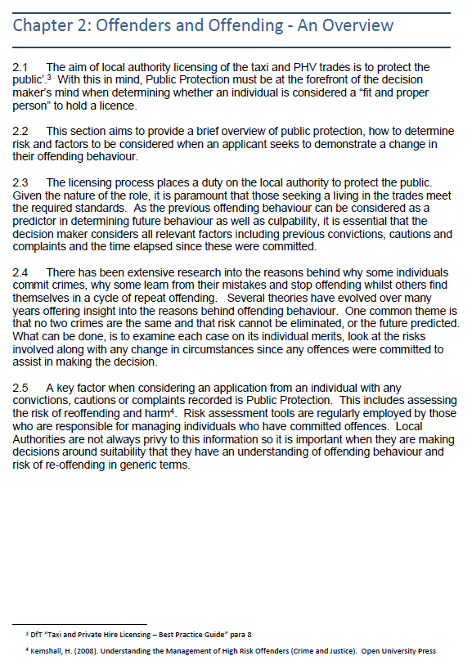

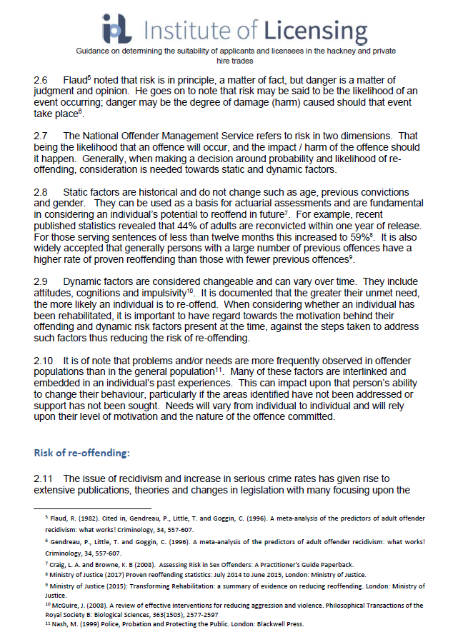

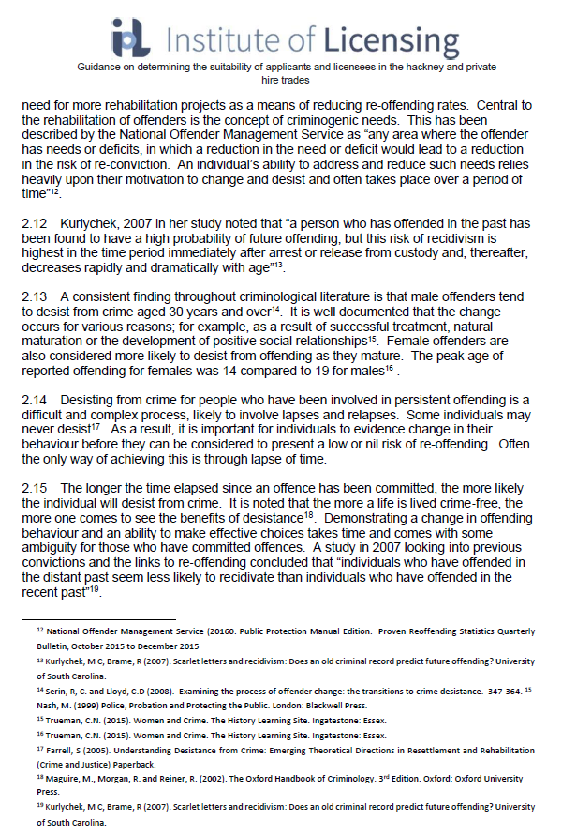

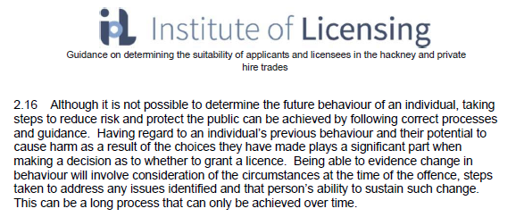

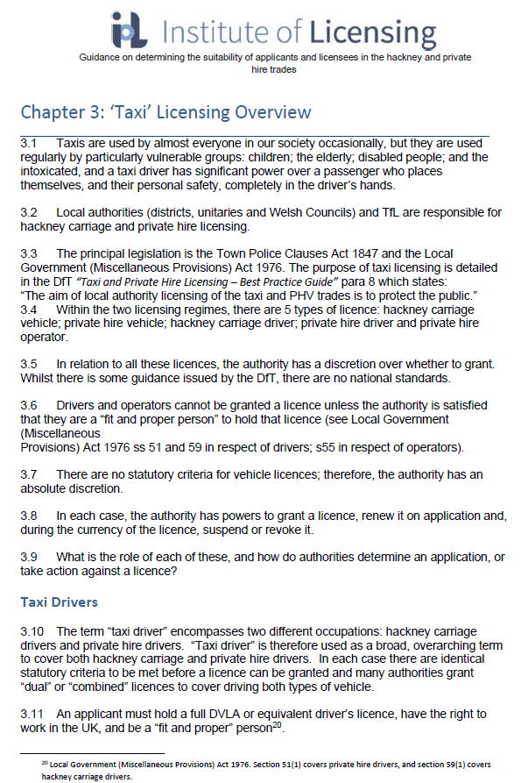

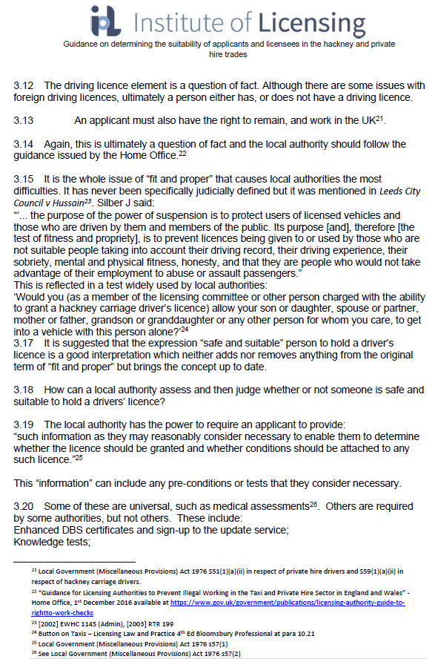

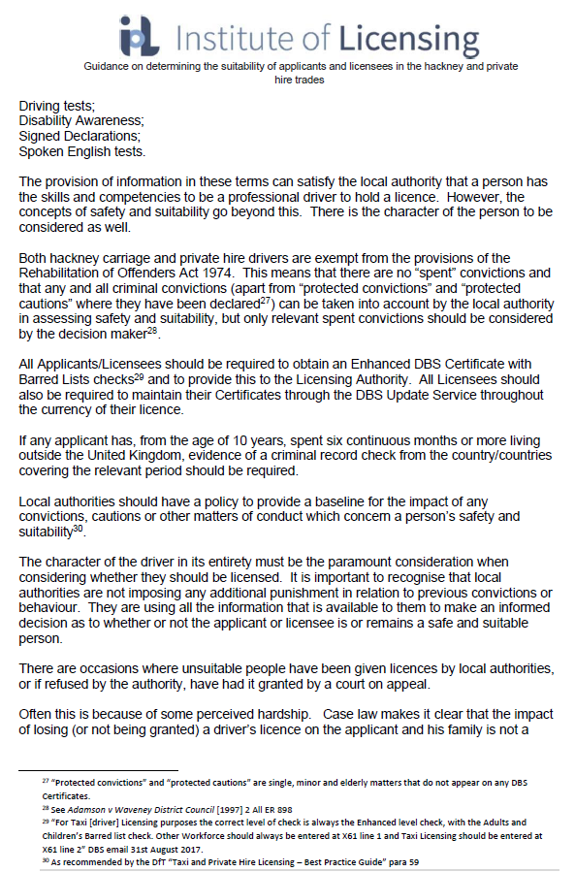

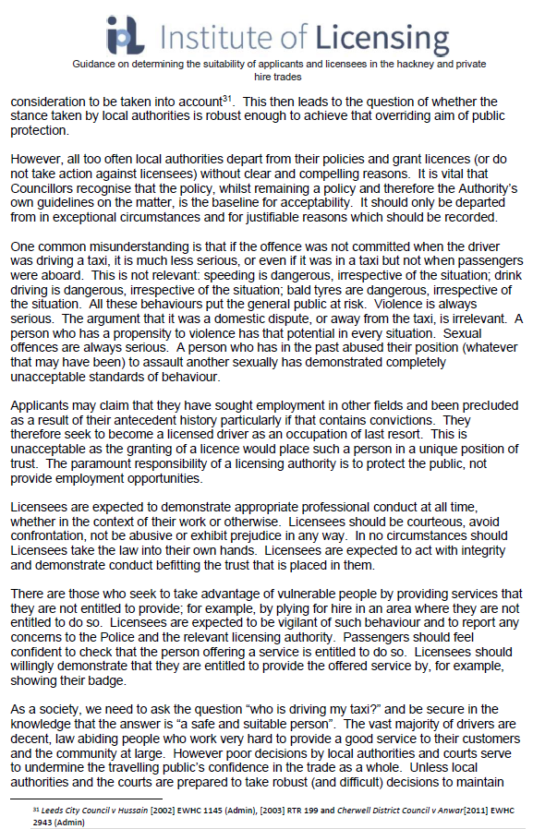

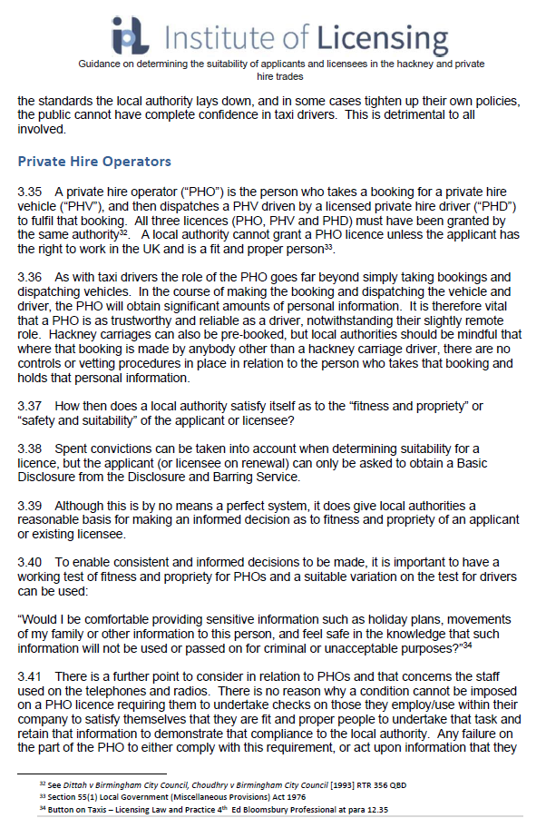

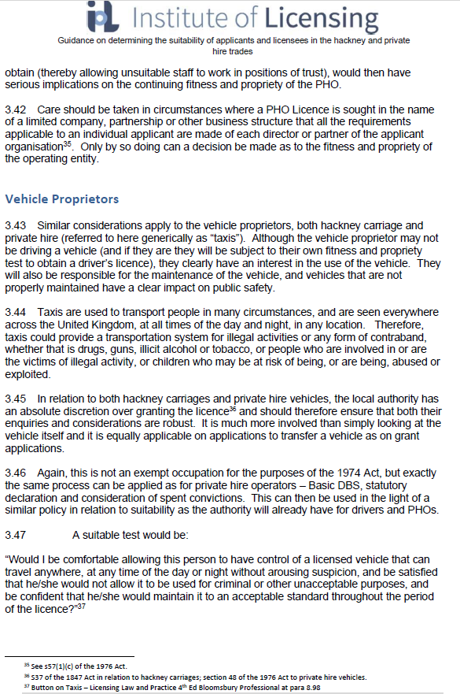

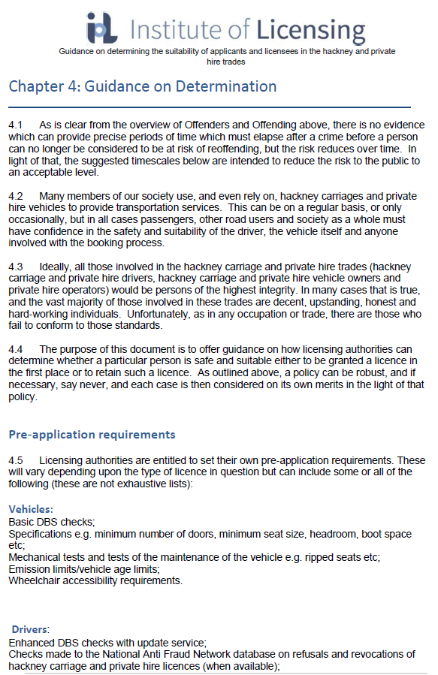

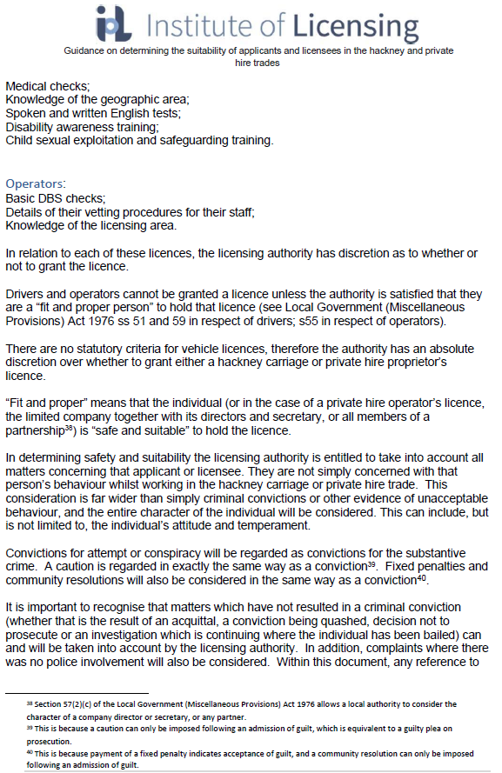

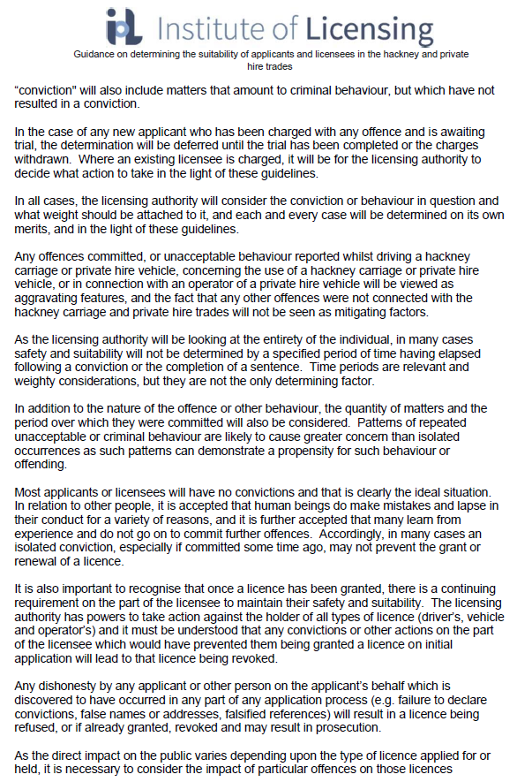

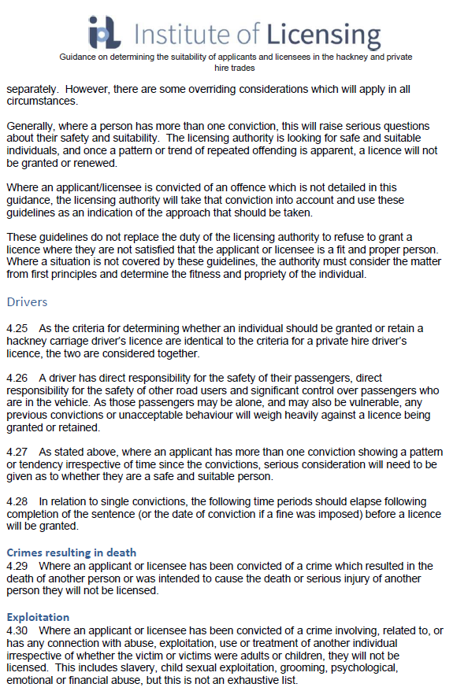

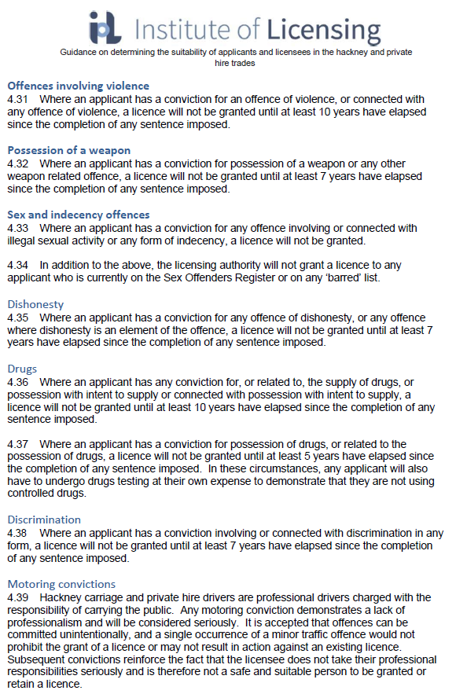

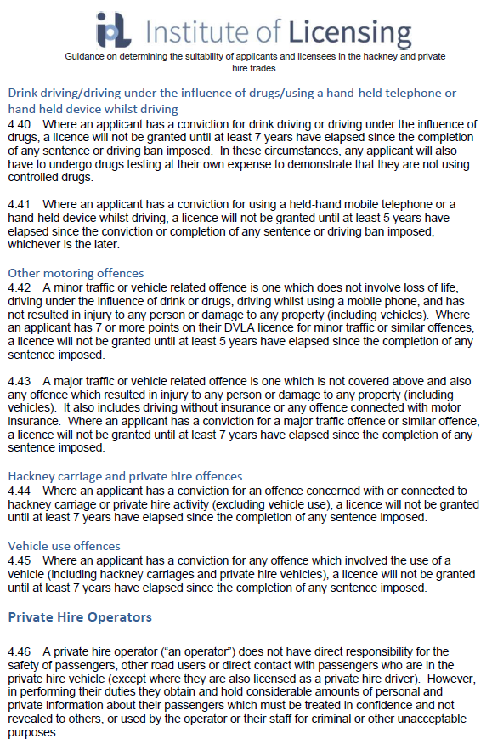

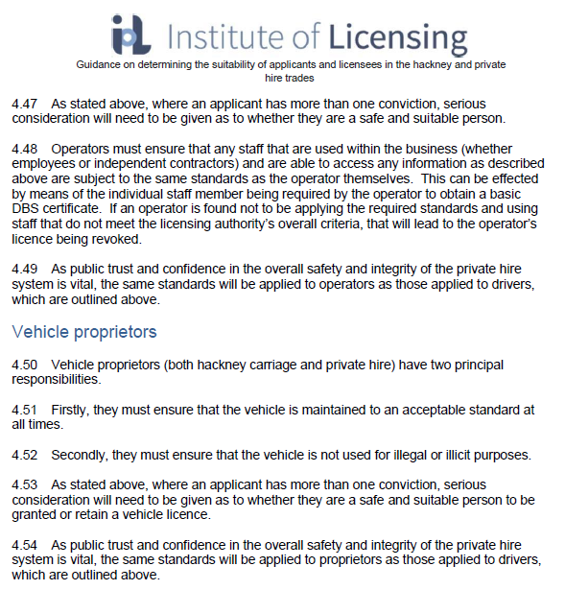

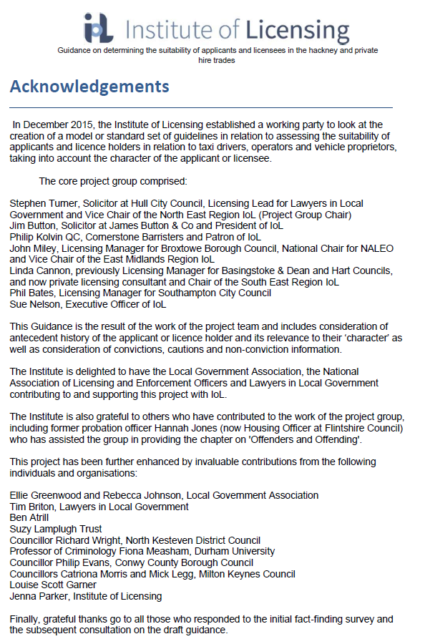

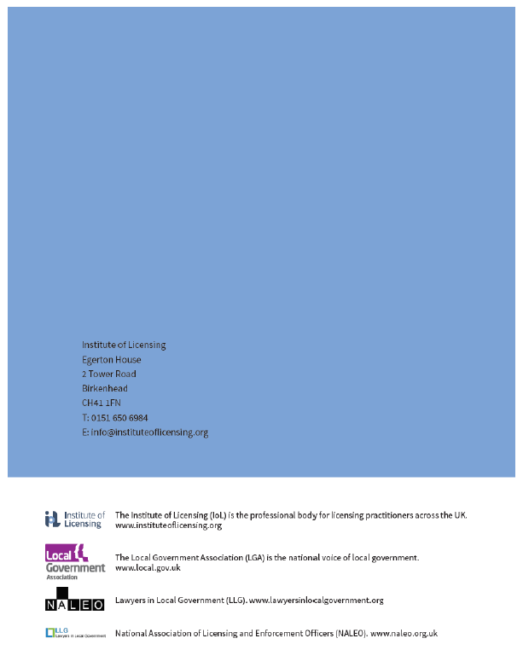

**APPENDIX 4 – Taxi and private hire vehicles: Equality Act medical exemption policy**

The Equality Act 2010 places a number of legal duties on licensed drivers when transporting disabled passengers.

**Assistance dogs**

The Equality Act 2010 places duties on both licensed Hackney Carriage and Private Hire Vehicle Drivers to carry guide, hearing and other assistance dogs accompanying disabled people, and to do so without additional charge.

These duties apply equally to dogs provided by UK charities affiliated with Assistance Dogs UK, equivalent overseas organisations, or assistance dogs which have been trained by their owners; and regardless of whether the dog is wearing a recognisable harness or jacket, or subject to formal certification. Where a prospective passenger informs a driver that a dog they wish to travel with is an assistance dog, this should be accepted at face value.

Assistance dogs are trained to ride with their owner in the main passenger compartment of a vehicle, usually lying at their feet, and the owner will instruct their dog to enter and exit the vehicle. Passengers with assistance dogs should be asked if they have any preference over which seat they sit in the vehicle – some may prefer to sit in the front passenger seat of a saloon vehicle, as the larger footwell can offer more space for the dog to sit in. Drivers should be prepared to provide any other reasonable assistance requested by the passenger; however it is unlikely that assistance dogs will require assistance in entering or exiting most vehicles beyond opening the passenger door. Drivers should not try to separate assistance dogs from their owners by insisting that the dog rides in a different part of the vehicle – doing so may cause distress to both the dog and the owner. Assistance dogs may ride in the rear load space of an estate car, if the dog’s owner consents to this.

Assistance dogs are bred and selected for their calm nature, and receive substantial specialist training before beginning their roles. They are subject to regular grooming and veterinary health checks. While we recognise that a number of drivers who are not experienced with dogs may feel uneasy at being in such close proximity to one, this does not constitute valid grounds for refusing to carry a passenger with an assistance dog. Similarly, religious beliefs also do not provide grounds for refusing to carry assistance dogs in taxis and private hire vehicles, nor other legal requirements under UK law.

Drivers with certain medical conditions that are aggravated by exposure to dogs may be exempted from these requirements on medical grounds.

Exemption from carrying assistance dogs which accompany disabled persons, can only be sought on medical grounds.

Therefore, applicants will need to demonstrate the grounds for applying this exemption by providing medical evidence to the licensing authority.

The main reasons a hackney carriage or private hire vehicle driver may wish to apply for a medical exemption are:

1. if they have a condition such as severe asthma, that is aggravated by contact with dogs;
2. if they are allergic to dogs; or
3. if they have an acute phobia to dogs.

The licensing authority, therefore, expects the number of drivers likely to be eligible for an exemption to be very low.

To apply for an exemption for the carriage of assistance dogs, the Carriage of assistance dogs exemption: application form must be completed by a Specialist Medical Practitioner. The form is available at: https://www.gov.wales/carriage-assistance-dogs-exemption-application-form

Examples of suitable medical professionals include, but are not limited to:

1. specialist / consultant
2. specialist nurse (for example, an asthma nurse)
3. practice nurses
4. the council’s nominated independent doctor

In exceptional circumstances, but only where no other alternatives are available, the licensing authority may consider evidence from the applicant’s General Practitioner.

The form must be accompanied by sufficient evidence of the allergy e.g. allergen test results, clinical history etc. A simple statement from a medical professional will not be considered as sufficient for the purpose of the exemption request.

If a driver has a chronic phobia to dogs, the licensing authority would expect this to be supported by a report from a psychiatrist or clinical psychologist before a driver is granted an exemption.

The applicant will be responsible for all costs associated in the provision of the necessary medical evidence.

If an exemption from carrying assistance dogs is granted, an exemption certificate and badge as prescribed by law will be issued to the driver.

An exemption will be granted for a specified period of time as determined by the licensing authority.

Consideration will be given to the type of Hackney Carriage vehicle that will be driven. Particular consideration will be given to the interior of the vehicle, and whether the vehicle has a partition separating the driver from the assistance dog and passenger.

The prescribed exemption badge must be clearly displayed at all times in any Hackney Carriage or Private Hire vehicle that the exempt driver will be driving, and made available to an Authorised Officer on request.

In the absence of a medical exemption certificate from the licensing authority, it would be a criminal offence for any hackney carriage or private hire driver to refuse to carry an assistance dog, to refuse to allow the assistance dog to remain with the passenger throughout the journey, or to make any additional charge for the carriage of the assistance dog.

**Wheelchairs**

The Equality Act 2010 places duties on both licensed Hackney Carriage and Private Hire Vehicle Drivers who operate Wheelchair Accessible Vehicles to carry passengers in a wheelchair and provide assistance to ensure safety and reasonable comfort, and to do so without any additional charge.

The types of assistance that may be required include:

* If the passenger wishes to remain in the wheelchair, the driver must help the passenger to get in and out of the vehicle and secure the wheelchair in accordance to the vehicle specification.
* If the passenger wants to transfer to a seat, the driver must help him or her to get out of the wheelchair and into a seat and back into the wheelchair; the driver must also load the wheelchair into the vehicle together with any luggage.

A driver who fails to comply with any of the above duties without valid defence will commit a criminal offence, and may be fined up to £1,000 for each offence on conviction. Offences may also lead to revocation or suspension of taxi licences.

A ‘reference wheelchair’ is defined in statute as having the following dimensions:

* Length: 1200mm (approx. 48”) including footplates
* Width: 700mm (28”)
* Total seated height: 1350mm (54”)
* Height of footrest: 150mm (6”)

It is anticipated that the above dimensions for a reference wheelchair will cover the majority of manual wheelchairs – however, we recognise that some wheelchairs with specialist functionality, or motorised wheelchairs and mobility scooters, may exceed these dimensions and may not be able to be loaded and carried safely in all designated taxis. In such cases, drivers will be expected to assess whether the passenger can be safely carried in their vehicle, to carry the passenger if their safety and reasonable comfort can be assured, or to assist them in locating a suitable alternative vehicle otherwise, where this is practicable. Such circumstances may constitute a defence to an offence mentioned above.

In all cases, we expect drivers to treat passengers with respect and sensitivity, and to provide a clear explanation to the passenger as to why they have not been able to convey them.

Certain medical grounds may exist meaning the driver cannot provide assistance, for example where a person’s physical condition makes it impossible, or reasonably difficult, to assist passengers in a particular type of wheelchair.

Given that the main reasons for a hackney carriage or private hire vehicle driver to request a medical exemption are likely to be back or muscle-related injuries, which are not likely to be conducive to driving for long periods, the licensing authority expect the number of drivers likely to be eligible for an exemption to be low.

To apply for an exemption to the carriage of wheelchairs and offering assistance, the Carriage of wheelchairs exemption: application form must be completed. The form must be completed by the applicant’s General Practitioner or other Specialist Medical Practitioner, and must be accompanied by sufficient evidence such as a full diagnosis, details of ongoing investigations etc. A simple statement from a medical professional will not be considered as sufficient for the purpose of the exemption request. Any costs incurred in this process will be borne by the applicant.

The form is available at: https://www.gov.wales/carriage-wheelchairs-exemption-application-form

**Licensing authority decision**

The licensing authority will reach a decision based on the information from the medical form and associated reports. If the form or report is ambiguous in any way a decision will not be made and further information will be sought form the applicant’s specialist medical practitioner seeking a clear response.

Applicant's that have a temporary condition will be granted a time limited exemption certificate. If the applicant wishes to extend the period of exemption a further medical assessment (using the form in Appendix A) will need to be completed prior to the expiration of the exemption certificate. Form is available from the Licensing Authority.

If an extension to a temporary certificate has not been be sought, drivers will be expected to resume normal duties under the Equality Act 2010 once the exemption certificate has been expired.

Drivers issued with a temporary medical exemption certificate must return it to the licensing authority within one working day after the expiry of the certificate.

**Appeal**

Any driver aggrieved by the licensing authority’s decision to refuse the issue of a medical exemption certificate may appeal to the Magistrates’ Court within 28 days of the date of the refusal.

This code is subject to change in line with Welsh Government standards, please visit https://www.gov.wales/taxis-private-hire-vehiclesfor the latest version.

**APPENDIX 5 – Right to Work acceptable ID Guidance**

**List A – acceptable documents to establish a continuous statutory excuse**

1. A passport (current or expired) showing the holder is a British citizen or a citizen of the UK and Colonies having the right of abode in the UK.
2. A passport or passport card (in either case, whether current or expired) showing that the holder is an Irish citizen.
3. A document issued by the Bailiwick of Jersey, the Bailiwick of Guernsey or the Isle of Man, which has been verified as valid by the Home Office Employer Checking Service, showing that the holder has been granted unlimited leave to enter or remain under Appendix EU(J) to the Jersey Immigration Rules, Appendix EU to the Immigration (Bailiwick of Guernsey) Rules 2008 or Appendix EU to the Isle of Man Immigration Rules.
4. A current passport endorsed to show that the holder is exempt from immigration control, is allowed to stay indefinitely in the UK, has the right of abode in the UK, or has no time limit on their stay in the UK.
5. A current Immigration Status Document issued by the Home Office to the holder with an endorsement indicating that the named person is allowed to stay indefinitely in the UK, or has no time limit on their stay in the UK, together with an official document giving the person’s permanent National Insurance number and their name issued by a government agency or a previous employer.
6. A birth or adoption certificate issued in the UK, together with an official document giving the person’s permanent National Insurance number and their name issued by a government agency or a previous employer. Definition includes a full birth certificate issued by a UK diplomatic mission (British Embassy or British High Commission.
7. A birth or adoption certificate issued in the Channel Islands, the Isle of Man or Ireland, together with an official document giving the person’s permanent National Insurance number and their name issued by a government agency or a previous employer.
8. A certificate of registration or naturalisation as a British citizen, together with an official document giving the person’s permanent National Insurance number and their name issued by a government agency or a previous employer.

**List B Group - 1 – documents where a time-limited statutory excuse lasts until the expiry date of permission to enter or permission to stay**

1. A current passport endorsed to show that the holder is allowed to stay in the UK and is currently allowed to do the type of work in question. This includes a current passport endorsed with a stamp showing an individual has been granted leave to enter and there are no work-related conditions attached. If, under the conditions of the 85 individual’s leave, work was restricted or prohibited the endorsement placed in the individual’s passport would explicitly set that out as a condition.
2. A document issued by the Bailiwick of Jersey, the Bailiwick of Guernsey or the Isle of Man, which has been verified as valid by the Home Office Employer Checking Service, showing that the holder has been granted limited leave to enter or remain under Appendix EU(J) to the Jersey Immigration Rules, Appendix EU to the Immigration (Bailiwick of Guernsey) Rules 2008 or Appendix EU to the Isle of Man Immigration Rules.
3. A current Immigration Status Document containing a photograph issued by the Home Office to the holder with a valid endorsement indicating that the named person may stay in the UK, and is allowed to do the type of work in question, together with an official document giving the person’s permanent National Insurance number and their name issued by a government agency or a previous employer.

**List B Group 2 – documents where a time-limited statutory excuse lasts for six months**

1. A document issued by the Home Office showing that the holder has made an application for leave to enter or remain under Appendix EU to the immigration rules (known as the EU Settlement Scheme) on or before 30 June 2021 together with a Positive Verification Notice from the Home Office Employer Checking Service.
2. A Certificate of Application (digital or non-digital) issued by the Home Office showing that the holder has made an application for leave to enter or remain under Appendix EU to the immigration rules (known as the EU Settlement Scheme), on or after 1 July 2021, together with a Positive Verification Notice from the Home Office Employer Checking Service.
3. A document issued by the Bailiwick of Jersey, the Bailiwick of Guernsey or the Isle of Man showing that the holder has made an application for leave to enter or remain under Appendix EU(J) to the Jersey Immigration Rules or Appendix EU to the Immigration Rules (Bailiwick of Guernsey) Rules 2008, or Appendix EU to the Isle of Man Immigration Rules together with a Positive Verification Notice from the Home Office Employer Checking Service.
4. An Application Registration Card issued by the Home Office stating that the holder is permitted to take the employment in question, together with a Positive Verification Notice from the Home Office Employer Checking Service.
5. A Positive Verification Notice issued by the Home Office Employer Checking Service to the employer or prospective employer, which indicates that the named person may stay in the UK and is permitted to do the work in question.

**APPENDIX 6 - Hackney Carriage and Private Hire Driver Code of Conduct**

**(Dual Driver)**

**Standards of behaviour for drivers**

This code of conduct applies to all licensed hackney carriage and private hire drivers. It should be read in conjunction with this licensing authority’s taxi licensing policy and licence conditions.

The licensing authority may reconsider your fitness and propriety to act as a licensed driver if you fail to comply with this code of conduct.

Ceredigion County Council’s taxi operators and drivers are firmly committed to offering the highest levels of service to all our passengers and promise the following:

**Drivers should:**

1. Be clean and tidily dressed in accordance with the Licensing Authority’s Taxi/PHV Driver’s Dress Code, with their badge visible at all times.
2. Greet passengers in a friendly way and offer reasonable help with their luggage at both ends of the journey.
3. Act in a professional manner at all times.
4. Ensure that the vehicle is in a clean, safe and satisfactory condition at all times.
5. Attend punctually when undertaking a pre-booked hiring.
6. Be professional and understanding to other road users.
7. Provide the hirer with a receipt on request.
8. Assist when necessary, passengers into and out of the vehicle.
9. Treat information they receive about passengers in a discreet and confidential manner.
10. Switch off the engine if required to wait.
11. Always ask if a vulnerable passenger needs help and should not make assumptions.
12. If the passenger wants to travel outside local authority boundary, agree the fare before setting off or agree to use the taximeter (where applicable).
13. (In the case of drivers of wheelchair accessible vehicles) Ensure that they are able to correctly deploy the vehicle ramps and are able to safely transport the passenger in the wheelchair into and out of the vehicle and secure the wheelchair correctly.

**Drivers should not:**

1. Make discriminatory remarks relating to age, gender, sexuality, disability, race, religion or belief.
2. Use offensive or inappropriate language in public.
3. Smoke, vape/use e-cigarettes, eat or drink in the vehicle.
4. Give or take details of any blogs or personal websites or use any form of electronic communication to send messages to a passenger that do not relate to matters around the hiring of the vehicle. This includes social networking sites such a Facebook, Twitter or any other form of electronic communication for the purpose of social messages.
5. Use their position to force or indoctrinate passengers into following a political, spiritual or religious belief.
6. Take photographs (other than images captured on and approved vehicle CCTV system) of passengers even if it is at their request.
7. Behave in a manner that may be considered intrusive, intimate, overly personal or unprofessional with any passenger and should at no time provide any form of gift or gratuity, no matter how small or invaluable.
8. Allow any audio equipment to become a nuisance to passengers.
9. Make improper use of the vehicle’s horn by sounding it as a means of alerting hirers of his/her presence, other than in an emergency.

**Conduct of hackney carriage drivers at taxi ranks (official or unofficial ranks)**

Drivers should:

1. Rank in an orderly manner and proceed along the rank promptly and in order.
2. The driver must remain with their hackney carriage at all times during periods in which it occupies a hackney carriage rank. It is an offence to leave a hackney carriage unattended on the rank.
3. Be polite and courteous to any taxi marshals and follow their instructions.
4. Not allow the vehicle to be on the rank unless it is available for immediate hire.
5. Not wait for pre-booked fares on the rank.

This dress code is subject to change in line with Welsh Government standards, please visit to https://www.gov.wales/taxis-private-hire-vehiclesfor the latest version.

**APPENDIX 7 - Hackney Carriage and Private Hire Driver Dress Code**

**Guide on driver’s dress code**

It is recognised that the taxi trade, both hackney carriage and private hire, play an important role in portraying a positive image of the area.

To ensure that the hackney carriage and private hire trade portrays a professional image and to ensure that driving is carried out safely the following dress code applies:

1. All clothing must be clean, in good conditions and free from damage
2. Shorts and skirts must be no shorter than knee length
3. Footwear must fit around the heel of the foot
4. Hoods should not be worn over the head whilst driving

Examples of acceptable clothing include:

* Trousers/smart jeans
* Shirt
* Smart t-shirt
* Smart shorts
* Polo shirts
* Jumpers

Unacceptable standards of dress include:

* Clothing bearing slogans or graphics that are of an offensive/suggestive nature
* Clothing that is dirty, smelly, faded or damaged
* Footwear such as flip flops or sliders that do not have heel straps
* Pronounced heels
* Baseball caps or other headwear that obscures the face
* Clothing that leaves the shoulders and top of the arms uncovered such as vest tops
* Clothing that does not cover the chest, stomach/midriff such as low cut tops or crop tops.

The above list is not exhaustive, and there may be other standards of dress that are deemed not acceptable by authorised officers of the licensing authority. Failure to comply with the dress code may result in a written warning. Persistent failures to comply on more than two occasions within 12 months may result in a referral to the licensing committee for determination of any additional action.

This dress code is subject to change in line with Welsh Government standards, please visit visit to https://www.gov.wales/taxis-private-hire-vehicles for the latest version of the Dress code.

**APPENDIX 8 – Vehicle Application Process**

**Application form & supporting documents**

Before a licence is issued in respect of a hackney carriage or private hire vehicle, the applicant, being the proprietor of the vehicle, must complete and submit to the Licensing Authority a complete application on the form prescribed by the Authority.

The following documents must be submitted with the application:

1. The Vehicle's most recent, up to date V5 document.
2. A valid, current MOT issued by DVSA, (formerly known as VOSA)
3. A certificate of compliance completed by one of the testing stations participating in the testing and inspection of hackney carriages in Ceredigion.
4. A certificate of insurance issued on a fully comprehensive basis which covers the use for “Carriage of Passengers for Hire and Reward” and also for the named driver(s) of such vehicle.
5. Evidence that the vehicle is registered under the Vehicle (Excise) & Registration Act 1994.
6. A basic DBS certificate.
7. A one-time check code for a HMRC tax check.

The licence will not be issued unless the required documents are produced. These documents must be readily available for examination at any time during the currency of the licence by an Authorised Officer of the Licensing Authority.

The applicant may be required to submit further documentation attesting to the vehicles’ fitness to be a licensed hackney carriage. This may include documents issued by a relevant certifying body or agency after a vehicle has been modified or adapted or after extensive repair work has been undertaken.

Each application will be treated on its own merit and if granted, is valid for a maximum period of twelve months. It is the proprietor’s responsibility to ensure that an application to renew the licence is submitted in sufficient time prior to the licence expiry date as there is no automatic period of grace.

Any applications received after the expiry date will usually be treated as a new application, unless at the Officers discretion the circumstances deem it acceptable to renew the application.

No vehicle licence will be issued until the appropriate fee is paid. Where payment is made by cheque which is subsequently dishonoured, any licence issued will be null and void.

A vehicle licensed by this Authority remains a licensed vehicle for hire & reward by hackney carriage for the duration of its licence or until the licence is lapsed, suspended, revoked or surrendered. The removal of any livery is prohibited once the vehicle is licensed.

**APPENDIX 9 - Hackney Carriage Licence Conditions**

1. **GENERAL**
2. A vehicle licensed by this Authority remains a licensed vehicle for hire & reward by hackney carriage for the duration of its licence or until the licence is lapsed, suspended, revoked or surrendered. The removal of any livery is prohibited once the vehicle is licensed.
3. The vehicle must only be driven by a person holding a current dual drivers’ licence issued by Ceredigion’s Licensing Authority. The only exception being when the licensed vehicle is being road tested by an employee of a garage employed by the proprietor following repair and/or maintenance work to the vehicle.
4. **RESPONSIBILITIES OF NOTIFICATION**
5. If, during the period of a licence granted by the Licensing Authority, the information supplied by the applicant for the licence is altered for any reason, notice in writing of the alterations must be made immediately to the Licensing Authority.
6. Under Section 50(3) of the Local Government (Miscellaneous Provisions) Act 1976 the proprietor of any licensed vehicle must, by law, report to the Licensing Authority, within seventy-two [72] hours of the occurrence, of any incident involving that vehicle causing damage affecting the safety, performance or appearance of the vehicle.
7. If a licensed vehicle is transferred or sold to another person, the proprietor must inform the licensing authority, in writing, to whom the vehicle has been transferred within fourteen days.
8. **GENERAL VEHICLE CONSTRUCTION**

[SUBJECT TO LICENSING COMMITTEE DECISION ON 10/9/24]

1. This Authority does not licence vehicles that have been written off. It is the proprietor’s responsibility to ensure that any vehicle he submits for licensing has been suitably checked by him prior to purchase or lease. The authority accepts no liability for any vehicles which are refused a licence due to having been written off.
2. Any vehicle must be right hand drive and:
3. Be constructed as such that the doors open sufficiently wide as to allow easy entry and exit and to cause no inconvenience to passengers.
4. Must be all white in colour and confirmed so on the vehicles’ V5 document.
5. All vehicles must be properly equipped to operate in all weather conditions.
6. All vehicles to be considered for licensing must comply with:
   1. All aspects of the requirements of the Motor Vehicle (type Approval) Regulations 1980
   2. The Motor Vehicle (Type Approval) Regulations (Great Britain 1984).
   3. The Motor Vehicles (EC Type Approval) Regulations 1998 and with any further national or international legislation as may be applicable.
   4. The Road Vehicles (Construction and Use) Regulations 1986 (C & U).
   5. All respects of British and European vehicle regulations and be ‘type approved’ to the requirements of the M1 category of European Community Whole Type Approval Directive 2007/46/EC as amended.
7. In the absence of European Community Whole Type Approval, or if a vehicle has been modified in any way since manufacture, vehicles may be considered for licensing that have:
   1. National Small Series Type Approval: http://www.dft.gov.uk/vca/vehicletype/index.asp

or

* 1. Individual Vehicle Approval: http://www.dft.gov.uk/vca/vehicletype/index.asp

1. All hackney carriages specifically adapted for carriage of wheelchair users must be available for hailing by a wheelchair user at any time.
2. **VEHICLE AGE POLICY**
3. At the date of first presenting the vehicle for a hackney carriage licence, the vehicle must be no older than the 5th anniversary of the date of first registration with the with the Driver & vehicle licensing agency (DVLA).
4. Vehicles specifically designed and so adapted for the carriage of wheelchair users or passengers with impairments or physical restrictions may be first presented for licensing no later than the 8th anniversary of the date of first registration with the Driver & vehicle licensing agency (DVLA).
5. No vehicle older than the 10th anniversary of the date of first registration will be eligible for re-licensing with the exception of vehicles specifically adapted to carry wheelchair users or passengers with impairments or physical restrictions which may continue to be renewed thereafter, at the sole discretion of the Licensing Authority, or until the anniversary of the 15th year of the vehicle having first been registered with the DVLA, whichever is earlier.
6. For vehicles that have reached the maximum age for licensing but are in an exceptionally good condition, the operator or proprietor can refer to **Appendix 11** – Exceptional condition Policy.
7. **TAXIMETER**

‘Taximeter’ has the same meaning as in Section 80 of the Local Government (Miscellaneous Provisions) Act 1976, being:

‘…any device for calculating the fare to be charged in respect of any journey in a hackney carriage or private hire vehicle by reference to the distance travelled or time elapsed since the start of the journey, or a combination of both;’

1. Taximeters must be fitted to all hackney carriages, and may be fitted to private hire vehicles.
2. Where a taximeter is fitted, it must be:
   1. Fully compliant with the Measuring Instruments (Taximeters) Regulations 2006, and be certified by a notified body in accordance with the Measuring Instruments Directive (MID) (2004/22/EC), in particular Annex 007;
   2. In the case of taxis, fitted with a device, the use/action of which will bring the taximeter into action and cause the word 'HIRED' to appear on the face of the taximeter and such a device must be capable of being locked in a position such that the machinery of the taximeter is not in action and that no fare is recorded on the face of the taximeter;
   3. In the case of taxis, calibrated against an appropriate standard to ensure the tariff charged does not exceed the maximum fares determined by the licensing authority;
   4. Calendar controlled;
   5. Fixed to the vehicle with appropriate seals/appliances to prevent any person from tampering with the meter except by breaking, damaging, or permanently displacing the seals/appliances;
   6. Have the word ‘FARE’ printed on the face of the meter in plain letters so as clearly to apply to the fare recorded thereon; and
   7. Supported by a certificate/report of compliance issued by a taximeter installed approved by the local authority (the licensing authority will only accept a certificate that has been issued within the previous 10 working days).
3. With respect to a taxi, in the event that a proprietor fails to present to the licensing authority a valid certificate/report of compliance (unless delayed or prevented by sufficient cause accepted and agreed by the licensing authority), the licensing authority may suspend the licence and require the proprietor of that taxi to return all the plates to the licensing authority subject to any appeal period
4. When the taximeter is in action there shall be recorded on the face of the taximeter in clear legible figures a fare not exceeding the rate which has been set by this authority and displayed on the tariff card.
5. The taximeter shall be placed in such a position that all letters and figures on the face are clearly visible at all times to any person being conveyed in the carriage and for that purpose, the letters and figures shall be capable of being suitably illuminated during any period of hiring.
6. A proprietor of a hackney carriage shall not tamper with, or permit any person other than an approved taximeter specialist, to tamper with any taximeter, with which the carriage is equipped, or with the fittings thereof, or with the seals attached thereto.
7. **ROOF SIGN**

1. A Hackney Carriage must be equipped with a securely mounted roof light, which may only be white in colour with the exception of amber or red being permitted on the rear of the sign. The illuminations within the roof sign must complement the external casing. By this; the Licensing Authority means that the internal illuminations shall ensure the sign remains white at the front and amber at the back when the unit is lit.
2. The rooflight must be bright enough to clearly show that the vehicle is available for hire. Dull or diffused lamps must be replaced.
3. An illuminated roof sign shall be wired to the taximeter so as it is extinguished whilst carrying a metered fare.
4. The roof sign shall bear the words “For Hire” or “TAXI” or “TACSI” in plain letters at least two inches in height and be illuminated so that it indicates clearly and conveniently to persons outside the carriage whether or not the carriage is for hire.
5. **MAINTENANCE**
6. The vehicle shall be kept clean and maintained in conditions compliant with the Motor Vehicles (construction and use) Act, the Road Traffic Act and the conditions imposed by the Licensing Authority.
7. The vehicle must remain in an efficient, tidy, clean and safe condition for the carriage of passengers. By efficient, the Licensing Authority means that the passenger must be able to enter or exit the vehicle without having to remove goods or debris from the seats or footwells.
8. **SIGNS AND ADVERTISING**
9. There shall be a legible sign fitted in a conspicuous position within the vehicle requesting passengers to use the seat belts provided.
10. There shall be an approved legible sign fitted in a conspicuous position within the vehicle prohibiting passengers from smoking in the vehicle. Replacement signs may be obtained from the Authority for a minimal fee.
11. The proprietor shall ensure that a sign of a size, type and design determined by and provided by the Licensing Authority shall be affixed to both front doors of the vehicle. The signs are to be affixed in accordance with the verbal or written instructions of Officers of the Licensing Authority. The Licensing Authority logo will remain in the ownership of the Licensing Authority and when the vehicle ceases to be licensed by the Authority the logos are to be removed and returned without undue delay to the licensing Authority.

1. No fittings, signs or advertisements are to be painted on or attached to the vehicle or displayed within the vehicle unless approved by the Licensing Authority in writing.
2. No-Smoking stickers are provided by the LA and must be affixed to the inside of the rear windows of the vehicle to inform passengers that smoking is not permitted within the vehicle.
3. All advertisements shall conform with the requirements of the Advertising Standards Council in all matters relating to good taste, both in content and appearance and shall not relate to matters concerning tobacco, gambling, alcohol, politics, religion, matters of a sexual nature, or any other content likely to cause offence.
4. **CARD PAYMENTS**
5. Licensed vehicles may be fitted with a council approved credit and debit card payment device. The device must have the facility to produce a printed receipt.
6. Where a vehicle is fitted with a card payment device two, double-sided signs must be displayed, either specifying card company logos or a bilingual (English & Welsh) sign stating ‘This licensed vehicle now accepts credit and debit card payments including contactless’
7. The sign must be positioned internally at the top of both passenger windows.
8. Should a problem occur with a card payment, the driver should follow this advice:

* Ask the passenger to try the payment card again
* If the issue persist, ask the passenger if they have an alternative card or cash
* Offer to take the passenger to the nearest ATM (cashpoint)
* If the passenger refuse to pay the fare, consider contacting the police.
* Drivers should check that their card payment is working before they start work, including ensuring it is capable of printing receipts.

1. **SEATING ARRANGEMENTS**
2. The maximum number of passengers that can be carried in a vehicle for it to be capable of being licensed as a hackney carriage is eight [8].
3. The vehicle must be able to seat at least three [3] but no more than eight [8] passengers in addition to the driver. Each seat shall be deemed to provide seating for one [1] person; irrespective of age.
4. Vehicles which are licensed to carry eight passengers shall not contain seating for more than eight passengers. For this purpose, where separate seats are fitted, each seat shall be deemed to provide seating for one passenger irrespective of age.
5. Where one seat or more has been removed for the carriage of wheelchairs, mobility scooters or other mobility aid, that space must be made permanently available for the user(s) or their equipment and the fixing points of the removed seat(s) must be permanently blocked off or otherwise disabled to the satisfaction of the Licensing Authority and without prejudicing the tethering of the wheelchair and/or mobility aid.
6. Seats, including wheelchair(s) in vehicles must be either forward or rearward facing.
7. Each seat, whether separate or continuous and including wheelchair(s), must have available for use a seat belt for each passenger and must comply with the current Motor Vehicles (wearing of seatbelts) Regulations.
8. All vehicles with restraint anchorage points must have seat belts or harnesses assigned to that vehicle and made available for immediate use for each anchorage point.
9. Any harnesses or belts assigned to a vehicle must bear indelibly upon them the index plate of that vehicle and must not be transferred or loaned to another vehicle.
10. When in use, all harnesses must be securely attached to the vehicle and operate as intended by the manufacturer. “Disabled person belts” are seat belts or harnesses which have been specifically designed or adapted for use by an adult or young person suffering from some physical or mental impairment and are intended for use solely by such a person.
11. **ACCESSIBILITY**

**Accessibility Conditions for Designated Vehicles**

The Licensing Authority’s objective is to ensure, so far as is reasonably practicable, that all residents of Ceredigion have reliable access to safe transport within the Authority.

“Disabled people account for about one fifth of people in the UK. The Department for Work and Pensions estimates that there are currently over 10 million disabled people in Britain, 4.6 million of whom are over state pension age. Seven hundred thousand are children. One in four households has a disabled member; and projections by the Office of National Statistics show a clear increase in the population of the UK until 2031. It is also predicted that there will be 27 million people over the age of 50 by 2031. Disability rates increase with age, and some estimates predict a rise of 69 per cent over the next 20 years in the number of people facing disability” (DfT Consultation on improving Access to Taxis, February 2009)

These conditions are intended to improve the accessibility of licensed (hackney carriages and private hire) vehicles for wheelchair users and people with disabilities and/or impairments. It is important therefore to focus on the service our Hackney and Private Hire trade provides by improving access to taxis so that all residents of Ceredigion receive an equal level of service and improved access to jobs, services, leisure facilities and social networks.

This Policy is intended to work alongside the Hackney Carriage and Private Hire Licensing Overarching Policy and should be read in conjunction with that Policy. Reference should be made to the conditions relating to the type of vehicle which is or may be licensed. (i.e. Hackney Carriage or Private Hire Vehicle).

The Licensing Authority may attach to the grant of a hackney carriage licence, under the Local Government (miscellaneous provisions) Act of 1976, such conditions as it may consider reasonably necessary. In addition to these conditions and, whilst observing the Equality Act 2010, a licence shall not be granted to a special purpose vehicle unless the vehicle conforms to the conditions laid out within the overarching policy and the accessibility conditions imposed by the Authority.

**Vehicle Classification:**

The following types of vehicle may be licensed as a Hackney Carriage or Private Hire vehicle providing it is compliant with all current statutory requirements for motor vehicles and with the non-statutory requirements imposed by the Licensing Authority:

* **Category M1:** Vehicles designed and constructed for the carriage of passengers and comprising no more than eight seats in addition to the driver's seat.
* **Category M2:** An M2 category vehicle would not ordinarily be licensable as a hackney carriage or private hire vehicle unless it has been adapted to be approved as a vehicle category type M1.
* **Category N1:** Vehicles designed and constructed for the carriage of goods and having a maximum mass not exceeding 3.5 tonnes which have been adapted to carry up to eight [8] passengers.

**Vehicle Certification**

The following certification/documentation may be accepted by the Licensing Authority at the point of licensing, provided the documents have been issued by the relevant certifying body following an examination undertaken on the vehicles’ most recent modification(s):

i) Voluntary Single Vehicle Approval (VSVA) confirmation of compliance

ii) Voluntary Individual Vehicle Approval (VIVA) confirmation of compliance

iii) Certificate of Initial Fitness (COIF)

iv) European Whole Vehicle Type Approval (EWVTA)

**Wheelchair accessible vehicles (WAVs) & Special Purpose Vehicles (SPVs)**

**Specification:**

i) All vehicles adapted and/or modified for the carriage of wheelchair users must have successfully passed a Voluntary Individual Vehicle Approval (VIVA) examination and the relevant DVSA/VOSA documentation (see above) attesting to the approval must be presented to the licensing authority upon first presenting the vehicle for a licence and upon each renewal thereafter.

ii) No equipment and / or fittings may be attached to, or carried on the inside or outside of a licensed vehicle other than those approved by the relevant certifying body. For example: An approved seat belt is one which meets either British or European Standards, or equivalents, is as set out in Construction and Use Regulation 47, is correctly installed, in good working order and displays ‘e’ or ‘E’ mark followed by a number or a BS‘ kitemark’

iii) All surfaces over which a wheelchair user may travel shall have a slip resistant finish applied and maintained.

iv) There must be adequate, visible advice within the vehicle advising wheelchair users and the driver on the positioning of the wheelchair and use of wheelchair tethering and restraint systems.

v) Upon the exterior of the vehicle, there must be clear indication that the vehicle is wheelchair accessible: It shall be fitted with a sign specified by the Licensing Authority and situated adjacent to any entrance for a wheelchair user.

vi) The word ‘TAXI’ or ‘TACSI’ must be clearly legible printed upon the roof light and must be forward facing and be clearly visible both by day and night to indicate that the Hackney Carriage is available for hire. A Private Hire vehicle may not have a roof light attached or installed upon it.

vii) Vehicles equipped with lifting equipment must comply with current LOLER (lifting operations and lifting equipment regulations). More information can be obtained from the Health and Safety Executive or by following this link: <http://www.hse.gov.uk/pubns/indg339.pdf>

**Voluntary Individual Vehicle Approval**

Modifications such as a conversion, where the vehicle becomes different to the original manufacturers specification, or some sort of adaption to carry wheelchair users or passengers with specialised needs, do not normally come within the scope of standard MOT inspections, therefore it is essential, for the purposes of public safety, that all modifications to vehicles are inspected by a competent authority such as DVSA (Formerly known as VOSA) to ensure that the modification/s, design and construction are safe, fit for their intended purpose and meet all relevant road vehicle and safety regulations. An example of where a vehicle modification falls beyond the inspection criteria of an MOT inspection is where a passenger lift has been installed. The lift must be inspected and weight tested to LOLER standards by a competent person prior to being certified as being safe and fit for service.

Vehicles previously licensed under the VOSA Voluntary Single Vehicle Approval (VSVA) scheme will continue to be valid and no further VIVA examination is required provided that the vehicle has not undergone further adaptations since the VSVA confirmation of compliance document was issued, in which case it must be submitted for an examination under the current VIVA scheme.

Passenger vehicles that have been modified and/or adapted require the VOSA VIVA inspection confirmation of compliance document at the point of licensing. A VSVA and/or VIVA compliance document attesting to the most recent modification/adaptation must be presented to the Licensing Authority at the date of first presenting the vehicle for licensing, and at each renewal thereafter.

A relevant VSVA and/or VIVA compliance document shall be made readily available for inspection by an authorised officer or constable.

**Priority seats and space for passengers with reduced mobility**

i) The legal minimum width of a priority seat cushion, measured from a vertical plane along the front of the seat and passing through the centre of that seating position, must be 220mm on each side.

ii) There must be adequate space for a guide dog under, or adjacent to, at least one of the priority seats. This space must not form a part of the gangway.

iii) Where a seat has been removed for the carriage of wheelchair users; that space must be made permanently available for wheelchair users and the fixing points of the removed seats must be permanently blocked off or otherwise disabled to the satisfaction of the Licensing Authority.

iv) Seats must be either forward or rearward facing. Passengers, including those who travel whilst seated in their wheelchair must never travel sideways within the vehicle.

**Harnesses & Seat belts**

Disabled person belts are seat belts or harnesses which have been specifically designed or adapted for use by an adult or young person suffering from some physical or mental impairment and are intended for use solely by such a person.

i) Any wheelchair space shall be fitted with the following:

a) A wheelchair and wheelchair user restraint system complying with item 19 of Directive 2007/46/EC, Annex XI, Appendix 3;

**OR**

b) A restraint system comprising:

i) A four point wheelchair tie-down system suitable for general wheelchair application; and

ii) A wheelchair user restraint system comprising a minimum of three anchorage points to provide a pelvic and upper torso restraint system.

iv) All Disabled person belts must be securely attached to the vehicle and operate as intended.

v) All harnesses or belts assigned to a vehicle must bear indelibly upon them the index plate of that vehicle and must not be transferred or loaned to another vehicle.

**Duties of the Driver**

1. The Licensing Authority is seeking to ensure, so far as is reasonably practicable, that drivers of designated vehicles licensed by this authority are competent enough to convey passengers in a safe and appropriate manner.
2. Sections 165, 166 and 167 of the Equality Act 2010 places duties upon drivers when carrying disabled passengers. To ensure that drivers understand and carry out these duties, the Licensing Authority has set out these conditions which complement the Equality Act 2010.
3. It is important to understand that disabilities are not always visible. It may not be immediately obvious that a passenger has special requirements. Physical access for wheelchair users is important but an accessible vehicle is only part of the service a designated vehicle and driver must provide.

**Due Care**

i) It is the duty of the driver to show due care and patience when conveying passengers. The driver must take into consideration any disability or impariment when conveying passengers and offer assistance as appropriate and as required.

ii) The driver and operator of a vehicle must ensure that their passengers are carried in safety and in reasonable comfort whether or not the passenger has a disability or impairment that affects their day to day activities.

iii) The driver of a designated vehicle must undertake the appointed section of the MIDAS training, which is currently supplied by the Corporate Health and Safety Team of the Local Authority. If, after undertaking the training, the Corporate health and Safety Team is satisfied that the driver is competent to convey a wheelchair user in a safe and appropriate manner and can competently utilise the ramps, harnesses and other equipment, he or she will be issued with a certificate. A logo will be placed upon the drivers’ badge which will enable all passengers to identify a trained driver. The driver of a designated vehicle shall also be listed on the designated vehicles list and therefore it is essential that the proprietor of the vehicle submits to the Authority the names of those drivers assigned to drive that vehicle.

**All drivers of wheelchair accessible vehicles must:**

i) Be fully conversant with the correct method to operate the ramps, lifts and wheelchair restraints that are fitted to the vehicle,

ii) Ensure that all wheelchairs are firmly secured to the vehicle using an approved restraining system and that the brakes of the wheelchair have been applied prior to the vehicle setting off,

iii) Ensure that any wheelchairs, equipment and passengers are carried in such a way that no danger is likely to be caused to any passenger in accordance with the Road Vehicles (Construction & Use) Regulations 1986,

iv) Ensure that the passenger is able to choose to remain seated in their wheelchair whilst undertaking their journey and that the wheelchair is affixed to the vehicle securely,

v) Ensure that the passenger is able to choose to be seated in a standard seat and that they are assisted into the seat where required and if so, the driver must make provisions to carry the wheelchair and is not to make any additional charge for doing so.

**Assistance Dogs**

i) The driver shall, on request carry a guide dog, hearing dog or any other assistance dog, belonging to a passenger, free of charge. Drivers are advised to familiarise themselves with safety aspects of carrying an assistance dog. Guidance can be found on the Guide Dogs website: <https://www.guidedogs.org.uk/services/guide-dog-services/assistance-dog-travel-guide/travel-by-car#.VYv-spaD67R>

**Visually Impaired passengers**

i) For visually impaired passengers, the driver must state to that passenger the fare which is recorded on the taximeter upon commencement and termination of the journey and provide a written receipt, which shall state the day, date and time of fare, the amount paid, driver name and the journey start and end locations,

ii) When required, place a visually impaired person’s hand on the open door and indicate the position of the roof to avoid injury to the passenger,

iii) Tell the passenger which way the vehicle is facing,

iv) Where possible, ensure that visually impaired passengers are dropped off in a safe place, where they may not be in danger of other vehicles,

v) If required, let the passenger know where they are at the end of the journey and which way the vehicle is facing. (e.g. “We are at the top of Great Darkgate Street alongside the Park and Ride Bus Stop”)

**Hearing Impaired Passengers**

i) When speaking, speak clearly and look at the passenger so they may lip read if they are able to do so,

ii) Ensure that the passenger is aware that you have understood their instructions and that you know where the passenger wishes to go to,

**Mobility Assistance**

i) The driver must, whether or not at the request of the passenger, offer to provide such assistance as required to enable the passenger to enter or exit the vehicle. For pre-arranged/pre-booked journeys, the operator accepting the booking should enquire if the passenger has any special requirements; i.e. a guide dog or wheelchair provision. At the same time, the passenger should also state if they have any special requirements.

**Fares**

i) Unless previously arranged, the driver of a designated vehicle may not charge a passenger more than what is specified on the taximeter, regardless of the passengers’ impairments or physical attributes or for assistance of loading the vehicle or carriage of assistance dogs. Reference should be made to the conditions relating to the taximeter and fares which may be charged.

**Exemptions**

i) A driver shall notify the licensing authority and his/her employer if they have any pre-existing conditions which may affect their ability to carry assistance dogs and/or passengers with special requirements.

ii) Medical exemptions involving the carriage of disabled persons and/ or the carriage of any assistance dog may apply to new or existing drivers who suffer certain medical conditions. If the driver suffers from any medical condition which affects his / her ability to carry disabled persons and/ or an assistance dog of any sort, he / she must provide evidence to the licensing authority that they have a specific problem to qualify for such an exemption by means of a medical certificate issued by their General Practitioner,

iii) The exemption certificate must be kept upon the driver at all times whilst undertaking his duties and be readily available for inspection at any time by an authorised officer.

**Glossary**

**Wheelchair accessible vehicle**

“Wheelchair accessible vehicle” is included within the “Special Purpose Vehicle” category as defined by the EU Directive 2007/46/EC and means: “vehicles of Category M1 construction or converted specially so that they accommodate one or more person(s) seated in their

wheelchair(s) when travelling on the road”.

**Special Purpose Vehicle**

EU Directive 2007/46/EC defines a special purpose vehicle as:

“A vehicle intended to perform a function which requires special body arrangements and/or equipment”.

**Designated Vehicle**

A vehicle which is licensed by the Authority that is wheelchair accessible or specifically adapted or constructed to carry passengers with a disability or impairment.

**Designated Vehicles List**

A list for the general public to access information about companies which may be able to offer a specific type of vehicle or trained driver to a passenger who has specific requirements

**Wheelchair user**

Means a person who, for ambulatory or physical restrictions, is confined to or relies upon a wheelchair for mobility purposes.

**Disabled person belts**

Disabled person belts are seat belts or harnesses which have been specifically designed or adapted for use by an adult or young person suffering from some physical or mental impairment and are intended for use solely by such a person.

**Assistance Dog**

An Assistance Dog means any dog that is individually trained to do work or perform tasks for the benefit of an individual with a disability, including a physical, sensory, psychiatric, intellectual, or other mental disability

**DfT – Department for Transport**

A Government Department that works with Local Authorities, agencies and partners to support and develop the transport network in the UK.

1. **VEHICLE INSPECTIONS & SECTION 68 NOTICES**
2. The vehicle must be presented for inspection to an Authorised Oficer within the county of Ceredigion at such time as the Licensing Authority may by notice to the applicant require. The Authority is empowered to request such an inspection up to three times annually.
3. The cost of such inspection is included in the fee charged by the Licensing Authority. That part of the fee relating to the cost of the vehicle inspection Licensing Authority is non refundable in the event that a licence is refused or revoked by the Licensing Authority or surrendered by the licence holder.
4. IMMEDIATE SUSPENSION NOTICE: A vehicle which has been deemed unfit following inspection by an Authorised Officer will be issued with an IMMEDIATE vehicle suspension notice under the provisions of section 68 of the Local Government (Miscellaneous Provisions) Act 1976.
5. The vehicle must be removed from service immediately.
6. The proprietor has up to two months to repair the defect/s listed on the suspension notice and submit the vehicle for an examintation at a DVSA (formerly VOSA) station participating in the testing and inspection of hackney carriages in Ceredigion who, if satisfied the defect/s have been rectified, will stamp the notice.
7. It is the proprietor’s responsibility to return this notice to the Licensing Authority before the vehicle is returned to service.
8. If the vehicle is not submitted for, or fails an examination by the DVSA station, or if an Officer is not satisfied that the vehicle is fit within the two month suspension period, the hackney carriage licence will be revoked.
9. The suspension notice will not be lifted until the completed notice is returned to the Licensing Authority and signed by an authorised officer.
10. DEFERRED SUSPENSION: If, following an impromptu inspection, an Authorised Officer or Constable deems the vehicle to be unfit by virtue of “minor defects” the driver will be issued with a DEFERRED vehicle suspension notice under the provisions of section 68 of the Local Government (Miscellaneous Provisions) Act 1976.
11. The vehicle may continue to be in service, however, the proprietor has up to seven days to repair the defect(s) listed on the suspension notice and submit the vehicle to a Licensing Officer who, if satisfied the defect(s) have been rectified, will sign the notice.
12. It is the proprietor’s responsibility to return this notice to the Licensing Authority within the seven day period.
13. If an Officer is not satisfied that the vehicle is fit, the hackney carriage licence will be suspended until such time as the Officer deems the vehicle to be fit and the vehicle must be immediately removed from service.
14. If, within two months, the Officer is not satisfied that the vehicle is fit, the vehicle licence will be revoked.
15. The Suspension notice will not be lifted until the completed Notice is returned to the Licensing Authority and signed by an authorised Officer.
16. The proprietor shall comply with any notice served on him under section 68 of the Act by such Officer or Constable suspending the licence and requiring him to present the vehicle for inspection or testing at such reasonable time and place as may be specified for the purpose of ascertaining its fitness.
17. A vehicle which has failed its MOT and/or compliance inspection must be repaired and submitted for re-examination at a DVSA testing station participating in the testing and inspection of hackney carriages in Ceredigion within fourteen [14] days from the date of the test or a further full vehicle inspection is to be undertaken.
18. The cost of any inspection or repair following a suspension notice issued is not included in the licence fee charged by the Licensing Authority and must be borne by the proprietor of the hackney carriage
19. The proprietor of the hackney carriage shall ensure the vehicle is not used for carriage of passengers for hire & reward until the suspension notice has been lifted by an authorised officer.
20. The driver and/or proprietor may be subject to enforcement action where there are found to be defects on a vehicle that may compromise the safety of the public.
21. See Appendix 12 for In Vehicle Visual and Audio Recording – CCTV
22. See Appendix 13 for Dash Cam Policy
23. **STRETCHED LIMOUSINES**
24. There is a requirement for stretched limousines that carry fewer than 9 passengers to be licensed.
25. The Vehicle must meet the specifications of the Construction & use Regulations and conditions set out in **Appendix 16**.
26. **MODIFICATIONS/ADDITIONAL EQUIPMENT**
27. No modifications to the vehicle or the fitting of additional equipment may take place without prior written consent from the licensing authority. A written application explaining the full nature of the modification or equipment must be accompanied by appropriate information and a confirmation from the vehicle’s manufactured that the modification/equipment will not compromise the vehicle’s safety and specification.
28. A satisfactory engineers report may be required.
29. All vehicles adapted and/or modified since first registration for the carriage of wheelchair users or passengers with impairments or physical restrictions must successfully pass a basic voluntary individual vehicle approval (VIVA) examination and the relevant documentation attesting to the approval must be presented to the licensing authority upon initial application and upon each renewal thereafter.
30. The Licensing Authority may suspend, revoke or refuse to renew any licence in respect of a hackney carriage for any reasonable cause, including:
    1. If the vehicle is deemed by the Authority as unfit for use as a hackney carriage and/or poses a risk to the travelling public,
    2. Any offence under, or non-compliance with, the provisions of the Town Police Clauses Act 1847 or Part II of the Local Government (Miscellaneous Provisions) Act 1976,
    3. Any breaches of the hackney carriage licence conditions or overarching policy where the licensing sub-committee decide that that action is appropriate

**MISCELLANEOUS**

1. Employers have duties under health and safety law for on-the-road work activities. The Health and Safety at Work etc. Act 1974 states the employer must ensure, so far as reasonably practicable, the health and safety of all employees whilst at work. The employer must also ensure that others are not put at risk by work-related driving activities. The self-employed have similar responsibilities. More information can be obtained from the Health and Safety Executive.
2. The Health and Safety (First-Aid) Regulations 1981 require employers to provide adequate and appropriate equipment, facilities and personnel to ensure their employees receive immediate attention if they are injured or taken ill at work. These Regulations apply to all workplaces including those with less than five employees and to the self-employed.
3. An approved serviceable fire extinguisher bearing the British Safety mark BS 5306-3:2009 shall be carried in the vehicle. Upon it, clearly legible and indelibly marked, the index number of the vehicle.
4. An approved and complete first aid kit shall be carried in the vehicle whenever it is used for hire and reward. Upon it, clearly legible and indelibly marked, the index number of the vehicle.
5. The proprietor of a vehicle also has duties under road traffic law, e.g. the Road Traffic Act and the Motor Vehicles (Construction and Use) Regulations, which are administered by the Police and other agencies such as the Driver and Vehicle Standards Agency (DVSA).
6. Smoking or Vaping of any kind is not permitted in the vehicle at any time, whether the vehicle is being used for hire & reward, or for private, social or domestic purposes.

**APPENDIX 10 - Private Hire Vehicle Licence Conditions**

* + 1. **GENERAL CONDITIONS**

1. Before a licence is issued in respect of a private hire vehicle, the applicant, being the operator of the vehicle, must complete and submit to the Licensing Authority a complete application on the form prescribed by the Authority.
2. Each application will be treated on its own merit and shall remain in force for a maximum period of twelve [12] months. It is the operator’s responsibility to ensure that an application for renewal is submitted in sufficient time prior to the licence expiry date as there is no automatic period of grace. Any applications received after the expiry date may, at the discretion of an authorised officer of the licensing authority, be treated as a new application.
3. A vehicle licensed by this Authority remains a licensed vehicle for hire & reward by private hire for the duration of its licence or until the licence is lapsed, suspended, revoked or surrendered.
4. The driver, operator and vehicle must all have current licences issued by this Authority.
5. The vehicle can only be driven by a person holding a current dual drivers’ licence issued by Ceredigion’s Licensing Authority. This condition applies except when the licensed vehicle is being road tested by an employee of a garage employed by the operator following repair and/or maintenance work to the vehicle.
6. The application process can be viewed at Appendix 8 - Vehicle application process.
   * 1. **VEHICLE SPECIFICATION**
7. The vehicle must comply with all relevant statutory requirements including, but not limited to those contained in the current Motor Vehicles (Construction and Use) Regulations.
8. The vehicle must comply with all current statutory requirements for motor vehicles and with the non-statutory requirements imposed by the Licensing Authority. This condition is without prejudice to the powers granted under section 68 of the Local Government (Miscellaneous Provisions) Act 1976.
9. The vehicle must be a category M1 four wheeled motor vehicle fitted with four road wheels and have at least four doors or a category M1 minivan (e.g. Panel van converted for use as a WAV) with at least two doors excluding any door provided for the exclusive use of the driver. Double rear doors count as one.
10. Any vehicle must be right hand drive and:
    1. Be constructed as such that the doors open sufficiently wide as to allow easy entry and exit and causes no inconvenience to passengers.
    2. Must not be of such design and/or appearance as to lead anyone to believe that the vehicle may be a hackney carriage.
    3. May be any colour except white.
    4. All vehicles must be properly equipped to operate in all weather conditions.
       1. **VEHICLE AGE POLICY**
11. At the date of first presenting the vehicle for a hackney carriage licence, the vehicle must be no older than the 5th anniversary of the date of first registration with the with the Driver & vehicle licensing agency (DVLA).
12. Vehicles specifically designed and so adapted for the carriage of wheelchair users or passengers with impairments or physical restrictions may be first presented for licensing no later than the 8th anniversary of the date of first registration with the Driver & vehicle licensing agency (DVLA).
13. No vehicle older than the 10th anniversary of the date of first registration will be eligible for re-licensing with the exception of vehicles specifically adapted to carry wheelchair users or passengers with impairments or physical restrictions which may continue to be renewed thereafter, at the sole discretion of the Licensing Authority, or until the anniversary of the 15th year of the vehicle having first been registered with the DVLA, whichever is earlier.
14. For vehicles that have reached the maximum age for licensing but are in an exceptionally good condition, the operator or proprietor can refer to Annex 11 – Exceptional Condition Policy.
    * 1. **VEHICLE IDENTIFICATION**
15. The operator shall ensure the licence number issued by the licensing authority is fixed and displayed on the vehicle at all times during which the vehicle is licensed. This number is to be displayed by means of a licence plate issued by the Licensing Authority to the operator upon payment of a deposit, the amount of which to be prescribed by Ceredigion County Council.
16. A private hire vehicle shall display, at all times during which the vehicle is licensed as a private hire vehicle, a YELLOW plate issued by the Licensing Authority upon receipt of a deposit paid by the operator. The plate must show the vehicle licence number, the number of passengers the vehicle is licensed to carry and the vehicle’s registration mark.
17. The operator shall ensure that the licence plate is fixed and displayed upon the exterior rear of the vehicle either immediately above or below the bumper in such a position as the vehicle’s registration mark is not obscured, with the particulars thereon facing outwards and in such a manner and place that the licence plate is clearly visible by daylight from the road at the rear of the vehicle.
18. The licence plates must be fixed in such a manner that they can be removed by an Authorised Officer or Constable.
19. The plate shall be returned to the Licensing Authority within seven [7] days upon expiry or revocation of the licence. The deposit shall be refunded unless replacement plates are required. Failure to return the plates upon surrender, expiration, suspension or revocation or at the request of the Licensing Authority or Authorised Officer is an offence under section 58(2) of the Local Government (Miscellaneous Provisions) Act 1976.
20. Loss of a licence plate must be immediately reported to the Licensing Authority and a replacement must be obtained on payment of such reasonable fee as the Licensing Authority may prescribe.
21. No vehicle may be substituted for that licensed. If the licensed vehicle is transferred to another person, the operator must inform the licensing authority, in writing, to whom the vehicle has been transferred within fourteen [14] days.
    * 1. **MAINTENANCE**
22. The vehicle shall be kept clean and maintained in conditions compliant with the Motor Vehicles (construction and use) Act, The road traffic Act, Road safety Act, and the conditions imposed by the Licensing Authority.
23. The vehicle must remain in an efficient, tidy, clean and safe condition for the carriage of passengers. By efficient, the Licensing Authority means that the passenger is able to enter or exit the vehicle without having to remove goods or debris from the seats or footwells.
    * 1. **SEATING ARRANGEMENTS**
24. The maximum number of passengers that can be conveyed in the vehicle for it to be capable of being licensed as a private hire vehicle is eight [8]. Any vehicle which carries more than eight [8] passengers is classified as a Public Service Vehicle (PSV) under the Public Passenger Vehicles Act 1981, s1(1) and is not licensable as a private hire vehicle by the Licensing Authority.
25. The vehicle must be able to seat at least three [3] but no more than eight [8] passengers in addition to the driver. Each seat shall be deemed to provide seating for one [1] person irrespective of age.
26. Vehicles which are licensed to carry eight [8] passengers shall not contain seating for more than eight [8] passengers. For this purpose, where separate seats are fitted, each seat shall be deemed to provide seating for one [1] passenger irrespective of age. Where continuous seating are fitted the length of the seat measured in a straight line lengthwise, on the front of the seat, must be such as will allow adequate seating of at least 405mm per person.
27. Where one seat or more has been removed for the carriage of wheelchairs, mobility scooters or other mobility aid that space must be made permanently available for the user(s)/equipment and the fixing points of the removed seat(s) must be permanently blocked off or otherwise disabled to the satisfaction of the Licensing Authority and without prejudicing the tethering of a wheelchair and/or mobility aid.
28. Seats, including wheelchair(s) in vehicles must be either forward or rearward facing.
29. Each seat, whether separate or continuous and including wheelchair(s), must have available for use a seat belt for each passenger and must comply with the current motor Vehicles (wearing of seatbelts) Regulations.
30. The vehicle must provide adequate seating capacity and head and knee room etc. as follows:
    1. Height (inside): from the lumbar cushion of the seat to the roof at the lowest part must be no less than 800mm.
    2. Knee Space: the measurement between the rear of the front seats and the lumbar cushion of the back seat must be not less than 640mm.
    3. Seats (width): the measurement of the back seat from the lumbar cushion to the front edge must not be less than 450mm.
    4. Rear Seat (length): the length of the rear seat measured in a straight line lengthwise on the front of the seat must be such as will allow adequate sitting accommodation to the extent of at least 405mm per person.
31. All vehicles should comply with current seat belt regulations. All vehicles with seat belt anchorage points must have seat belts fitted.
32. All vehicles with restraint anchorage points must have seat belts or harnesses assigned to that vehicle and made available for immediate use for each anchorage point.
33. Any harnesses or belts assigned to a vehicle must bear indelibly upon them the index plate of that vehicle and must not be transferred or loaned to another vehicle.
34. When in use, all harnesses must be securely attached to the vehicle and operate as intended by the manufacturer. “Disabled person belts” are seat belts or harnesses which have been specifically designed or adapted for use by an adult or young person suffering from some physical or mental impairment and are intended for use solely by such a person.

WEARING OF SEATBELTS AND USE OF CHILDSEATS FROM SEPT 2006

Under the The Road Vehicles (Construction and Use) Regulations 1986, S.47, a“child restraint” means a seat belt for the use of a young person which is designed either to be fitted directly to a suitable anchorage or to be used in conjunction with a seat belt for an adult and held in place by the restraining action of that belt: Provided that for the purposes of paragraph (2) *(c)*(ii)(B) and (2)*(c)*(iii) it means only such seat belts fitted directly to a suitable anchorage and excludes belts marked with the specification numbers BS AU 185 and BS AU 186 or 186a.

* + 1. **BOOKINGS**

1. All fares must be pre-booked via the operating base
2. A private hire vehicle does not require a taximeter. Where a vehicle has been leased and has a taximeter installed that taximeter may be retained until the vehicle is replaced or returned, provided that the taximeter complies with the legal requirements. The taximeter shall be maintained by the Operator and must be in full proper working order at all times, and programmed with the current tariff in force at the time. Discount to the fare shown on the meter is permitted. However no charge in excess of that displayed on the meter may be levied. The meter must not start running until the hirer is seated in the vehicle and has stated their destination.
   * 1. **ROOF SIGN**
3. Roof lights are not permitted.
4. Should the vehicle have a roof sign or roof light, the sign must be removed and in a manner which does not cause damage to or impact negatively upon the appearance, structure or safety of the vehicle.
   * 1. **VEHICLE INSPECTIONS & SECTION 68**
5. The vehicle must be presented for inspection within the County of Ceredigion at such time as the Licensing Authority may by notice to the applicant require. The Authority is empowered to request such an inspection up to three times annually.
6. The cost of such inspection is included in the licence fee charged by the Licensing Authority. The part of the fee relating to the cost of the vehicle inspection is non- refundable in the event that the application for the grant or renewal of a licence is not granted by the Licensing Authority.
7. A vehicle which has been deemed unfit following an impromptu inspection by an Authorised Officer of the Licensing Authority or Police Service will be issued with an IMMEDIATE vehicle suspension notice under the provisions of section 68 of the Local Government (Miscellaneous Provisions) Act 1976. The vehicle must be removed from service immediately. The operator has up to two [2] months to repair the defect/s listed on the suspension notice and submit the vehicle for an examination at a DVSA (formerly VOSA) station participating in the testing and inspection of private hire vehicles in Ceredigion who, if satisfied, the defect/s have been rectified, will stamp the notice. It is the operator’s responsibility to return this notice to the Licensing Authority before the vehicle is returned to service. If the vehicle is not submitted for, or fails an examination, or if an Officer is not satisfied that the vehicle is fit within the two [2] month suspension period, the private hire licence will be revoked. The suspension notice cannot be lifted until the completed notice is returned to the Licensing Authority and signed by an authorised officer.
8. If, following an impromptu inspection, an Authorised Officer or Constable deems the vehicle to be unfit by virtue of “minor defects” the driver will be issued with a DEFERRED vehicle suspension notice under the provisions of section 68 of the Local Government (Miscellaneous Provisions) Act 1976. The vehicle may continue to be in service however, the operator has up to seven [7] days to repair the defect/s listed on the suspension notice and submit the vehicle to a Licensing Officer who, if satisfied the defect/s have been rectified, will sign the notice . It is the operator’s responsibility to return this notice to the Licensing Authority within the seven [7] day period. If an Officer is not satisfied that the vehicle is fit, the private hire licence will be suspended and the vehicle must be immediately removed from service. The suspension notice cannot be lifted until the completed Notice is returned to the Licensing Authority and signed by an authorised officer. If, within two [2] months, the Officer is not satisfied that the vehicle is fit, the vehicle licence will be revoked. The Suspension notice cannot be lifted until the completed Notice is returned to the Licensing Authority and signed by an authorised Officer.
9. The operator shall comply with any notice served on him under section 68 of the Act by such Officer or Constable suspending the licence and requiring him to present the vehicle for inspection or testing at such reasonable time and place as may be specified for the purpose of ascertaining its fitness.
10. A vehicle which has failed it’s MOT and/or compliance inspection must be repaired and submitted for re-examination at a DVSA testing station participating in the testing and inspection of private hire vehicles in Ceredigion within fourteen [14] days from the date of the test or a further full vehicle inspection is to be undertaken.
11. The cost of any inspection or repair following a suspension notice issued is not included in the licence fee charged by the Licensing Authority and must be borne by the applicant.
12. The operator of the private hire vehicle shall ensure the vehicle is not used for carriage of passengers for hire & reward until its fitness is ascertained by an authorised officer or constable.
13. The driver and/or operator may be subject to enforcement action where there are found to be defects on a vehicle that may compromise the safety of the public.
    * 1. **ALTERATION OF VEHICLE**
14. No material alteration or change in the specification, condition or appearance of the vehicle shall be made without the prior written approval of the Licensing Authority at any time where the licence is in force.
15. If the vehicle is a Special Purpose Vehicle, it will be subject to the voluntary individual vehicle approval [VIVA] scheme and a document issued by DVSA attesting to its fitness shall be produced upon application or renewal of a private hire licence.
16. The Licensing Authority may suspend, revoke or refuse to renew any licence in respect of a private hire vehicle for any reasonable cause, including -
17. If the vehicle is deemed by the authority as unfit for use as a private hire vehicle and/or poses a threat to the travelling public.
18. Any offence under, or non-compliance with the provisions of the Town Police Clauses Act 1847 or Part II of the Local Government (Miscellaneous Provisions) Act 1976 on the part of the operator or driver.
19. Any breaches of the private hire vehicle licence conditions or Overarching policy where the licensing sub-committee decide that that action is appropriate.
    * 1. **RESPONSIBILITIES OF NOTIFICATION**
20. If, during the period of a licence granted by the Licensing Authority, the information supplied by the applicant for the licence is altered for any reason, notice in writing of the alterations must be made immediately to the Licensing Authority.
21. Under Section 50(3) of the Local Government (Miscellaneous Provisions) Act 1976 the operator of any licensed vehicle must, by law, report to the Licensing Authority, within seventy-two [72] hours of the occurrence of any incident involving that vehicle causing damage affecting the safety, performance or appearance of the vehicle.
22. If the Operator of a private hire vehicle in respect of which a vehicle licence has been granted by the Licensing Authority transfers his interest in the private hire vehicle to a person other than the Operator whose name is specified in the licence, he shall, within fourteen days after the transfer, give notice in writing thereof to the Licensing Authority specifying the name and address of the person to whom the private hire vehicle has been transferred.
    * 1. **MISCELLANEOUS**
23. Employers have duties under health and safety law for on-the-road work activities. The Health and Safety at Work etc. Act 1974 states that employers must ensure, so far as reasonably practicable, the health and safety of all employees whilst at work. The employer must also ensure that others are not put at risk by work-related driving activities. The self-employed have similar responsibilities.
24. The Health and Safety (First-Aid) Regulations 1981 require employers to provide adequate and appropriate equipment, facilities and personnel to ensure their employees receive immediate attention if they are injured or taken ill at work. These Regulations apply to all workplaces including those with less than five employees and to the self-employed.
25. An approved serviceable fire extinguisher bearing the British Safety mark BS 5306-3:2009 shall be carried in the vehicle. Upon it, clearly legible and indelibly marked, the index number of the vehicle.
26. An approved and complete first aid kit shall be carried in the vehicle whenever it is used for hire and reward. Upon it, clearly legible and indelibly marked, the index number of the vehicle.
27. The Operator of a vehicle also has duties under road traffic law, e.g. the Road Traffic Act and the Motor Vehicles (Construction and Use) Regulations, which are administered by the police and other agencies such as the Driver and Vehicle Standards Agency (DVSA) (Formerly the DVLA).
28. Journey times and routes must be adjusted to take account of adverse weather conditions.
29. Drivers must not feel pressured to complete journeys where weather conditions are exceptionally difficult and the driver must be given the hirer’s details should they need to contact the hirer in order to cancel a journey.
30. Smoking of any form is strictly prohibited within the vehicle at all times irrespective of whether the vehicle is being used for hire and reward or for private, social and domestic purposes. This includes the use of e-cigarettes or any other cigarette substitute which may appear as a cigarette.
    * 1. **INTERPRETATION**

In the licence and in these conditions, unless the subject or contents otherwise requires -

“Authorised Officer” means an Officer of the Licensing Authority authorised in writing by the Chief Executive to the Licensing Authority for the purposes of these conditions.

“The Licensing Authority” means the Licensing Authority of Ceredigion County Council.

“Private hire” has the same meaning as in the Local Government (Miscellaneous) Provisions Act 1976 and Town Police Clauses Act 1847.

“Licence Sign” and “Licence Plate” means the rear plate issued by the Licensing Authority for the purposes of identifying the vehicle as a private hire vehicle duly licensed by the Licensing Authority.

“Operator” means the person or persons or body named in this licence as the operator of the vehicle and includes any part operator.

The “Vehicle” means the private hire vehicle in respect of which this licence is issued or the vehicle stated in the application to be licensed.

“Minor defects” means any defect, at the discretion of the officer or constable, which deems the vehicle worthy of a deferred suspension.

“Unfit” is a term used to describe the vehicle being unsafe or unsuitable for its intended use.

A 'Special Purpose' vehicle (SPV) means a vehicle intended to perform a function which requires special body arrangements and/or equipment. This category, for the purpose of the Licensing function means Wheelchair Accessible Vehicles (WAV’s).

“Category M1” means vehicles designed and constructed for the carriage of passengers and comprising no more than eight seats in addition to the driver's seat.

“Special Purpose Vehicle” (SPV) is a vehicle intended to perform a function which requires special body arrangements and/or equipment. This category includes Wheelchair Accessible Vehicles (WAV’s).

“Wheelchair Accessible Vehicles” (WAV) Vehicles of category M1 (only) constructed or converted specifically so that they accommodate one or more persons seated in their wheelchair(s) when travelling on the road are referred to as WAV’s.

**Appendix 11 - Vehicles in exceptional condition**

1. The current situation is that the conditions adopted by this Authority state that no vehicle older than its 10th anniversary shall be licensed to convey passengers under the LGMPA/TPCA and ordinarily, the Licensing Authority would not grant a licence to a vehicle which has surpassed that age restriction, with the exception of vehicles which are adapted or modified or specifically built to carry wheelchairs, which may be licensed up until its 15th Anniversary provided that section 48 is satisfied.
2. Our Policy also states that a vehicle being first presented to the Authority for licensing may be no older than 5 or 8 years from the date of first registration.
3. The above age restrictions may only be waived in the case of individual circumstances where an application is made to the Council and sufficient documentation and/or certification is provided that allows the Council to make a fully informed decision with regards to the vehicle’s fitness and suitability to continue being a Taxi / Private hire vehicle.
4. The application will need to be made in full. See **Appendix 8** for further information / guidance.
5. Some factors that the Council considers that the vehicle might be in “exceptional condition” are described later in this document.
6. Any licence granted as an exemption from the age restrictions will normally only be granted for a maximum 12-month period.
7. Consideration for an exemption from the age restrictions will only be given to vehicles that are currently licensed by this Council.
8. In the case of an existing vehicle licence is due to expire and has reached its maximum age limit, applications for vehicles to be considered under the Exceptional Condition Policy must be made in writing to the Licensing Section no later than 6 weeks prior to expiry of the existing licence. Late submissions will not be accepted and in such cases the vehicle will not be granted a further licence.
9. The application will be referred to the Licensing Committee for decision.
10. In determining whether a vehicle is considered to be in exceptional condition the vehicle will be checked by an Officer and the vehicle must comply with all elements of the ‘exceptional condition standard’ as set out below.
11. If the vehicle fails to meet the standard it will not be considered to be in exceptional condition. It is not acceptable for such a vehicle to be taken, repaired and represented for further consideration, and any further renewal will be refused.
12. It is important for applicants to understand that:
    1. Only vehicles considered to be in exceptional consideration as outlined below will be considered for licensing above the Council’s maximum age limits.
    2. The policy is not designed to ‘pass’ average vehicles and it is important that applicants recognise this before applying.
    3. It is likely that the vehicle will not meet the exceptional condition standard if there are advisory items on the last MOT certificate that have not been addressed.
    4. If the vehicle is considered to be in exceptional condition a standard MOT test will also be required before the licence can be renewed.

**Exceptional Conditions**

The standard used to determine whether a vehicle is in “exceptional condition”.

1. The following standards will be expected as a minimum when determining whether or not a vehicle is considered to be in exceptional condition:

The bodywork should be in excellent condition with all trims present, no signs of panel age deterioration, dents, scratches, stone chips, rust or any other abrasions that detract from the overall appearance of the vehicle. No tape may be used to cover defects.

The general paint condition should not show signs of fading, discolouration or mismatching that detract from the overall appearance of the vehicle.

Likewise, a poor spray-job / re-paint will not be acceptable.

Road wheels must be clean and free from significant marks or damage and rust free.

All wheel trims to be present and fitted according to the manufacturer’s specification and all matched.

Front and rear registration plates to be clean, clear, not obscured by tow bar etc., unbroken and conform to the relevant legislation.

Front and rear bumpers to have no significant or noticeable rust, dents, cracks or scrapes properly painted where required and be securely fitted.

Windscreen to be clean and free of scratches or chips.

Wiper blades should be in proper working order and clear the relevant screen properly

Wing mirrors and rear-view mirrors must be in good condition with no deterioration in the reflecting surface. Both wing mirrors must match.

Radiator grills should be secured and the original specification

All doors should be easily opened, in good condition with the correct functioning of door stay catches and devices (including sliding doors)

All door handles should be properly fitted easily operated and of original specification.

The interior trim, panels, seating and carpets, etc must be present and in excellent condition; clean, free of damage, odour, damp, stains and discoloration.

All panels should match the original trim.

Seats must be secure, clean and not unduly worn. Any seat covers should be a matching set, a good fit, clean and stain free without sagging, wrinkling holes or tears

All seat belts should be clean, undamaged and in good working order.

All anchorage point covers should be properly fitted and match original trim.

All instruments, accessories, ash trays etc fitted securely, matching the trim and clean.

Headlining is to be stain free, clean with no holes or tears.

All windows must operate correctly and easily

Heating, demisting and air ventilation systems (including passenger compartment controls where fitted must be fully operational.

The inside of the vehicle should be free from any trailing or loose wires.

The vehicle must be in excellent mechanical condition and in all respects safe and roadworthy with no signs of corrosion to the mechanical parts, chassis, underside or body work. There shall be no sign of water or oil leaks from the vehicle.

The boot or luggage compartment to be in excellent condition, clean, undamaged with no sign of water ingress.

If a hatchback the boot cover must be original with both lifting straps fitted.

**Wheel chair accessible vehicles:**

1. All of the above PLUS:
2. Wheelchair restraints must be in clean and in good condition
3. If designed to use ramps they must be securely stored and free from damage, deformity and sharp edges.
4. The anti-slip covering must be in good, clean condition and not worn or missing.
5. Paint work, stickers and official markings o the ramp must not be damaged, peeling or worn
6. Vehicles fitted with a wheelchair lift must have a LOLER certificate that is valid for a period of six months from the date of issue.

**Appendix 12 - Hackney and Private hire vehicles: CCTV specifications and conditions**

All licensing authorities should consult to identify if there are local circumstances which indicate that the installation of CCTV in vehicles would have either a positive or an adverse net effect on the safety of taxi and private hire vehicle users, including children or vulnernable adults, and taking into account potential privacy issues.

Guidance on the use of CCTV systems.

**General**

These guidelines set out to ensure that CCTV systems installed in Taxis and Private Hire Vehicles (PHVs) licensed by Ceredigion County Council are properly managed whilst being used to prevent and detect crime; and enhance the health, safety and security of both licensed drivers and passengers.

For the purpose of this Policy the term ‘CCTV system’ will apply to any electronic recording device attached to the inside of vehicle having the technical capability of capturing and retaining visual images and audio recording from inside or external to the vehicle. In addition to the standard CCTV camera system these may include for example, such devices as events/incident/accident data recording devices.

The installation and operation of CCTV must comply with the requirements of the Information Commissioner’s Office (ICO): [**In the picture: A data protection code of practice for surveillance cameras and personal information**](https://ico.org.uk/media/for-organisations/documents/1542/cctv-code-of-practice.pdf)

A signed statement of compliance from the company providing the CCTV system, must be provided confirming that the system meets the required specification detailed in this policy.

This policy will apply to any vehicle that contains a CCTV system as described above.

**Purpose of CCTV**

The council believes that will improve driver/passenger safety in licensed vehicles by:

* deterring the occurrence of crime
* reducing the fear of crime
* assisting the police with criminal investigations
* assisting insurance companies in investigating motor vehicle accidents

**CCTV requirement**

The use of CCTV systems in licensed vehicles is voluntary.

Any CCTV system must, as a minimum, meet the requirements set out in the specification in Annex A of this guide. Only CCTV systems meeting these requirements can be installed into hackney carriage and private hire vehicles.

**Download of data**

Data will only be downloaded for the following purposes:

1. In response to a legitimate data access request under the Data Protection Act

2018, in relation to the vehicle/driver

1. In response to a Subject Access Request compliant with the Data Protection

Act 2018

1. Where a written complaint has been made to the Licensing Section regardingthe vehicle/driver and the complaint cannot be resolved in any other method.

Further information on the downloading of data from CCTV systems is contained within the licensing authority’s download policy [**Insert link**].

**Data retention**

Data retrieved by the licensing authority will only be retained for the following periods:

1. Cases leading to prosecution 10 years from date of trial
2. Formal caution 3 years from date of caution
3. Written warning or no formal action 3 years from date of decision
4. Subject Access request 6 years from date of request.

**Data controller**

The information Commissioner’s Office (ICO) defines a “data controller” as the body which has legal responsibility under the Data Protection Act 2018 for all matters concerning the use of personal data. For the purpose of the installation and operation of a CCTV system in Hackney Carriage and Private Hire Vehicles, the “data controller” will be [insert council name].

**Third party data processor**

Where a service provider is used for the remote storage of CCTV data they will act as a “data processor”. A data processor, in relation to personal data, means any person (other than an employee of the data controller) who processes data on behalf of the data controller, in response to specific instructions. The data controller however retains full responsibility for the action of the data processor.

All CCTV systems in [insert council name] licensed Hackney Carriage and Private Hire Vehicles must be installed by a council approved service provider that acts as a data processor. For details of approved providers, please contact [insert contact details].

**Privacy Impact Assessment (PIA)**

The licensing authority has produced a PIA to consider the need for CCTV, to ensure that the issue of privacy has been considered, and to put appropriate controls in place to both minimise any intrusion and to protect the data.

**Signage**

All Hackney Carriages and Private Hire Vehicles with CCTV must display signage within the vehicle to indicate that CCTV is in operation. At least 3 signs must be displayed (1 on the passenger side in the front, and 1 each side of the vehicle in the rear).

The signage must be displayed in such positions so as to minimise obstruction of vision and to make it as visible as possible to passengers, before and after entering the vehicle.

In the limited circumstances where audio recording is justified, signs must make it very clear that audio recording is being or may be carried out and this must also be verbally brought to the attention of the passengers.

**Audio recordings**

Approved CCTV systems are permitted to record audio, but cannot be capable of continuous sound recording.

Sound can only be recorded via a ‘panic’ button operated by the driver or passenger. The driver can only operate the sound recording in the following circumstances:

* When he/she believes there is a risk to their or their passenger’s safety
* When he/she is concerned about potentially harassing or abusive language
* For the purpose of protecting their livelihood e.g. disputes about payment, concern of potential damage to the vehicle.

In these limited circumstance, where the audio recording is justifiable, signs must make it clear that audio recording is being carried out.

**Maintenance and use**

The maintenance and use of the system must be in accordance with the hackney carriage/private hire vehicle licence conditions set out in Annex B.

**Annex A: CCTV minimum specification**

|  |  |  |
| --- | --- | --- |
| **1.0 Operational technical specifications** | | |
| **Ref** | **Specification** | **Details** |
| 1.1 | 100% solid state design or a proven vibration and shock resistant system | The system should not have any fan and the recording should be vibration and shock proof, i.e.: - Flash-based SSD (100% industrial grade),  Hard disk with both mechanical anti-vibration and anti-shock mechanism and self-recovery and self-check file writing system. |
| 1.2 | 8 to 15 Volts DC | Operational between 8 and 15 volts DC |
| 1.3 | Reverse polarity protected | System to be protected against reverse voltage. |
| 1.4 | Short circuit prevention | System to be protected against short circuits |
| 1.5 | Over voltage protection | System to be protected against high voltage transients likely to be encountered in the vehicle electrical system. |
| 1.6 | Automotive electromagnetic compatibility requirements | The in-vehicle taxi camera system must be compliant with Council Directives:  • 2004/108/EC on Electromagnetic Compatibility(CISPR 22/EN55022),  • 2004/104/EC on Radio Interference (sections 6.5, 6.6, 6.8 and 6.9)  The taxi camera equipment should therefore be e-marked or CE-marked with confirmation by the equipment manufacturer as being non-immunity related and suitable for use in motor vehicles. |
| 1.7 | System activation (on / off) switch to be located in a position where it is not accessible from inside the vehicle (i.e. in the boot / engine compartment) | The system is required to be active at all times that the vehicle is being used as a licensed vehicle. The switch that deactivates the system must be located within the vehicles boot or engine compartment (i.e. it must only be possible to deactivate the system from outside of the vehicle) |
| 1.8 | First-in/first-out buffer recording principle |  |
| 1.9 | Built-in, automatic logging of all access actions, including date and personnel names |  |
| 1.10 | Security, duration and auto-clearing of log files |  |
| 1.11 | Image export formats and media | Images must be exported in commercially available formats. |
| 1.12 | Image protection during power disruption | Images must be preserved in the event of loss of power.  Battery back-up will not be permitted |
| 1.13 | Unit must operate without the ignition being turned on | The Unit must have the ability to operate for at least 2 hours without power from the ignition. |
| 1.14 | Image and audio  data shall be recorded and stored in a unit separate from the camera head |  |
| 1.15 | GPS capability | System must be compatible to allow for GPS capability. |
| 1.16 | The system must be capable of recording audio time synchronized to the recorded images. |  |
| 1.17 | The system shall not record audio except when audio recording is activated by means of an approved trigger. | The system should have the ability to start recording audio data by means of at least two trigger buttons (see also 1.26 below).  One trigger button must be capable of being activated by the driver. Once the trigger is activated the system must begin to record audio data. The system will continue to record audio until the same trigger is activated again. The second activation of the trigger must result in the cessation of audio recording(e.g. a button could be pressed to begin audio recording, i.e the trigger, which could for example be a button, would be pressed to begin audio recording, pressing the button again would stop audio recording).  The second trigger button must be capable of being activated by the passengers in the vehicle independently of the driver. Once the trigger is activated the system must begin to record audio data. The system will continue to record audio until the same trigger is activated again. The second activation of the trigger must result in the cessation of audio recording (i.e. the trigger, which could for example be a button, would be pressed to begin audio recording, pressing the button again would stop audio recording).  Both audio activation triggers must be independent of each other – this means that audio recording can only be deactivated by means of the same trigger (driver or passenger) that was used to activate the audio recording. |
| 1.18 | The audio playback, when triggered, shall be in ‘real time’ and synchronised with the images that are captured. |  |
| 1.19 | Digital sampling of the audio signal must exceed  8KHz |  |
| 1.20 | Digital resolution of the audio samples must exceed 10 bits. |  |
| 1.21 | The audio microphone shall be integrated within the camera head. |  |
| 1.22 | Audio data and image data must be stored together, not in separate files, and must be protected against unauthorised access or tampering. |  |
| 1.23 | The system must support testing of the audio function for installation setup and inspection purposes. |  |
| 1.24 | The system must ‘go to sleep’ to reduce battery drain during prolonged idle time. It must be capable of immediate reactivation |  |
| 1.25 | Images recorded by the system shall not be displayed within the vehicle |  |
| 1.26 | The system must have at least two emergency activation triggers (audio activate buttons). | One of the triggers / audio activate buttons must be capable of being operated by the driver – this must be independent of the audio recording activation switch. At least one other trigger / audio activate button must be capable of being operated by a passenger from any passenger seat in the vehicle. Once activated, this switch must trigger the recording of video and audio in accordance with section 6.1 below. The passenger must have sight of a notice that advises how to stop the audio recording |
| 1.27 | The system must include a visual indicator that will  clearly show when audio recording is taking place. This indicator must be  visible to all passengers within the vehicle. | This may take the form of an indicator LED built into the audio activation switch, or a remote LED that can clearly be seen by passengers. |
| **2.0 Storage capacity technical specification** | | |
| **Ref** | **Specification** | **Details** |
| 2.1 | Minimum of seven days i.e. (7 x 24 hours) of recording capacity | The camera system must be capable of recording and storing a minimum of fourteen days of images of HD1 (720/288) size or better.  Recordings must be overwritten after 28 days from date of capture, except in exceptional circumstances following a request from Dyfed Powys Police or Ceredigion County Council. However, in such cases the data must be deleted following conclusion of the matter. |
| 2.2 | Images must be clear in all  lighting conditions | System to provide clear images in bright sunshine, shade, dark and total darkness. Also, when strong back light is present. |
| **3.0 Camera Head Technical Specification** | | |
| **Ref** | **Specification** | **Details** |
| 3.1 | Camera installation nonobstructive | The camera and all system components shall be installed in a manner that does not interfere with the driver’s vision or view of mirrors or otherwise normal operation of the vehicle. |
| 3.2 | Protected camera  disconnect | The camera head shall be designed to disconnect for ease of removal and replacement by maintenance personnel. |
| 3.3 | Special tools for adjustment/ removal | To prevent inappropriate interference only tools supplied to authorised fitters should be capable of carrying out adjustments or removal. |
| 3.4 | Field of view to capture all  passengers in the vehicle | The lens of the camera must be of a type that captures the driver and all passengers of the vehicle on the recorded image.  The lens must be of a style not to create a “fishbowl” effect. |
| 3.5 | Images must be clear | System to provide clear images in all lighting conditions and allow different skin tones to be detected |
| 3.6 | Compatible for use in vehicles with a partition  (shield) | The camera system must be adaptable to provide clear images when a vehicle is equipped with a shield. This may be accomplished with the use of multiple camera heads. |
| 3.7 | Multiple cameras | The unit shall be capable of supporting up to four (4) cameras.  Four cameras may be required to provide adequate coverage in larger vehicles and/or certain purpose built vehicles. |
| **4.0 Technical specification: storage device** | | |
| **Ref** | **Specification** | **Details** |
| 4.1 | Impact and shock resistance | The recorder shall be impact resistant, sufficient to  withstand a typical car accident, or striking with a  large, heavy object such as a suitcase. |
| 4.2 | Controller in concealed  location | The storage unit shall be concealed from view and  effectively inaccessible except by authorised  personnel. |
| 4.3 | Download port provision | The recorder shall be equipped with a  communication port for downloading by authorised  personnel. |
| 4.4 | Download port shall be  located in an easily  accessible location such as  a glove compartment. | The recorder download port shall be located in the  glove box if practicable, if not then in a location  that does not require the removal of panels and is  accessible. |
| 4.5 | Download port cable length  (1 foot minimum) | Download port shall be at least one foot in length  for ease of download. |
| 4.6 | Recorder to be securely  affixed to the vehicle |  |
| 4.7 | Log to register each user  access |  |
| 4.7.1 | Log to register camera  system parameter  modifications |  |
| 4.7.2 | Log to register each image download session |  |
| 4.7.3 | Log to register modification/manipulation of downloaded images |  |
| 4.7.4 | Log to register exporting of downloaded images |  |
| 4.7.5 | Log to register exporting of downloaded clips |  |
| 4.7.6 | Log file protected against unauthorised access |  |
| 4.7.7 | Time/date stamp | All stored images must be time and date stamped. |
| 4.7.8 | Vehicle ID number stamp | All stored images must have two fields for vehicle  identification (VIN & number plate). |
| 4.7.9 | Controller non-modifiable ID  code stamp | Each recorded image shall be automatically stamped with a unique and non-modifiable code that identifies the controller that was used to record the image |
| 4.7.10 | Controller (Storage  Recorder) | Manufacturer to supply Ceredigion County Council with a  supply of specialised tools to allow for removal of  the controller and download of data when required. |
| **5.0 Specifications for video and audio recording** | | |
| **Ref** | **Specification** | **Details** |
| 5.1 | Video image recording  on system activation  (when audio is not  activated). | The system shall record images at a minimum rate of four  images per second. |
| 5.2 | Video image recording  when audio is  activated. | The system shall record images at the rate of twenty five  images per second during periods when audio recording is activated (either due to time requirement, or through  activation by the driver trigger switch or passenger audio  button). |
| 5.3 | When activated, audio recording must be in real time and synchronised with the video recording. | When activated, audio recording must be in real time and  synchronised with the video recording |
| 5.4 | System to continue to record images (and audio when applicable) when engine is off. | System must continue to record images (and audio when  applicable) for 30 minutes after engine / ignition is  switched off. |
| **6.0 Specification for activation via driver or passenger trigger/audio button** | | |
| **Ref** | **Specification** | **Details** |
| 6.1 | The activation of a trigger button must provide for overwrite-protected image storage when activated by driver or passenger. | The system must be fitted with at least two  trigger buttons that once activated will trigger  the protected recording of audio and video  (see also 1.17 and 1.26 above). |
| 6.2 | Emergency image overwrite protection capability | Image sequences resulting from emergency  activation shall be recorded in an area of  memory which is protected from being  overwritten |
| 6.3 | Overwrite protection capacity for at  least 3 activations |  |
| 6.4 | Overwrite protection self-clear on 96 hr timer |  |
| **7.0 Downloading technical specification** | | |
| **Ref** | **Specification** | **Details** |
| 7.1 | Time to download complete memory not to  exceed 30 minutes | Time to download to be accomplished in 30 minutes  or less. |
| 7.2 | Provision of necessary  software, cables, security keys to Ceredigion County Council  Licensing Team. |  |
| 7.3 | System must be compatible with a IT operating system  agreed with the local  authority |  |
| 7.4 | Downloaded images stored in non-volatile media |  |
| 7.5 | Downloaded images stored in secure format |  |
| 7.6 | Verifiable image authenticity | Each image shall be stamped with controller ID and  vehicle ID and be tamperproof |
| 7.7 | Provision of technical  support to Ceredigion County Council Licensing Team when necessary | To assist in accessing system in case of damage to  the vehicle or to the system in case of accident within  1 hour during normal working hours and within 8  hours otherwise. |
| 7.8 | Wireless Download  Prohibited | Unit must not allow for wireless downloads. Wireless  diagnostic may be used. All wireless hardware to be  disabled |
| 7.9 | Filter the specific images for events and times for the approximate time of the  crime committed |  |
| **8.0 Requirements in relation to System Information** | | |
| **Ref** | **Specification** | **Details** |
| 8.1 | Provision of service log  sheet with each unit shipped | The unit manufacturer shall have a service log shipped with the unit. The manufacturer shall also enclose detailed instructions for the drivers with each unit shipped. An installation manual shall also be furnished to authorised installers and fleet operators. |
| 8.2 | Serial number indication on service log | The unit will be marked with a serial number |
| 8.3 | Installation date  indication on service log | The provision for the installer to indicate the installation date |
| 8.4 | Provision of driver instruction card with each unit shipped |  |
| 8.5 | Provision of installation manual to installers and fleet operators |  |
| 8.6 | Clarity of operating instructions | The system shall be provided with clear and concise operation instructions which are written with due consideration to varying levels of literacy. |
| 8.7 | Installation by authorised agents | The unit shall be installed by manufacturer’s authorised agents. |
| 8.8 | Provision of authorised agents list to Ceredigion County Council Licensing Team | The manufacturer shall provide a list of all authorised agents to Ceredigion County Council Licensing Team. |
| 8.9 | Documentation | The manufacturer must provide clear and concise operating instructions which are written in layman’s terms. (Details on how the system records the images) |
| 8.10 | Image Protection | All captured images must be protected using encryption software that meets or exceeds the current FIPS 140-2 (level 2) standard or equivalent. |
| **9.0 Vehicle inspection facility** | | |
| **Ref** | **Specification** | **Details** |
| 9.1 | Provision of system status/health indicator | The driver shall have an indicator showing when the system is operational and when there is a malfunction |
| 9.2 | Mounting location of system status/health indicator to be seen by driver only | The indicators shall be mounted/installed for the  driver’s vision only. |
| 9.3 | Additional indicator requirement | Where a system is fitted with an indicator to show that the system is on, this indicator shall be separate to those listed above or of a different colour to avoid any possible confusion on the part of the drivers using the system. |
| 9.4 | Designed/Installed to be  testable by Ceredigion County Council  Licensing Team (or persons acting on behalf of the Council –such as vehicle inspectors) | The system shall be designed and installed such that the system may be easily tested by Ceredigion Council Licensing Team staff to ensure that all features are operating and that images are being recorded as prescribed. |
| **10.0 General system requirements** | | |
| **Ref** | **Specification** | **Details** |
| 10.1 | Vandal and tamper resistance |  |
| 10.2 | Provision of statement of compliance | In addition to a formal test of all aspects of this requirement specification, a statement of compliance shall be provided and signed by an officer of the company. |
| 10.3 | Reliability in operational and environmental conditions | The system shall provide reliable and full functionality in all operational and environmental conditions encountered in the operation of taxis. |
| 10.4 | Programmability of image timing parameters | It shall be possible to change timing and parameters without the requirement to change components. |
| 10.5 | Training and Technical Support and Equipment | Manufacturer must provide Ceredigion County Council  Licensing Team a Training and Technical Manual |
| 10.6 | Software and Hardware | Manufacturer to supply Ceredigion County Council with a  supply of cables and software to be installed under the supervision of the Council’s authorised staff. |
| 10.7 | Agreement between the  Camera Manufacturer and Ceredigion County Council | Agreement to allow the Ceredigion County Council the  relevant software from the manufacturer so that  in the event the Manufacturer goes out of business, the Council will be able to support the system. |
| 10.8 | All equipment must comply with any legislative requirements on respect of the Motor Vehicle Construction and Use Regulations |  |

**Annex B: additional conditions**

**Hackney Carriage/Private Hire Driver and Vehicle Additional Licence Conditions where CCTV is installed in a vehicle**

The vehicle proprietor shall ensure that:

1. No CCTV system shall be installed in a licensed vehicle, unless it is of a type that has been approved by the licensing authority, and written consent has been provided by the licensing authority confirming the type of system, location and number of cameras. The type of system, location and number of cameras shall not be varied without prior consent of the licensing authority.
2. The CCTV system is properly and regularly maintained and serviced in accordance with the manufacturer’s instructions by a suitably qualified person, approved by the licensing authority. Written records of all maintenance and servicing shall be made and retained by the proprietor for a minimum of 12 months. Such written records shall be made available on demand by an authorised officer of the licensing authority or a Police officer.
3. The CCTV system must be fully operational at all times the vehicle is in use for hire or reward. If the system is not operational the vehicle must not be used for hire or reward until it fixed and fully operational in accordance with the licensing authority’s CCTV specification.
4. The recording system and memory card (or other image memory recording system) must be securely stored within the vehicle and away from public access.
5. The system or the footage that is contained within it (nor must the proprietor allow the system to be tampered or interfered with my any person that does not have the licensing authority’s express authority to do so), except as would be expected in order to operate the system in accordance with the manufacturer’s directions.
6. The images contained in the recording device can only be downloaded by an Authorised Officer of the licensing authority or Police Officer.

**Hackney Carriage/Private Hire Driver Licence Conditions:**

1. The driver must ensure that the vehicle’s CCTV system is operational at all times the vehicle is used for hire or reward. If the system is not operational the vehicle must not be used for hire or reward until it fixed and fully operational in accordance with the licensing authority’s CCTV specification.
2. Audio recorded must be activated by the driver in the following circumstances:
3. Whenever an unaccompanied child (under 18 years old) or vulnerable adult is being carried in the vehicle
4. Any time the driver and passenger is in a dispute and the driver feels threatened by the behaviour of a passenger.

3. The driver must not tamper or otherwise interfere with the system or the footage that is contained within it (nor must the driver allow the system to be tampered or interfered with my any person that does not have the licensing authority’s express authority to do so), except as would be expected in order to operate the system in accordance with the manufacturer’s directions.

**APPENDIX 13 - Hackney Carriage and Private Hire Vehicles: Dash Cam Policy**

**Video Point of Impact System (VPIS) policy and conditions in relation to the installation and use in hackney carriage and private hire vehicles**

VPIS systems also known as vehicle dash cams are external facing cameras that record footage external to the vehicle. They are used to capture footage in the event the vehicle is involved in a road traffic incident.

They have many advantages such as identifying who is responsible for causing an accident, providing evidence, resolving disputes, and in some instances it may lower insurance premiums.

Vehicle proprietors of licensed hackney carriages and private hire vehicles that wish to install a VPIS system must do so in accordance with this policy and conditions.

VPIS/dash cams are subject to the General Data Protection Regulations (GDPR), and before purchasing a system, vehicle proprietors are advised to read the Information Commissioner Officer code of practice for surveillance cameras and personal information and Guide to GDPR, further information can be found on the Information Commissioner's Office website.

It should be noted that the vehicle proprietor is the data controller of the system and is responsible for the data, unless the system incorporates internal CCTV cameras (please see CCTV policy for further details).

Systems that record both internal and external images, must comply with this policy and the licensing authority’s CCTV policy and specification.

Conditions to be attached to Hackney Carriage and Private Hire Vehicle licence:

1. No VPIS system shall be installed in a vehicle unless it carries a CE marking and conforms to Council Directive 93/68/EEC or equivalent.
2. The vehicle proprietor must produce a VPIS/dash cam policy that clearly identifies the lawful basis for the processing of personal data collected, and the retention period of the data. The purpose of the system should be communicated to any driver of the vehicle.
3. The vehicle proprietor shall notify the Licensing Authority within 7 days of having a VPIS system fitted. Such notification shall be in writing and will contain details of the vehicle the system has been fitted to and the make, model and CE marking number (or equivalent) of the VIPS system.
4. An advisory notice, provided by the supplier, shall be displayed inside the vehicle on each of the rear side passenger windows. The notices shall be positioned in a prominent position where they can be easily read by persons both inside and outside of the vehicle. The proprietor shall ensure that the notices are maintained in a clean and legible condition.
5. The proprietor shall ensure that the system is properly and regularly maintained and serviced in accordance with the manufacturer’s instructions by a suitably qualified person. Written records of all maintenance and servicing shall be made and retained by the proprietor for a minimum of 12 months. Such written records shall be made available on demand by an authorised officer of the Licensing Authority or a Police officer.
6. Upon request for image retrieval by an officer of the Licensing Authority or a police officer the proprietor shall ensure that the VPIS system is made available to the system administrator, as soon as reasonably practicable, and in any event within 7 days of the request.
7. The proprietor of the vehicle shall take all reasonable steps to ensure that any driver of the vehicle is made aware of every condition in relation to any installed VIPS system and has been given adequate instruction regarding the need for the system to be made available as soon as reasonably practicable, and in any event within 7 days of any authorised request for any image retrieval.
8. The proprietor shall, where necessary, ensure that notification is lodged with the Information Commissioner to cover the purposes for which the VPIS system is used

This code is subject to change in line with Welsh Government standards, please visit <https://www.gov.wales/taxis-private-hire-vehicles>for the latest version.

**Appendix 14 - Vehicle Livery Policy**

**Hackney Carriage**

1. The Hackney Carriage vehicle livery consists of the following items:

* 1 x small square plate,
* 1 x rectangular plate,
* 2 door stickers,
* taximeter,
* rooflight,
* tariff card.

These must be compliant with the requirements laid out herein.

1. The proprietor must ensure the licence number issued at the point of licensing is fixed and displayed on the vehicle at all times during which the vehicle is licensed as a hackney carriage.
2. This number is to be displayed as follows:
   1. by the fixing of a WHITE rectangular plate that shows the vehicle licence number, the number of passengers the vehicle is licensed to carry and the vehicle’s registration mark upon the exterior rear of the vehicle either immediately above or below the bumper. It must not obstruct the vehicle’s registration mark and the particulars thereon facing outwards in such a manner and place that the licence plate is clearly visible by daylight.
   2. Also by fixing a smaller, white square plate that shows the vehicle licence number and the number of passengers the vehicle is licensed to carry to the inside of the vehicle so that the licence number is clearly visible to any passenger being conveyed in the vehicle.
3. These plates are non-transferrable and must remain securely fixed to the vehicle throughout the period in which it is licensed.
4. The deposit for the two plates is included in the initial licence fee. The deposit will be refunded upon expiry or revocation. In the instance of tired, damaged or defaced plates, replacements plates can be obtained for a fee.
5. The licence plates must be fixed in such a manner that they can be removed by an Authorised Officer.
6. Both plates shall be returned to the Licensing Authority within seven days upon expiry, suspension or revocation of the licence. Failure to return the plates is an offence under section 58(2) of the Local Government (Miscellaneous Provisions) Act 1976.
7. Lost or stolen licence plates must be immediately reported to the Licensing Authority and a replacement must be obtained. There will be a fee for replacement plates.
8. All Hackney Carriage proprietors will be provided with blue door stickers which must be placed upon the vehicle’s front doors and must remain affixed at all times throughout the duration of the licence in order for the carriage to be identifiable as a vehicle licensed by this LA.
9. All approved signs shall be kept clean and maintained in a good and clean condition.

**Private Hire**

1. The Private Hire Vehicle Livery consists of a single yellow plate.
2. The operator must ensure that this plate is fixed and displayed on the vehicle at all times during which the vehicle is licensed.
3. These plates are non-transferrable and must remain securely fixed to the vehicle throughout the period in which it is licensed.
4. The deposit for the plate is included in the initial licence fee. The deposit will be refunded upon expiry or revocation. In the instance of tired, damaged or defaced plates, replacements plates can be obtained for a fee.
5. The licence plates must be fixed in such a manner that they can be removed by an Authorised Officer.
6. The plate shall be returned to the Licensing Authority within seven days upon expiry, suspension or revocation of the licence. Failure to return the plates is an offence under section 58(2) of the Local Government (Miscellaneous Provisions) Act 1976.
7. Lost or stolen licence plates must be immediately reported to the Licensing Authority and a replacement must be obtained. There will be a fee for replacement plates.
8. No rooflight is permitted on a private hire vehicle
9. All approved signs shall be kept clean and maintained in a good and clean condition.

**Appendix 15 - Advertising Policy**

1. No business logos, fittings, signs or advertisements are to be painted on or attached to a hackney carriage or private hire vehicle or displayed within the vehicle unless approved by the Licensing Authority in writing. The operator or proprietor may make a request to the Authority by email and must submit a mock-up of the design to be used. Once the design is approved, it cannot be changed unless further written approval is obtained from the Authority.
2. All advertisements shall conform with the requirements of the Advertising Standards Council in all matters relating to good taste, both in content and appearance and shall not relate to matters concerning tobacco, gambling, alcohol, politics, religion, matters of a sexual nature, or any other content likely to cause offence.

**Appendix 16 – Policy On Special Event Vehicles: Including Limousines, Wheelchair & Prestige Type Vehicles**

This element of the Policy only applies to Private Hire Vehicles.

1. For the purpose of this Policy, a ‘special event vehicle’ shall mean a vehicle that is used for a particular occasion or occasions of a restricted nature e.g. transport to parties and is not a conventional vehicle used for standard Private Hire work.
2. Examples of vehicles that may fall within the ‘Special Event’ category are stretch limousines, classic cars, vehicle that has fewer than four seats or have wheelchair provisions for example vehicle that have rear operated lifts etc.
3. Proprietors of prestige type vehicles licensed as private hire vehicles or private hire vehicles used in special circumstances may seek the permission of the Authority to waive conditions of their licence relating to the display of licence plates, door stickers and driver badges.
4. This element of the Policy does not apply in relation to vehicles which are used exclusively in connection with weddings and funerals and as such are exempt from Private Hire Licensing.
5. The General Licence Conditions for Private Hire Vehicles will not normally allow for special event vehicles to be licensed for a number of reasons including the style and design of the vehicle and “classic” cars failing to meet admission standards.
6. Any special event vehicle that has not been type approved, which does not meet the requirements of the Construction and Use Regulations, or which otherwise would not meet the standard Private Hire vehicle conditions may apply to be licensed by seeking a variation or exemption from some of the standard conditions which would otherwise apply.
7. Each vehicle will be considered and assessed by Service Manager on its merit taking account of:

* the overall condition of the vehicle
* the number of passengers for which it is required to be licensed and
* The specific criteria from which an exemption is sought.
* type of wheelchair access (for example rear lift operating vehicles)
* type of Work or Contract the vehicle will be used for.

The Council’s primary consideration will always be the safety and comfort of the travelling public.

LIMOUSINE CONDITIONS

The following set of conditions will be attached to all stretched limousines:

1. Limousines are permitted to be Left or Right Hand Drive.
2. The majority of stretched limousines are imported from the U.S.A and are left hand drive. The Department for Transport has recommended that Councils should not refuse to licence limousines simply because they have characteristics which contravene their existing Policy, i.e. left hand drive. Limousines with sideways facing seating will be permitted.
3. A main characteristic of stretched limousines is their sideways facing bench seats. In line with the Department for Transport’s guidance outlined above, the Council will consider the suitability of limousines with sideways seating for Licensing. The vehicle must have a seat belt available for every travelling passenger.
4. Limousines will not be required to display any Council livery but will be required to display the Council’s private hire plate. (The plate serves to distinguish Private Hire Vehicles from ordinary saloon cars and Hackney Carriage vehicles and to make them clearly identifiable to the public. However, the naturally distinctive appearance of stretched limousines means that they are very unlikely to be confused with a Hackney Carriage or a private-use vehicle).
5. Limousines with heavily tinted glass in the rear offside/nearside windows will be considered for Licensing. However, heavily tinted glass in the driver cockpit would remain prohibited in line with legal requirements. It is recognised that the privacy provided by tinted glass in the passenger compartment is a central characteristic of a limousine. However, glass in the driver cockpit must satisfy the standards within the Road Vehicles (Construction and Use) Regulations 1986 as amended.
6. Limousines will be required to hold a valid Single Vehicle Approval (SVA) Certificate or an IVA certificate. (The SVA or IVA test comprises a visual examination of a vehicle and certifies its safety and roadworthiness).
7. The limousine must be fitted with tyres that meet with both the size and weight specification. (Given the increased weight of the vehicle, tyres of the correct weight and size rating must be used at all times).
8. Any seats in the driver’s compartment shall not be used to carry passengers. (This is to ensure that passengers are not carried in the front of the vehicle in order to improve driver and passenger safety).
9. In any advertisement publicising any limousine service, the Operator must state that the vehicle is only licensed to carry up to a minimum of 8 passengers. This is in order to inform customers of the maximum carrying capacity of the vehicle).
10. Alcoholic drinks provided in the vehicle shall be under the terms of an appropriate licence issued under the Licensing Act 2003 which relates to the sale and supply of alcohol. In order to comply with alcohol licensing requirements and safeguard public safety bottles of alcohol shall be placed in a secure place and should be removed when any passenger is under 18 years old. Any glassware in the vehicle must be made of either shatterproof glass or plastic, (safeguard public safety).
11. The driver shall not play or permit the performance of any media that, given its age classification or content, is unsuitable for the age of the passengers in the vehicle. (This is in order to safeguard child passengers from viewing unsuitable material).
12. If the limousine parks to provide some form of regulated entertainment for its passengers, a licence must be in place in accordance with the requirements of the Licensing Act 2003.
13. Any vehicle that has been constructed or adapted to seat more than eight passengers cannot be licensed as a Private Hire vehicle.
14. Due to the individual nature of a Limousine vehicle it will inevitably give rise to issues that would not apply to conventional Private Hire Vehicles and, therefore, it will be necessary to consider whether special conditions should be included on any licence. The Service Manager will determine any such additional special conditions. If the proprietor is not satisfied with the proposed conditions, the matter will be heard and determined by the Licensing Panel.

“PRESTIGE” TYPE VEHICLES CONDITIONS

1. Prestige Vehicles that wish to be exempt from the requirements that they be plated, and display side stickers will have to comply with all Private Hire Conditions other than Conditions relating to the plate and side stickers (Livery).
2. No cash work can be undertaken by the vehicle unless the vehicle is booked at least 1 hour before the commencement of the journey, or the operator has a written contract with particular business(es) or person.
3. No meter is permitted in the vehicle (unless integrated).
4. Vehicles must be under 8 years old though older vehicles will be considered by the Licensing Manager, and this predominately will permit older vintage cars or unique cars to be granted a licence.
5. Vehicle must be of a standard of comfort and be equipped to a level equal to or above that of luxury model vehicles such as Mercedes Benz E or S Class, BMW 5 and 7 Series, Lexus GS or LS, Audi A6, A8, Range Rover, Jaguar XF, XJ, Tesla, Maserati Ghibli, Quattro Porte, VW Phantom, Volvo S/V90, etc. (Higher specification executive-type saloon and MPV cars from other manufacturers may also be considered for example Mercedes Vito).
6. An “executive” window plate must be displayed at all times in the front windscreen of the vehicle.
7. No advertising is permitted on or in the vehicle at any time.
8. The driver of the vehicle must be appropriately dressed for formal occasion wearing a formal suit (jacket, trousers or skirt) and formal shoes. No casual wear shall be permitted to be worn by the driver.
9. The individual nature of a special event vehicle will inevitably give rise to issues that would not apply to conventional Private Hire Vehicles and, therefore, it will be necessary to consider whether any special conditions should be included on a licence. The Service Manager will determine any such special conditions. If the proprietor is not satisfied with the proposed conditions, the matter will be heard and determined by the Licensing Panel.

**It should be noted that Proprietors / Operators found to be breaching the above conditions will be stripped of “executive” status for period of 12 months by the Licensing Manager and the vehicle will be suspended until such time as the vehicle(s) complies with Private Hire Vehicle Conditions.**

**Appendix 17 - Private Hire Operator Application process**

**Application Form and Supporting Documents**

Before a licence is issued in respect of a Private Hire Operator, the applicant, being the Private Hire Operator, must complete and submit to the Licensing Authority a complete application on the form prescribed by the Authority.

The following documents and information must be submitted with the application:

1. An enhanced DBS certificate, completed and submitted via the LA
2. A certificate issued following a medical examination to the standard of that laid out in the DVLA D4 group 2 guidelines. Medical certificates required by this Authority must be produced by –
   1. A qualified general practitioner
   2. A consultant

*With full access to all the applicant’s medical records.

1. A recent digital photograph of the applicant. “Recent” in this instance means taken within the last 12 months.
2. The name and address of two professional people who can provide a letter of reference. The referees must have known the applicant for a minimum of 2 years. These persons should not be connected with the applicant’s family or the hackney carriage or private hire trade. Both should be prominent members of the community, for example, a Magistrate, Lawyer, Teacher or Clergyman etc.
3. The LA details of the premises from which the private hire business will be carried on, the address of where the licensed vehicles are kept, and details of the facilities provided for the repair and maintenance of vehicles.
4. A copy of the necessary planning permission for the premises used in connection with the business of operating private hire vehicles

The operator shall not engage in, allow or permit such operation until the necessary planning permission has been obtained.  Any breach of planning permission or requirements shall be deemed to be a breach of the Operator’s licence conditions.

The applicant/ operator must be able to provide evidence that the majority of their bookings are undertaken within the County of Ceredigion by means of accurate and up to date records of all fares undertaken.

The operator of a Private Hire business must be a fit and proper person as prescribed by Ceredigion County Council’s Private Hire & Hackney Carriage Fitness Criteria.

The licence will not be issued unless the required documents are produced. These documents must be readily available for examination at any time during the currency of the licence by an Authorised Officer of the Licensing Authority.

Each application will be treated on its own merit and if granted, is valid for a maximum period of five years. It is the operator’s responsibility to ensure that an application to renew the licence is submitted in sufficient time prior to the licence expiry date as there is no automatic period of grace.

Any applications received after the expiry date will usually be treated as a new application, unless at the Officers discretion the circumstances deem it acceptable to renew the application.

No Private Hire Operators licence will be issued until the appropriate fee is paid. Where payment is made by cheque which is subsequently dishonoured, any licence issued will be null and void.

**Appendix 18 – Operator of a Private Hire Business Conditions**

**Contents**

**INTRODUCTION**

These conditions apply to private hire operators.

All reference to "Operator" in these conditions below means a person holding a

licence to operate private hire vehicles issued pursuant to Section 55 of the

Local Government (Miscellaneous Provisions) Act 1976.

‘Licensing Authority’ refers to the [insert council name].

‘Authorised officer’ has the same meaning as in Section 80 of the Local

Government (Miscellaneous Provisions) Act 1976.

Any legal requirements that apply to the operation of a private hire operator

licence are regarded as if they are conditions of the licence, whether specifically

listed below or in the policy or not.

**1. General**

1.1 The operator must undertake sufficient checks to satisfy themselves that

only suitable drivers are used (and continue to be used) in the course of their

business. This will include checking and taking a copy of each driver’s hackney

carriage/private hire driver’s licence prior to that driver undertaking any

bookings. The failure of an operator to ensure that appropriate checks are

carried out may call into question the operator’s fitness and propriety. In addition,

a failure to take appropriate action in relation to drivers that persistently breach

licence conditions may also be detrimental to the continued fitness and propriety

of the operator.

1.2 Where an operator dismisses or disengages a driver they must report the

dismissal and reasons for it

to the Licensing Authority within 48 hours of the dismissal taking effect.

1.3 The Operator must notify the Licensing Office, in writing, within 5 working

days if they, any company director, or any individual named on the application

form:

a) changes home address

b) if any company or limited liability partnership changes its registered office

c) if any changes are made in the ownership/management/partnership of the

operation as specified in your application form. Please note that new owners or

additional partners will be required to have a basic DBS disclosure. The transfer

of the operator’s licence will not be completed until the Licensing Authority has

received a copy of the disclosure

d) if a director or nominated responsible person ceases to be employed in this

capacity

1.4 The operator must inform the Licensing Authority if they or the person

running the business are going to be absent from the day to day running of the

business for a period of 2 consecutive months. In doing this, the operator must

give the name of the person that will be responsible for the running of the

business on their behalf during this temporary period.

1.5 The Operator must not use, or facilitate the use of, any software,

technology or other device that is capable of impeding the lawful activities of

enforcement agencies or the regulatory activity of the Licensing Authority.

1.6 The Operators must comply with all reasonable requests made by

authorised officers of the Licensing Authority.

**2. Complaints system**

2.1 Private Hire Operators or an appointed representative from within the

business must initiate an investigation into any complaint received from the

public within 48 hours from receipt of the complaint.

2.2 The operator must maintain a register of complaints (digital or hard copy),

which must include the following information:

a. Complainant’s name, address/email address

b. Details of the complaint

c. Time and date of the alleged incident

d. Time and date the complaint was received by the operator

e. How the complaint was received e.g. phone, email etc.

f. Name of person that received the complaint.

g. Name of the alleged perpetrator

h. If the complaint was referred to the Licensing Authority –time and date of

when it was referred and who by.

i. Details of the action taken to resolve the complaint and by whom

j. Date the complaint was resolved

2.3 A copy of the complaints register must be available for inspection upon request of an authorised officer of the Licensing Authority. The records must be retained for a period of 6 months.

2.4 The operator must on receipt of a complaint concerning a licensed driver, immediately notify the complainant of their right to direct their complaint to the Licensing Authority.

2.5 The Operator shall ensure that details of how a customer may contact the operator in the event of any complaint relating to a contract for hire or purported contract for hire relating to or arising from his business, are displayed on the operator’s website, booking app or in the absence of online booking platform, at the booking office.

2.6 Where a complaint is received by the Licensing Authority, the operator must comply with any reasonable request for information and/or follow any reasonable directions/instructions made by an authorised officer or police officer

in respect of the complaint

2.7 The Operator must notify the Licensing Authority within 48 hours if the

operator receives a complaint about a driver operated by them when it has been

identified that the complaint relates to any of the following:

a) allegations of sexual misconduct (including the use of sexualised language)

b) racist behaviour

c) violence (including verbal aggression)

d) dishonesty including theft

e) Equality breaches

f) any other serious misconduct (including motoring related for example

dangerous driving or drink driving).

**3. Driver and Vehicle Records**

3.1 The operator must maintain and keep up-to-date the following records which must be immediately available for inspection on demand by any authorised officer of the Licensing Authority or police constable:

a) name and home address of every private hire vehicle driver operated by

him

b) details including licence number and date of expiry of the private hire

driver's licence of every private hire vehicle driver operated by him

c) name and home address of the proprietor of every private hire vehicle

operated by him

d) details including the private hire licence plate number and expiry date and

vehicle registration number of every private hire vehicle operated by him

**4. Disclosure and barring service checks**

4.1 All applicants for a grant or renewal of a Private Hire Operator’s licence

must submit a Disclosure & Barring Service basic disclosure (dated within one

month of the application) in order to satisfy the authority that they are a ‘fit and

proper’ person. In the case of applications from a company or organisation, all

directors of the company/organisation must provide a basic disclosure. The cost

of these checks will be covered by the applicant/licence holder.

4.2 Following the grant of a licence, licence holders must submit a new basic

disclosure to the Licensing Authority annually.

4.3 Applicants that already hold a hackney carriage or PHV driver’s licence

with this authority are not required to provide the basic disclosure as part of their application for a private hire operator’s licence. As long as licence holders continue to hold a hackney carriage or PHV driver’s licence with this authority they are not required to submit a yearly basic disclosure.

4.4 The operator must view a basic DBS certificate (dated within one month of the

check) of any staff that have access to booking records or dispatch vehicles.

b) The operator must maintain a register of all such staff which shall include a record of when each DBS check has been undertaken. This register must be available for inspection by an authorised officer of the Licensing Authority upon request. The register should include the following:

1. the date that person’s employment in that role commenced

2. the date the operator checked the DBS certificate

3. the name of the person that checked the DBS certificate

4. the date the person ceased to perform that role

c) The register must be retained for 6 months in line with the booking records.

d) Should an employee cease to be on the register and later re-enter the register

a new basic DBS certificate (or use of the Update Service) should be viewed by

the operator.

4.5 Where the applicant/operator employs or intends to employ persons

involved in taking bookings or the dispatch of vehicles, the operator must

produce a policy on the employment of ex-offenders in those roles. The policy

must be available for inspection on request of an authorised officer of the

Licensing Authority.

4.6 The Operator must require that all staff employed in taking bookings or

dispatching vehicles to report to them within 48 hours of any conviction, binding

over, caution, warning, reprimand or arrest for any criminal matter whilst they are

employed in this role.

4.7 The operator must make certain that any outsourced booking and dispatch

functions have adequate safeguarding measures in place for the protection of

children and vulnerable adults. The operator must have required evidence of this

from the company before outsourcing these functions.

**5. Notification of convictions**

5.1 Within 48 hours of any arrest and release, and then after any subsequent

conviction, binding over, caution, warning, reprimand or arrest for any criminal or

motoring matter (whether or not charged) imposed on him / her during the period

of the licence, the licence holder must notify the Licensing Authority with full

details of the matter(s).

What must be reported:

a. Any conviction (criminal or motoring matter);

b. Any caution (issued by the Police or any other agency);

c. Issue of any Magistrate’s Court summonses against you;

d. Issue of any fixed penalty notice for any matter;

e. Any harassment or other form of warning or order within the criminal law

including anti-social behaviour orders or similar;

f. Arrest for any offence (whether or not charged);

g. Any acquittal following a criminal case heard by a court;

h. Any refused of any type of licence by any other regulatory authority or any

such licence is suspended, revoked or not renewed.

**6. Business premises**

6.1 The Operator must provide the Licensing Authority with the address of the

premises within the Licensing Authority area from which the business will be

carried on.

6.2 Where the operator’s premises is used by the public it must be kept clean,

adequately heated, ventilated and illuminated.

6.3 The operator shall ensure that any waiting area provided for the use of

prospective hirers shall be provided with adequate seating and kept physically

separate from any drivers resting area and operations room.

6.4 The private hire operator’s licence must be displayed in a prominent

position at any premises from which the operator operates. Any personal details

such as home address of the licence holder should be redacted from the display

copy prior to being displayed.

6.5 The operator shall provide a copy of these conditions of licence to the

public upon request.

**7. Booking records**

7.1 The operator must keep a record of every private hire booking either in writing in a suitable durable book which has consecutive page numbers or a computerised booking and dispatch system.

If a book is used, all entries must be clear, in English and easily legible, with no

line spaces or blank pages.

If a computerised booking system is used, it must able to produce a print out of any records requested by an authorised officer or police constable at all times.

7.2 For all accepted bookings an entry shall be made in the record book or computerised booking and dispatch system that shall include:

a) The name of the person making the record (if not made by a computerised

system)

b) The time and date on which the booking is made and,

c) The name of the person for whom the booking is made

d) Contact details of the person the booking is made for (email address or

phone number)

e) The agreed time and place of collection, or, if more than one, the agreed

time

and place of the first place of collection

f) The destination –as a minimum this should include the street and/or building

name and postal area. Where possible it should include a full postcode.

g) The time the journey was completed

h) The total cost of the completed journey

i) The hackney carriage/private hire driver’s name

j) The s hackney carriage/private hire driver’s licence number

k) The registration number of the vehicle allocated to the booking

l) the name of any individual that responded to the booking request

m) The name of the person that dispatched the vehicle (if not dispatched by

computerised system)

n) If applicable, the name of the other operator from whom a booking was received

and / or to whom the booking was subcontracted.

7.3 Any amendment must be made to the original record by way of an addition.

7.4 All records of private hire bookings, whether retained in a book or on a digital format, must be retained for at least 6 months from the date of the last entry and be readily available for production to an authorised officer of the Licensing Authority or police constable for inspection at any time during the hours of operation.

**8. Personal data**

8.1 The loss of personal data by theft or otherwise must be reported to the

Licensing Authority in writing within 24 hours, and also immediately to the police

in the event of theft being suspected. To note, a data loss may also need to be

reported to the Information Commissioner’s Office, for more information see:

<https://ico.org.uk/for-organisations/report-a-breach/>

**9. Working hours**

9.1 The operator must take steps to ensure that drivers do not work

excessively long hours. Drivers should not be permitted driver for more than 10

hours per day and must have a break lasting at least 30 minutes after driving for

5.5 hours. The driver must also have a break at the end of this period, unless it’s

the end of the working day.

**10. Insurance**

10.1 Operators must ensure that at all times there is in force, for all private hire

vehicles operated, a policy of insurance covering the carriage of passengers for

hire or reward by pre-booking only or such security as complies with the

requirements of Part VI of the Road Traffic Act 1988.

10.2 Any premises that provide access to members of the public must be

covered by Public Liability insurance.

10.3 Operators must ensure that where a vehicle is covered under a fleet

insurance policy, drivers are aware of the content of the policy, including its

limitations and exclusions. The operator must keep a record, signed by the

driver, within each individual’s record file when this has been completed. A copy

of any individual’s records must be produced, on request, to any authorised

officer of the Licensing Authority.

**11. Ride Sharing/Car-pooling**

11.1 At the time of booking, individual hirers must be made aware of and

explicitly consent to bookings that are part of a ride sharing/carpooling journey.

11.2 As part of ride sharing/car pooling schemes, operators must offer the option

to hirers to only share with other passengers of the same sex. If hirers select this

option passengers of the opposite sex may not be added to the same booking.

**12. Standards of service**

12.1 The operator must provide prompt, efficient and reliable service to

members of the

public at all reasonable times and for this purpose must in particular:

a) Provide adequate information and communications technology, facilities and

staff, as appropriate.

b) Ensure the highest level of customer service and care.

c) Ensure that when a private hire vehicle has been hired to be in attendance

at an appointed time and place, the vehicle shall, unless delayed or prevented

by sufficient cause, punctually attend at that appointed time and place.

d) Ensure that any telephone facilities and radio equipment (for which an

OFCOM Radio Licence may be required) are maintained in a sound condition

and that any defects are repaired promptly.

**13. Public Service Vehicles**

13.1 Public Service Vehicles (PSVs) may not be used to undertake a private hire

vehicle booking, unless with the informed consent of the hirer.

**Notes**

I. These conditions should be read in conjunction with the provisions of Part II

of the Local Government (Miscellaneous Provisions) Act 1976.

II. Operators must conduct their business in accordance with all relevant

statutory provisions. This includes health, safety and welfare legislation,

environmental legislation and equalities legislation.

III. The Operator must not fail or refuse to accept a booking by or on behalf of

a disabled person accompanied by an ‘assistance dog’ when the reason for

failure or refusal is that the disabled person will be accompanied by the

‘assistance dog’

IV. Failure to declare any conviction within the required timescale together with

the nature of the conviction will be taken into account in deciding whether a

licence holder is a fit and proper person to hold a hackney carriage/private hire

driver licence. This may result

in the suspension, revocation or refusal to renew the private hire driver licence.

V. Any infringement of the licensing conditions could lead to suspension of

revocation of the licence.

VI. Any person aggrieved by any conditions specified in the licence may

appeal to a magistrate’s court within 21 days of issue.

VII. The renewal of a licence should be made in advance to ensure continuity.

There is no automatic period of grace. Unlicensed operation of private hire

vehicles is an offence.

VIII. All operators must comply with their obligations under the Data Protection

Act 2018 and should be registered with the Information Commissioner

**CONVICTIONS, CAUTIONS,**

**WARNINGS AND ETC. NOTIFICATION FORM**

**CYNGOR SIR CEREDIGION COUNTY COUNCIL**

Local Government (Miscellaneous) Provisions Act 1976

Part II

|  |  |  |  |  |  |  |  |  |  |  |  |  |  |  |  |  |  |  |  |  |  |  |  |  |  |  |  |  |  |  |  |  |  |  |  |  |  |  |  |  |  |
| --- | --- | --- | --- | --- | --- | --- | --- | --- | --- | --- | --- | --- | --- | --- | --- | --- | --- | --- | --- | --- | --- | --- | --- | --- | --- | --- | --- | --- | --- | --- | --- | --- | --- | --- | --- | --- | --- | --- | --- | --- | --- |
| **COMPLETE USING BLOCK CAPITALS and BLACK INK** | | | | | | | | | | | | | | | | | | | | | | | | | | | | | | | | | | | | | | | | | |
| **Name:** | | | | | | | | | | | | | | | | | | | | | | | | | | | | | | | | | | | | | | | | | |
| **Address:** | | | | | | | | | | | | | | | | | | | | | | | | | | | | | | | | | | | | | | | | | |
| **Post Code:** | | | | | | | | | | | | | | | | | |  | | | |  | | |  | | | |  | | |  | | | |  | | |  | | |
| **Date:** | **D** | **D** | **M** | | **M** | | **Y** | | **Y** | | **Y** | | **Y** | | **Dual driver No** | | | | | | | | | | | |  | | | | | | | | | | | | | | |
| **DVLA Licence No** | | | |  | |  | |  | |  | |  | |  | | |  | |  | |  | | |  | | | |  | |  | | |  | |  | | |  | |  | |
|  | | | | | | | | | | | | | | | | | | | | | | | | | | | | | | | | | | | | | | | | | |
| Offence: | | | | | | | | | | | | | | | | | | | | | | | | | | | | | | | | | | | | | | | | | |
| Court: | | | | | | | | | | | | | | | | | | | | | | | | | | | | | | | | | | | | | | | | | |
| Date of Offence: | | | | | | | | | | | | | | | | D | | | | D | | | M | | | M | | | | | Y | | | Y | | | Y | | | | Y |
| Date of Conviction: | | | | | | | | | | | | | | | | D | | | | D | | | M | | | M | | | | | Y | | | Y | | | Y | | | | Y |
| Penalty: | | | | | | | | | | | | | | | | | | | | | | | | | | | | | | | | | | | | | | | | | |
| Details of Offence: | | | | | | | | | | | | | | | | | | | | | | | | | | | | | | | | | | | | | | | | | |
|
|
|
|

This form must be completed and presented to the licensing authority within 48 HOURS from the date of any conviction, caution, warning, reprimand or penalties, & endorsements. In the case of a custodial sentence the licensing authority should be notified as soon as is reasonably practicable.

**Send the completed form to:**

The Licensing Section, CCC, Penmorfa, Aberaeron, Ceredigion SA46 0PA / [publicprotection@ceredigion.gov.uk](mailto:PUBLICPROTECTION@CEREDIGION.GOV.UK)

**Appendix A - Review of Hackney Carriage and Private Hire Vehicle Licensing Policy – Insurance Write Offs (Salvaged Vehicles) Proposed Policy Wording.**

**1. Obtaining a licence to use a vehicle as a Hackney Carriage or Private Hire Vehicle for the first occasion – Application Requirements**

1. **Vehicles written off for insurance purposes.**

The Council will not licence any vehicle to be used as a hackney carriage if it has been rated as a Category A, Category B, Category C, Category D or Category S Salvaged vehicle (write-off).

Vehicles rated as a Category N insurance write-off may be licensed as a hackney carriage provided the applicant or proprietor has provided an appropriate engineer’s report (approved by the Licensing Authority) which verifies the standard of repairs.

The Council will not licence any vehicle to be used as a private hire vehicle if it has been rated as a Category A, Category B, Category C, Category D or Category S Salvaged vehicle (write-off).

Vehicles rated as Category N Salvaged vehicle (insurance write-off) may be licensed as a private hire vehicle provided the applicant or owner has provided an appropriate engineer’s report (approved by the Licensing Authority) which verifies the standard of repairs.

**2. Renewing a licence to use a vehicle as a Hackney Carriage or Private Hire Vehicle - Application requirements**

1. **Vehicles written off for insurance purposes.**

The Council will not renew any licence to use a vehicle as a hackney carriage if the relevant vehicle has been become rated as a Category A, Category B, Category C, Category D or Category S Salvaged vehicle (write-off for insurance purposes) after the date on which the vehicle was first licensed by the Council to be used as a hackney carriage.

Vehicles rated as a Category N Salvaged vehicle (insurance write-off) may be re-licensed as hackney carriages provided the applicant or owner has provided an appropriate engineer’s report (approved by the Licensing Authority) which verifies the standard of repairs.

1. **Vehicles written off for insurance purposes**

The Council will not renew any licence to use a vehicle as a Private Hire if the relevant vehicle has been become rated as a Category A, Category B, Category C, Category D or Category S Salvaged vehicle (write-off for insurance purposes) after the date on which the vehicle was first licensed by the Council to be used as a hackney carriage.

Vehicles rated as a Category N Salvaged vehicle (insurance write-off) may be re-licensed as Private Hire provided the applicant or owner has provided an appropriate engineer’s report (approved by the Licensing Authority) which verifies the standard of repairs.