

**Ceredigion County Council**

**Engagement and Participation Policy**



This is the easy read version of our Engagement and Participation Survey.

Please read it and tell us what you think by answering the questions.

When you have finished, post your answers back to us. Our address is on page 13.

Please do this by Sunday 31August.

**A red post box with a white sign

**

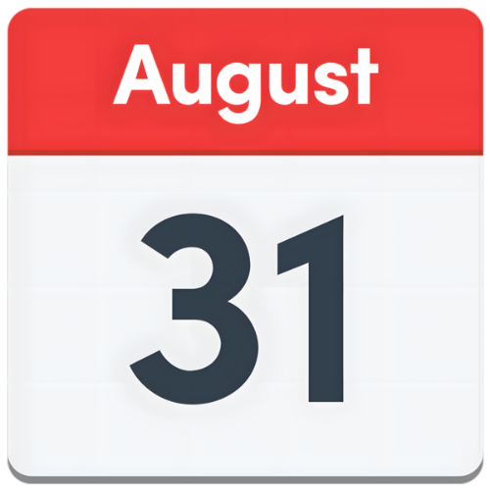

# Background

We are updating our rules about how we talk and listen to people in Ceredigion.

The rules are written in our Engagement and Participation policy.

**A group of people standing around a person in a wheelchair

**

**Engagement** **means** thatthe council talks to you and listens to you to help us make good choices for the area.

**Participation means** thatyou get to share your ideas and help make decisions.

**We want to make sure everyone has a chance to share their ideas.**

# Questions

1. Have you ever taken part in a Council activity where we have asked for your opinion about something?

Yes No

2. Please use this space to tell us about your experience:

1. How do you like to share your views? Please number them from 1 (best) to 5 (worst):

Online survey

Paper survey

In person meetings

Focus groups

Through a community group

1. What makes it hard for you to share your views with us? Tick all that apply:

Not enough information

I don’t think my views matter

It’s too complicated

I don’t have time

It’s hard for me to use technology

There are too many surveys

Other reasons

Use this space to tell us more about other reasons:

5. Please use this space to tell us what we can do to make it easier for you to take part:

6. Please use this space to tell us about any local topics you want to talk about more:

7. We are thinking about new ways to talk with people. Would you like to try these?

**Community Assembly** – A meeting where people share ideas and help make decisions.

**Participatory Budgeting** – You help decide how some money is spent in your area.

**Legislative Theatre** – Acting out problems and finding ways to fix them.

None of the above

8. How happy are you with how the Council listens to people?

Very happy

A bit happy

Not sure

A bit unhappy

Very unhappy

# Join the People's Panel

Would you like to join a group that shares views with the Council?

Yes No

If yes, please put your email address below:

__________________________________________________

Equality Questions **(optional)**

These are questions about you. You don’t have to answer them. You can skip any question that you do not want to answer.

How old are you?

Are you male or female? If you use a different word to describe yourself, please say what this is.

Is your gender now the same as it was when you were born?

Are you heterosexual/straight, or gay or bisexual?

If you use a different word to describe yourself, please say what this is.

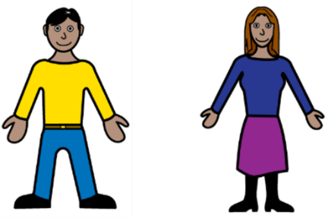

Are you British, Cornish, English, Northern Irish, Scottish or Welsh?

If you use a different word to describe yourself, please say what this is.

What is your ethnic group?

Asian, Asian British or Asian Welsh

Black, Black British, Black Welsh, Caribbean or African

Mixed or Multiple ethnic

White

Another ethnic group

What is your religion?

Christian

Buddhist

Hindu

Jewish

Muslim

Sikh

No religion

Another religion or belief

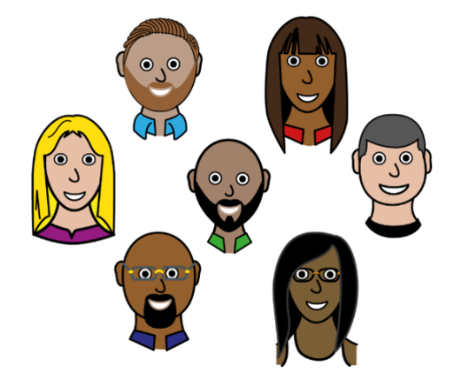

A group of religions symbols 

 Two soldiers holding guns in front of the British flag


Have you served in the UK Armed Forces before now?

Yes, in the Regular Armed Forces

Yes, in the Reserve Armed Forces

No

Are you a disabled person?

Yes, my day-to-day activities are limited a lot

Yes, my day-to-day activities are limited a little

No

Do you prefer to speak Welsh or English?

English

Welsh

A Welsh red dragon flag and an English George Cross flag



Can you understand, speak, read or write Welsh?

Understand Speak Read Write

Thank you for completing this survey.

Please return it to a Ceredigion Library or post it to:

Equality and Inclusion team

Ceredigion County Council

Penmorfa County Hall

Aberaeron

Ceredigion

SA46 OPA

If you want to talk to someone about our Engagement and Participation Policy or about this survey:

**Telephone – 01545 570881**

**Email –** [**clic@ceredigion.gov.uk**](mailto:clic@ceredigion.gov.uk)

The survey will close on 31 August 2025.

We will read all the answers and use them to help write our new policy.

We will ask you what you think of the new policy over winter 2025.